Animality and Nationality in Graphic Novels: The Representation and Categorisation of Native Americans in the Red Wolf story arcs.

Holly May Treadwell

Contents.

Introduction…………………………………………………………………………. 4
Chapter One: The Bloodthirsty Savage……………………………………………... 9
Chapter Two: The Naïve Sidekick………………………………………………… 17
Conclusion…………………………………………………………………………. 33
Works Cited………………………………………………………………………... 37
Supplementary Bibliography………………………………………………………. 48

Abbreviation Key:
MA = Mighty Avengers: The Coming of Red Wolf (Thomas and Buscema, 1970).
MooT = Red Wolf: Man Out of Time (Edmonson et al, 2016).
OA1 = Occupy Avengers 1: Taking Back Justice (Walker et al, 2017).
OA2 = Occupy Avengers 2: In Plain Sight (Walker et al, 2017).
Introduction.

[Comics] can illustrate action-packed snapshots of popular society, and in these snapshots, one can study a minute and pristine microcosmic universe.
- Sheyahshe 3

The recent boom in blockbuster adaptations of superheroes and the subsequent rise in comics sales (Drum) has brought comics into the mainstream media. As Horn states, now that comics ‘are no longer dismissed as grubby purveyors of mindless entertainment, the cartoonists and their employers must expect to be called into account on aesthetic and ethical grounds’ (Horn 62). Early comics were plagued with racial and racist stereotypes and even today many comics ‘repeat the sins of their literary ancestors, particularly in representing Indigenous people in only one or two generic fashions’ (Sheyahshe 10). The importance of recognising and analysing such representations comes from the fact that ‘comics have always reflected people’s likes and dislikes, preferences, and prejudices’ (Pewewardy, American 193). Indeed, as Sheyashe writes,
Comic books can reveal more about popular society and culture than just the black-and-white idea of good versus evil […] A comic book can inspire and teach. More importantly, comics can provide their audiences with a clearer view of ingrained societal and cultural attitudes. (Sheyahshe 3)
The consideration of comics as pseudo art (Kukkonen 114) and ‘juvenile, disposable trash’ (Versaci 2) has meant that they have had more freedom in their ability to comment on and critique societal attitudes and political events, resulting in their depictions of life being far more accurate than a novel or TV show, which are often heavily censored. As the recognition of this potential grows, recent years have seen the publication of works such as Michel A. Sheyahshe’s Native Americans in Comic Books, Fredrick Strömberg’s Black Images in Comics, Frederick Luis Aldama’s Multicultural Comics, and Binita Mehta and Pia Mukherji’s Postcolonial Comics, which have opened up the field to include issues of representation, especially surrounding race and colonialism. However, the exploration of the latter in the field often excludes popular superhero comics, and chooses to focus instead on autobiographics and other non-fiction works. Similarly, many studies into racial representation in comics focus on twentieth century works, and far too many of these ignore Native Americans. Sheyahshe’s work is a much-needed change from this habit, and is the first and only study dedicated entirely to the representation of Native Americans in comics. However, it’s 2008 publication meant that it preceded Marvel’s ‘All New, All Different’ reboot, which saw a more diverse line-up of characters such as Lunella Lafayette (Moon Girl), Kamala Khan (Ms Marvel), Sam Wilson (Captain America), Cindy Moon (Silk), and Red Wolf (who was Marvel’s first Native American superhero (Saunders et al 146)) enter the mainstream Marvel universe. As such, Sheyahshe’s work missed out on the opportunity to examine the “all-new” Red Wolf in his role as the lead in his own comic and as a main character in an Avengers storyline. This study therefore picks up where Sheyahshe left off, and takes a critical approach to the use of categories in the writing and illustrating of Red Wolf: Man out of Time (2016; henceforth cited as MooT), Occupy Avengers 1: Taking Back Justice (2017; OA1), Occupy Avengers 2: In Plain Sight (2017; OA2), and with the occasional comparison to Red Wolf’s 1970 debut in Mighty Avengers: The Coming of Red Wolf (MA).
This study focuses on issues of animality and nationality due to the way dominant portrayals of Native Americans function to liken them to non-human animals; indeed, all aspects of these stereotypes are traits commonly attributed to both groups. There is a long history of animalisation as a tool of human oppression and it was this dehumanisation that was used to “justify” colonial atrocities such as the native slave trade and the trail of tears (Roberts 51, 182; Sivasundaram 157; Peterson 7; Gruen and Weil 480; Deloria, Playing 4; Martin 63; Seshadri 7). As Wolfe states, ‘you can’t talk about race without talking about species, simply because both categories – as history well shows – are […] constantly bleeding into and out of each other’ (Wolfe 43). This study aims to acknowledge this historical animalisation of Native peoples and examine the ways in which it still haunts contemporary Native characters and communities. Furthermore, this animalisation often focused on indigenous people’s physicality (Green 327; see also Feest 46; Matijasic 31-50) so it seems especially necessary to explore the progress and lack thereof in the comics medium, which depicts characters visually as well as textually.
Exploring themes of animality and nationality in respect to Red Wolf seems particularly fitting due to his animal namesake. Many traditional Native American peoples derive names from their tribe’s or their personal animal guardian (Versluis 58; Roberts 182), so the character’s name could be a reference to this tradition. However, it is worth remaining sceptical considering the long history of animalisation, and recognising the potential for his name to act as a continuation of this stereotyping. Thus, the character’s name, the historical dehumanisation of Native Americans, and the continuous likening of Native peoples to non-human animals call for the exploration of the crossovers between animality and nationality and how they interact in regard to Marvel’s most prominent Native character, both from his 1970 debut and in comics from 2016 and 2017. This study is intended as one possible response to this call.
In order to thoroughly examine how animality and nationality interact, I have focused on the two dominant portrayals of Native characters and used these categories as a basis from which to compare the writing and illustrating of Red Wolf and the other two Native characters present in his story arc, Silas and Frank Fireheart. Whilst white characters exist free of categorisation for the most part and are presented as three-dimensional, Indigenous comics fans such as Sheyahshe realised that the indigenous heroes he read about ‘seemed to more readily fall into certain categories’ (Sheyahshe 2); they are slotted into fixed boxes, turned into caricatures of their culture, and thus their expression of humanity is limited. The method of categorisation is clearly problematic as it has a tendency for simplification, but in this context they are appropriate and necessary precisely because these categories have defined Native characters for centuries; one must examine the category in order to recognise any continuous stabilisation or indeed deconstruction of it.
The main question this paper aims to answer is: how do the depictions of Native characters in these comics (particularly Red Wolf as a Southern Cheyenne character) destabilise and further construct existing problematic categorisations? Secondarily, this study will also examine what needs to be improved in these representations in order to portray Native American characters as full, complex humans with agency over their own stories, rather than caricatures. In order to answer these questions efficiently, I have broken down the categories into three and four main components, which are outlined below, and this allows me to examine in more detail exactly where and how representations destabilise or stabilise these categories, and allow or disallow the character agency. It is also worth noting that the two categories I have chosen to use are not of my own invention; they have come out of a long background of research into the representation of Native Americans in both the comics medium and more general Western media.
Chapter One focuses on the category of the Bloodthirsty Savage, which can be broken down into three main traits: lawlessness, violence, and anger. This is a well-established category, and this exact phrasing has been used by scholars such as Kilpatrick (xvii), Green (327), and Berkhofer (98). The broader category and concept of the “savage” is also discussed by Sheyahshe (15-17), Pewewardy (Studies 5-6), Pearce (xxi), Deloria, (Playing 4), Stedman (248), Roberts (26), Jackson (677-678), Harvey (525), Douglas (12), Jahoda (15-25), Krech (16), and many other scholars. The word savage is clearly problematic in nature; it is an insulting and racist term that has ‘consistently plagued aboriginal people for centuries, and been used to justify any number of crimes and cruelties against’ Native communities (Leask, Not So; see also Krech 16; Deloria, Playing 4; Harvey 525; Cunneen 20-29). The racist nature of this term stems from the implicated dehumanisation and animalisation of Native peoples, as savage originally meant “wild” or “in a state of nature” (Krech 16-17) and was used to indicate their supposedly animal-like existence (Green 328; Roberts 58). Indeed, colonial narratives claim ‘that indigenous people are no better than carnivorous animals that wantonly kill and destroy’ (Green 329). Green’s specification of ‘carnivorous animals’ relates to offensive portrayals of Natives as cannibals, and the assumption that carnivores are dangerous and overly violent. The adverb, ‘wantonly’, emphasises this depiction, as it suggests that this assumed violence is unprovoked and unnecessary. Overall, the images of Natives as Bloodthirsty Savages ‘in one way or another deny the humanness of the Native Americans’ (Green 329). The proliferation of this pejorative term is exactly why it is so present in analyses such as this; in order to challenge and deconstruct the perception of Native peoples as “savages”, it is crucial to be able to recognise where and how media stabilises this perception.
Chapter Two focuses on the category of the Naïve Sidekick, which is constructed through four key components: a lack of so-called “higher” thinking, simplicity, haplessness, and the position of sidekick. This is also a well-established category, although the specific phrasing is not pre-existing and comes from combining many scholar’s discussion of the concept. The Naïve Sidekick category draws on the dominant portrayal of Native characters as ‘child-like’, outlined by Wright (‘Interview’ 10), Anderson (302), and Green (327); ‘bumbling’ and foolish, discussed by Pewewardy (Studies 9), Wright (‘Interview’ 10), and Stedman (245); in need of / dependent on white people, examined by Pearce (8), Roberts (25), and Green (327); naïve, discussed by Roberts (25), Sheyahshe (15), Kilpatrick (xvii), and Bird (3); and as Sidekick/ the White Man’s Helper, outlined by Sheyahshe (9, 39), Green (327), O’Neil (24), Keiser (78), Friar and Friar (1-12), and Bataille and Silet (116). By combining the central concepts of these discussions into a brief but clear summary, I arrived at the “Naïve Sidekick”. This category is certainly more benign than the first, but its pervasiveness and apparent fixedness (alongside its insulting implications) still makes it inaccurate, unnecessary, and racist. It also displays the animalisation of Native Americans through the overarching view that animals lack intelligence and exist to serve humans’ purposes, whether that be as slaves, food, or entertainment, as this consideration of animals as human sidekicks without intrinsic value was also the dominant colonial view of indigenous peoples. Like the Bloodthirsty Savage, categories such as this need to be examined and named precisely because of the racism that underlies them.
It is important to undertake such analyses in order to acknowledge and understand that such racism is not delegated to the past, but is very much present in even the most contemporary representations. Such ‘Anti-Indianism’ is ‘emerging as a major issue in recent cultural scholarship and deserves further examination’ (Cook-Lynn 3), which is one of the things this study is attempting to achieve. As Pewewardy states,
America cannot truly understand the real issues of contemporary American Indian lifestyles and worldview without understanding the popular Indian images of the past, present, and future. Understanding the contemporary images and perceptions of American Indians in comic books is extremely important, not only for Indian people but also for the mainstream culture. (Pewewardy, American 198).
Therefore, by examining the ways in which the Red Wolf comics both construct and deconstruct these categories, this paper aims to show the continuing existence of racist stereotypes, how these allow or disallow the character agency, and to outline the progress made in moving away from these categories as a foundation for future depictions. By doing so, I also aim to demonstrate the overarching attitudes in modern, Western society towards Native Americans and the need for representational change in order to inspire real-life, political change regarding the oppression of indigenous communities around the world.

Chapter One: The Bloodthirsty Savage.

The oldest and most wide-spread depiction of Native Americans in Western media is that of the Bloodthirsty Savage (Green 324), who is ‘often crazed, seeking vengeance or just malicious fun’ (Berkhofer 98). Native characters in this category are presented as lacking rational thinking and driven by instinct, as being primitive in their attention to vengeance rather than “justice”, and as enjoying causing pain and destruction. Early European explorers ‘took back [such] stories of wild savages that fit neatly into the preconceived notions the Europeans had of what a savage would be’ (Kilpatrick 1), demonstrating that such portrayals were an ‘invention’ that preceded any contact with real Native peoples (Kilpatrick 1). Despite this view lacking any basis in real observations, this notion of “Indian savagery” continues today in several aspects of American culture, including manufacturing (the Tomahawk Mulcher), the armed forces (Tomahawk Missiles), and sports (the Atlanta Braves, Washington Redskins, Cleveland Indians, and Kansas City Chiefs, for example), where Native culture is used to reflect violence, physical power and to intimidate opponents (Green 324; Giago; MPR Staff). The language and objects chosen as synecdoches of Native culture further display the pejorative and racist views towards indigenous people, as they all connote destruction and hostility, and thus reduce Native culture to violent stereotypes.
Whilst Native characters nowadays are less often presented as outright bloodthirsty, some of the components of this stereotype remain prevalent. Within the category of the Bloodthirsty Savage, there are three main traits that demonstrate the character’s animosity and animality: lawlessness, violence, and anger. By presenting Native people as lacking any moral compass or social order, being violent and dangerous, and driven by anger, they are likened to non-human animals, of whom the same traits are assumed (Gunther; Bekoff). These characterisations were used as “evidence” that both groups needed ‘to be civilised by a supposedly superior culture’ (Green 328). The proliferation of zoos and circuses exemplify this attitude (Berger, About 3-28), where animals were stolen from their natural habitats, tamed, and trained for human entertainment, as does the Civilisation Act, which stole Native children from their communities and forced them to attend boarding schools where the practises of their culture were forbidden and they were taught how to be “American citizens” (Tighe 8; Martin 63). Indeed, many depictions of Native characters include the white hero teaching the Native character to obey the laws and customs of their culture, the most famous example being Friday in Defoe’s Robinson Crusoe, who is “saved” by Crusoe, taught to speak English, and converted to Christianity (Defoe).
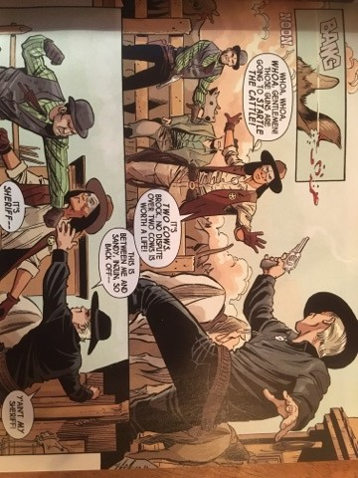
Marvel’s 1970 Red Wolf stabilises this category as he is introduced attempting to murder the man who killed his family (MA 4), thus presenting him as having no regard for “American” laws. Thankfully, contemporary Marvel destabilises this lawlessness trope in Man out of Time, as Red Wolf is the sheriff of the town and therefore the enforcer of the law, rather than the student of it. The first time we encounter Red Wolf, he is attempting to calm an argument between two white men, who are threatening each other with violence (figure 1). The stance of the man to the right (Brock) is predatorial, as his knees are bent and his left arm is stretched behind him for balance, indicating his readiness to attack. The man to the left (Sandy) is holding his left arm out with his palm facing down and fingers closed tightly, which is associated with the assertion of dominance and tyranny (Kuhnke 143) and makes him appear immoral and aggressive. In contrast, Red Wolf is positioned between the two men, reflecting his metaphorical position as being “neutral”; the mediator of the argument. His face appears calm, not scrunched in anger like Sandy’s, and his hands and open fingers assert authority, but in a non-threatening and calming way (Kuhnke 143), unlike the closed fingers of Sandy. In addition, both of his arms are outstretched, one towards each man, with his palms tilted and fingers open. This body language suggests that he is reaching out to the men, both with his arms and with the offering of “reason” (that ‘no dispute over two cows is worth a life’ (MooT 4). This attempt at rationale fails; neither of the white men listen and Red Wolf is forced to use physical violence in order to stop the men from killing each other. Thus, the perception of Native people as ‘more animal than rational’ (Pearce 5; see also Kincheloe; Hakluyt vii) is reversed, as Red Wolf is the voice of reason, the enforcer of the law, and the calming mediator between two irrational white men.
Figure 1: Red Wolf attempts to calm an argument between two men (MooT 4).
Indeed, when Red Wolf visits his mother, who asks ‘How is the civilised world?’ (MooT 8), he replies: ‘Not very civil. In frequent need of the law’ (MooT 8). Not only does this interaction directly address and reverse the stereotype of Natives as savage and white colonisers as civilised, it implies that Red Wolf is needed in order to keep the colonist settlers in check; that he is the bringer and the enforcer of “civilisation”, demonstrating his agency in this situation. Moreover, if Bhabha’s notion of mimicry as a means to destabilise the mythos of colonial superiority is applied here, then Red Wolf’s embodiment and enforcement of the law further deconstructs the category of the “lawless” savage by positioning him as “similar” to the supposedly superior white man (Bhabha 127). One problem with this depiction, however, is that the law Red Wolf enforces is also the colonial law – that which stripped away land and rights from Native populations in the first place, so it places him on the same side as his oppressor. This problem, though, is fairly minor and an issue of discomfort rather than outright racism, and overall the comic does a good job at destabilising the category.

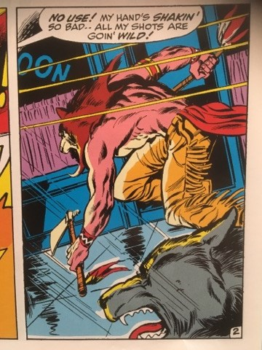
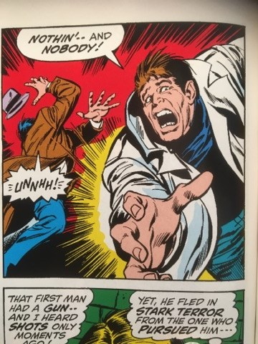
The second component that demonstrates animosity and animality is violence: Native populations were often included in people’s consideration of nature as wild and thus dangerous, threatening, and cruel (Shepard 273; Krech 16-17; Gunther), and this is reflected in the categorisation of Native characters as predatory. An example of this is the Comanche characters in Straight Arrow (Meagher), who are territorial and ‘ready to fight with little encouragement or reason’ (Sheyahshe 17). The Mighty Avengers presents Red Wolf in a similar way, as he is first introduced “hunting down” an enemy and shouting, ‘Too late for you to do anything – but die!’ (MA 4), the bold wording implying his embodiment of the extreme and barbaric view that death is the only suitable punishment. This depicts Red Wolf as ruthless and unforgiving, and when Vision prevents him from killing his enemy, Red Wolf laments that ‘My prey has fled’ (MA 5). The noun holds strong connotations of animality and positions Red Wolf as a dangerous predator, rather than a hero fighting injustice. Furthermore, in figure 2 Red Wolf is crouched low to the ground, his head is lowered so it looks like he has the head of a wolf, and the shading on his overly muscular back looks like fur. This imagery not only further animalises the character, but also furthers the depiction of Native characters as dangerous through the visual reference to werewolves, which are typically presented as uncontrollably and aimlessly violent (McKay and Miller). Furthermore, Vision’s intervention is itself a demonstration of the view of Native Americans as violent and murderous: upon seeing a white man run past firing a gun, shouting, ‘Die, blast you.. DIE!’ (MA 2), violently shoving people out the way (as shown through the harsh and tightly packed movement lines in figure 3), and then a Native American following, Vision pursues and tells Red Wolf that ‘a human life is not to be lightly taken’ (MA 3). Vision appears to ignore Birch’s attempt to kill Red Wolf and his disregard for the safety of ordinary passers-by, as his bullets were ‘goin’ wild’ (MA 2; see the yellow movement lines in figure 2) and could easily have killed civilians; instead he targets and lectures the Native character, who is only “disregarding” the life of one man, whom Vision already knows is a criminal (MA 4). Furthermore, Vision’s statement that a life should not be taken “lightly” reveals his belief that Red Wolf lacks real motive or reason for killing Birch, indicating Vision’s embodiment of the view that Native Americans are ‘predatory animal[s] that kill aimlessly and wantonly’ (Green 327; see also Keiser 152; Friar and Friar (118); and Bataille and Silet 83). Vision’s assumption that the Native character is the wrong-doer, despite evidence to the contrary and his awareness of Birch’s criminal status, reflects the racism of the criminal justice system, where Native Americans suffer racial profiling, are incarcerated at 38% higher than the national rate, and receive longer sentences than any other ethnic group (Tighe 12). Even more problematic is that this view is not presented in order to be challenged. The comic does go on to tell Red Wolf’s side of the story, which shows that Birch is a murderer and that Red Wolf’s attempt to kill him was not a “light” decision and instead reasonably justified, but Vision’s racist assumption is never questioned and thus the comic normalises such views.
Figure 2: Red Wolf and Lobo pursue Birch (MA 2)
Figure 3: Birch flees Red Wolf and shoves a man out of his way (MA 3)
Moving from 1970 to 2016, the assumption of Natives as violent and murderous is directly addressed in Man out of Time, as the townspeople instantly accuse ‘savages’, the ‘Apache’ tribe, and finally Red Wolf himself of murder when two townspeople are found dead (MooT 10). This attitude is reflective of Vision’s, but here is included in order to directly criticise this racism. The reader knows that Red Wolf was visiting his mother when the murder took place, and Red Wolf points out that the tracks lead ‘off to the Malpais. Not from my tribe’, and that ‘There are no Apache within a state’s distance’ (MooT 10), making the accusations seem ridiculous in their unfoundedness, and the accusers idiotic in their lack of knowledge of Native tribes, tracking, and basic geography. Occupy Avengers 1 also destabilises this trope by depicting Red Wolf as being reluctant to harm or kill his enemies; he is shown to have agency over any internal violent instincts, shouting, ‘I don’t want to kill anyone!’ and shooting his enemies in the legs in order to stop their assault (OA1 36). Here, we can see Red Wolf’s anti-violence morality override his instinct to survive, as he makes an effort not to kill his enemies even when it may be easier to do so.
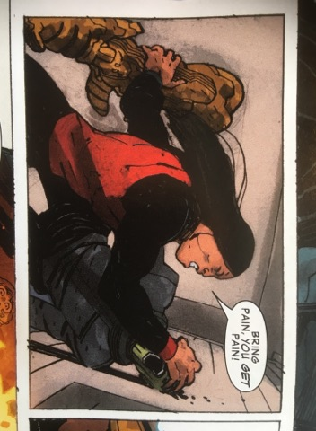
However, Occupy Avengers 2 takes a step backwards regarding this stereotype. Similarly to the Mighty Avengers, Red Wolf appears violent and ready to kill his enemies, shouting things such as, ‘I will break you!’ (OA2 32) and ‘Bring pain, you get pain!’ (OA2 59). Such threatening exclamations fit into Hardy’s outline of the “Bloodthirsty Savage” who ‘expressed a greater desire for power and revenge’ (Hardy 9), as the latter especially reflects the notion of “pay-back” rather than “justice” through the parallelism of his statement. In addition, Red Wolf’s face in these moments perpetuates this stereotype (see figure 4 and 5), as his teeth are exaggeratedly bared in the latter, and in the former his mouth is wide open whilst shouting a threat. The onomatopoeic ‘CRAAASH’ and the jagged text also emphasise the impact and thus the violence of Red Wolf’s attack.
Figure 5: Red Wolf fights the Skrulls continued (OA2 59)
Figure 4: Red Wolf fights the Skrulls (OA2 32)
The later issues of the comic appear to recognise the problematic nature of this depiction, and revert to the morality shown in Man out of Time and Occupy Avengers 1. Towards the end of the comic, Red Wolf stops Nighthawk from killing the Hydra agents, telling her, ‘Do not let your rage – your need for vengeance – consume you’ (OA2 75), thus subverting the above depiction of Native characters as violent, and the following depiction of them as rage-driven.

The third and final component of the Bloodthirsty Savage is anger: Native characters are typically depicted as being ‘devoid of any expression, except when he is enraged’ (Sheyahshe 102). Anger is considered a basic or primary emotion according to many psychologists (see Parrot 12; Ekman 45-60; Plutchik 3-33; and Handel), and not dependant on any form of complex cognition. The presentation of Native characters as lacking all complex emotions implicates their supposed animality, as debates surrounding animal emotions continue into the present day (Dawkins 883). Furthermore, the pejorative perception of anger in Native Americans disregards and erases their historical and current oppression, by presenting it as dangerous and animalistic, rather than a justified reaction to the racism they continue to face. This stereotype of the angry Native is clearly discriminatory, yet it is exemplified by characters such as Thunderbird (Moore et al; Wein et al) and Street Wolf (Harris and Francis), who often appear resentful and hostile (Sheyahshe 102, 115).
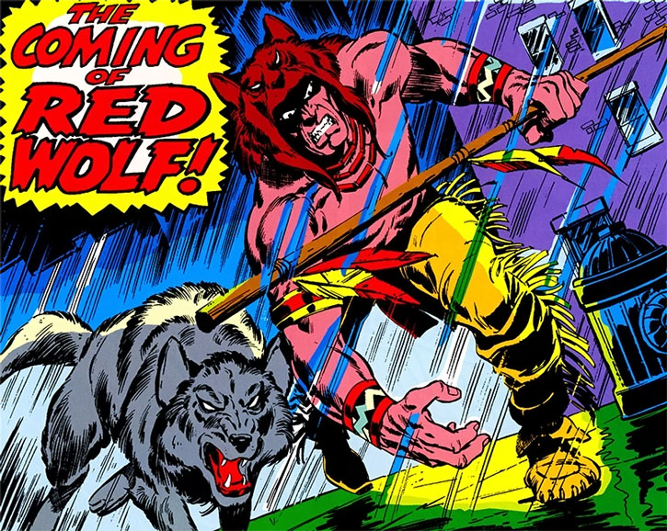
Red Wolf, too, often enforces this category of the ‘angry Indian’ (Sheyahshe 102): he is mostly depicted with a neutral or slightly frowning expression, and the only variation of this depiction is when he is angered, such as in figure 6. The shadow over his eyes makes him appear mysterious, sinister, and dangerous, and removes the character from ‘identification and sympathy’ through the reader’s inability to see his face clearly and thus to connect with him as an individual (Worden 10). The basic whites and pupils of his eyes that are visible are similar in shape and expression to the wolf, Lobo’s, and his bared teeth make him appear animalistic and predatorial, as does his stance. Red Wolf’s low-hanging arms, the width of his shoulders, and the exaggerated size of his hands and muscles are reminiscent of a gorilla, further feeding into the racist depictions of Natives as sub-human (Pewewardy, Studies 2), especially the “science of race” that sought to justify the oppression of people of colour by claiming ‘physical differences between human groups as innate, morally and intellectually determinant’ (Douglas 5). That is, that people of colour were closer to animals than white humans, and thus lacked human intelligence, morality, law, and culture. In addition, his bent knees, his long stride, and the proximity of his body to the ground brings him onto the same visual level as Lobo and is reminiscent of a predator stalking its prey, and this crouched position occurs frequently throughout the comics (for example, see figure 2 above). The purple, black, and blue colouring of the background shows the reader that it is dark outside, which furthers this sense of danger through its connection to nocturnal predation, and the rain adds to the sinister setting. Lastly, the subtitle bubble has extremely jagged edges and is written in red, both of which connote danger and anger. Together, all aspects of this introductory image make him appear dangerous, angry, and animalistic, taking away his agency and perpetuating derogatory stereotypes of Native peoples.
Figure 6: Red Wolf pursues his enemy with Lobo at his side (MA 2)
Figure 7: Red Wolf and Barton are captured by Hydro Man (OA1 33)
Forty-seven years later, Occupy Avengers 1 also depicts Red Wolf as dangerous and angry, especially when viewed in comparison to Barton. The angle of the frame in figure 7 has the reader looking up at Barton, his lips are slightly parted, his eyebrows are raised in the centre in concern, and his complexion looks smooth. Overall, he looks angelic and innocent, which is contrasted to Red Wolf, whom the frame is looking down upon. In addition, his eyebrows, mouth, and face are tilted down, his eyes are narrow and partially hidden underneath his eyebrows, his complexion is tainted by shadows and shading, and his lips are parted more than Barton’s, displaying his teeth. This imagery conveys a sense of animality and the position of the viewer implies a metaphorically “lower” position in comparison to Barton, also feeding into the sub-human rhetoric. Red Wolf looks angry here, and this discrepancy perpetuates the view of Native Americans lacking ‘emotions other than mindless fury’ (Stedman 251).
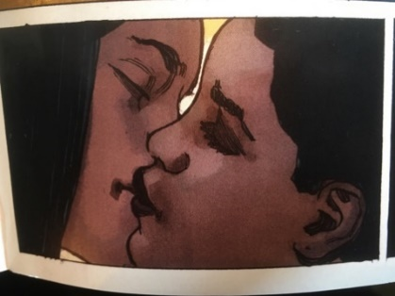
This first volume received criticism online for this presentation of their Native hero as stoic and lacking personality (Schmidt; Cundle), and Marvel does appear to have responded to this feedback, unfortunately rather late in the story’s run. At the very end of Occupy Avengers 2, the reader is finally shown a different, softer side of Red Wolf, through which they deconstruct views of Native people as lacking emotion and thus having a ‘lower desire for love and affection’ (Hardy 9). When left alone for a moment before joining the battle against Hydra, Red Wolf tells Tilda that he wishes they had more time together, at which point Tilda grabs and kisses him (OA2 107-108). At first, Red Wolf looks surprised (figure 8), and this provides him with a sense of innocence and vulnerability, before he closes his eyes and his face looks serene, content, and soft, as his eyebrows are unusually relaxed, his mouth is not turned down, his eyes are angled gently upwards, and his complexion is clear and untainted by harsh shading (figure 9). His face is also partly hidden behind Tilda’s, reflecting her control over the situation and furthering the sense of Red Wolf’s innocence and even shyness. The lighting of these panels is also noteworthy; the rest of the scene involves dark grey and blue backgrounds, but for the close-ups of Tilda and Red Wolf, the background is bright but soft, and the light bounces off their hair and faces. Moreover, the panel in figure 8 is unusually wide and yet all background detail, especially the array of weapons, is removed in favour of the yellow/white background, surrounding the characters with a sense of serenity and adding to the depiction of Red Wolf’s softer side. These panels appear to move from the physical space of the battle into the emotional space of the characters, and does well rejecting the portrayal of Native Americans as lacking any emotion other than anger, and gives Red Wolf some form of agency by having him instigate this refreshing show of emotion.
Figure 8: Tilda kisses Red Wolf (OA2 107)
Figure 9: Tilda and Red Wolf kiss (OA2 108)

Whilst the older depictions of Red Wolf from 1970 portray him as violent and murderous, and even the newer ones often portray him as angry, the 2016-2017 portrayals do more frequently destabilise the Bloodthirsty Savage stereotype, by directly criticising racist assumptions and portraying him as lawful and reluctant to harm people. Man out of Time certainly appears to destabilise the tropes more often than the Occupy comics, which sometimes appear to take a step back in terms of progress. This inconsistency reflects the fact that society still has a lot of progress to make regarding Native American rights, and shows that the comics medium needs to take more consideration in allowing the characters a wider range of emotion and more agency over their own story.

Chapter Two: The Naïve Sidekick.

As media grew out of the brazen depiction of Native characters as Bloodthirsty Savages, another stereotype emerged: ‘Indigenous characters evolved slowly from the despised faceless nemesis of the hero to the simple-minded helper. Some Native characters even became popular enough to warrant their own comic book title, but always under the guise of their dutiful subservience to the white man’ (Sheyahshe 9). Out of the Bloodthirsty Savage grew the Naïve Sidekick, and this stereotype is still prevalent in modern popular culture due to its slightly more subtle racism in comparison to the “savage”.
In the category of the Naïve Sidekick, there are four main traits that demonstrate both the character’s naivety and their perceived animality. The first of these traits is a lack of “higher” thinking, by which I refer to the cognitive capacity for imagination, interpretation, and critical thinking. Traditionally, animals have been considered to lack ‘all higher cognitive function’ (Byrne 114); for a long time scientists were reluctant to even confirm the existence of ‘consciousness in other-than-human animals’ (Waldau 155). Similarly, ‘Native peoples have been firmly placed in the lower echelons of intelligence by many Euro-Americans since first contact was made’ (Kilpatrick xvii; see also Gobineau 391-413), and even today philosophical thought is assumed to be beyond their culture (Pomedli xi-xii). These perceptions of non-human animals and Native people have obviously been proved false (Byrne 120-122), yet these problematic categorisations persist in contemporary representations.
The most obvious and famous example is Tonto, from The Lone Ranger (Lansdale et al), whose name literally translates to “silly”, “fool”, and “dumb” in Spanish, Portuguese, and Italian respectively. Another example is Adam Sandler’s recent film, Ridiculous 6, which has come under fire for insulting Native Americans, mocking their culture, and playing on the “dumb Native” stereotypes (Schilling; Moyer). The 2015 film is an explicit example of the continuous presentation of Native Americans as lacking intelligence. It is worth noting that the film-makers have attempted to defend such presentations by claiming that they were part of the satiric nature of the film (Moyer), but the stereotypes that it presents are too prevalent and are too much the norm in Western culture for the film to avoid feeding into and enforcing such dangerous and disrespectful views. The problem that arises with such depictions is outlined by Berger, who explains how the ‘circulation of images that deny or question the humanity of […] politically disempowered groups plays a supporting role in normalising discriminatory, violent, and potentially even genocidal behaviour against individuals from those groups’ (Berger, Sight 133). Considering, then, the continuing institutional racism faced by Native American communities, depictions such as Tonto and the characters in Sandler’s film cannot exist innocently or ironically; they can only add to the discrimination already faced by these groups.
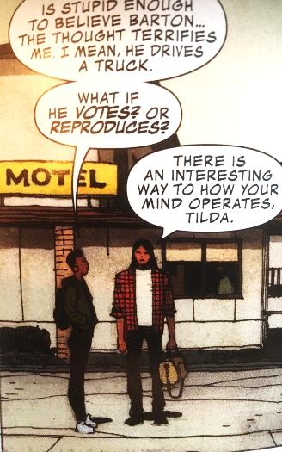
Occupy Avengers 1 also stabilises this trope by presenting Red Wolf as incapable of understanding tactics, as he asks Barton ‘Why are you taunting [an enemy]’ (OA1 29). Barton replies that he is ‘messin’ with his mind – creating a tactical advantage’ (OA1 29). Insults have a negative effect on one’s mentality due to the influence of social hierarchy on the human psyche: insulting someone, belittling them, or mocking them, as Barton does, undermines their conviction of themselves. Red Wolf’s question and Barton’s subsequent explanation implies Red Wolf’s lack of understanding of these tactics, and indeed the fairly basic psychology they are based on, as he appears unable to figure out the consequences of Barton’s words on the man’s mentality. This naivety is even more problematic if we consider the following infamous words as quoted by Freud: “the man who first flung a word of abuse at his enemy instead of a spear was the founder of civilisation” (Freud 36). The statement is intended to be witty, but it highlights an underlying racist perception: that of colonial intellect vs primitive violence. Indeed, Barton here represents the “civilised” psychological tactics, and Red Wolf only understands physical violence, reinforcing the idea of Native simplicity even in a comic as recent as 2017.
Figure 10: Red Wolf’s new look (OA2 5)
However, this presentation of Red Wolf as naïve is somewhat destabilised in Occupy Avengers 2, where Red Wolf states that they ‘are in position’ through a walky-talky (OA2 5). If we take this scene in isolation, it implies his involvement in a calculated plan and thus the capacity for rational deliberation rather than relying on instinctive aggression and naked impulse as the stereotypical portrayal of Native Americans usually shows us (Anderson 304). Moreover, his involvement indicates a level of cleverness, critical thinking, and imagination, especially by demonstrating his understanding of the plan through the imperative, ‘MOVE!’ (OA2 74). This command shows that he knows their cue and is taking a position of leadership. However, this increasing understanding of tactics coincides with the increasing “Americanisation” of the character. At the end of Occupy Avengers 1, Red Wolf and Barton ‘team up’ (OA1 43), and when we re-join them in volume 2, Red Wolf is now dressed in jeans and a checked flannel shirt (figure 10) and there are far fewer references to his culture. This correlation actually reinforces the stereotype of Native-ness as inherently naïve and whiteness as inherently knowledgeable, and even confirms the destructive view that ‘Native people will survive only if they disassociate themselves from the deadly rhetoric of “Indianness” (Pulitano 146). Therefore, despite the apparent progress in this scene when viewed in isolation, considering the full narrative leading up to it reveals it to be slightly less progressive.
Occupy Avengers 2 continues to iterate this stereotype regarding humour. Native people are often presented as stupid and bumbling (Sheyahshe 6, 87; Pewewardy, Studies 23; Stedman 245), and comedy is often ‘based on notions of the “stupid Indian”’ (Sheyahshe 87). Red Ryder’s sidekick, Little Beaver, is a prime example of this, as his ‘buffoonery’ provides comic relief for the white hero and demeans the culture he is supposed to represent (Sheyahshe 41). Moreover, the dominant and most accepted theory of humour in modern psychology and philosophy is the “Incongruity Theory”, first discussed by Beattie, Kant, Schopenhauer, and Kierkegaard, and developed by modern researchers such as Hurley, Dennet, and Adams; Suls; and Deckers and Buttram. According to the incongruity theory, humour requires three key abilities: imagination in the ability to ‘mentally represent the set-up of the joke’; critical thinking in the ability to ‘detect an incongruity’; and interpretation to ‘resolve the incongruity by inhibiting the literal, non-funny interpretations, and appreciating the meaning of the funny one’ (Gibson; see also Suls 39-40; Deckers and Buttram 53-64; Hurley, Dennet, and Adams 45-52). Essentially, humour requires the capacity for the kind of “higher” thinking explored above. In line with the presentation of animals and Native peoples as lacking this capacity (Hanson and Rouse 34; Roberts 25), Native characters are typically presented as being ‘bereft of a sense of humour’ (Sheyahshe 21). Some examples include the Native characters in White Indian (Franzetta), Shaman in Alpha Flight (Byrne et al; Mantlo et al), Marvel’s American Eagle (Moench et al), DC’s Tomahawk (Kubert), and Thunderbird in the X-Men (Moore at al; Wein et al), all of whom lack a sense of humour, and remain stoic and serious.
Figure 11: Red Wolf using google (OA2 46)
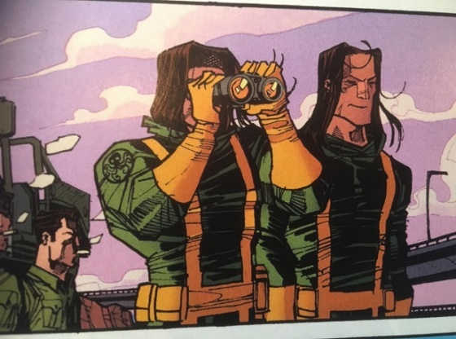
Red Wolf is presented as lacking the abilities of humour, particularly the ability to inhibit the literal, as he fails to understand Barton’s pun and explains to him that ‘There is no such thing as “vantastic” – that word does not exist’ (figure 11). This misunderstanding is made even more insulting by the relative obviousness of Barton’s word play, and thus indicates a severe inability to think critically. In addition, we can see that Red Wolf has searched the word on his phone to find out the meaning (figure 11), and has come to the conclusion that the word does not exist as, we assume, no results matched his search. However, even when predictive text is turned off, smart phones and most search engines will suggest a similar word that the computer believes you may have misspelled or mistyped; when I typed “vantastic” into an online dictionary, it suggested, as one would expect, that I might mean “fantastic” instead. It would be surprising, then, if Red Wolf’s search did not offer him the same alternative, in which case he appears even more lacking in intelligence by failing to connect the similar phonetics of the two.
Figure 12: Silas and Frank smiling (OA2 84)
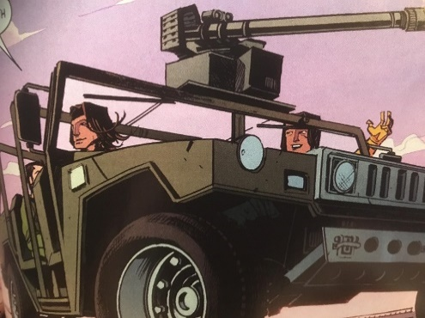
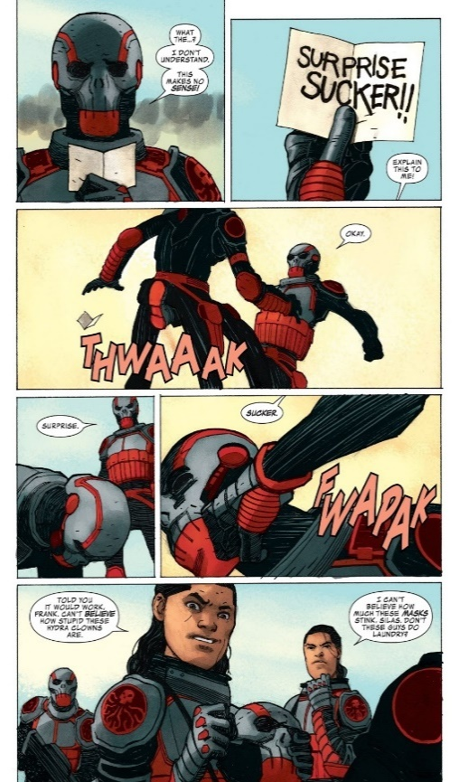
Occupy Avengers 2 does a better job at destabilising this category through Silas and Frank. The failure of most mediums to present Native humour is, according to Deloria, ‘a great disappointment’ (Deloria, Custer 146) as humour is a ‘vital element of Native life’ (Sheyahshe 15), so the depiction of Native characters as ‘always either very serious or very malevolent’ (Sheyahshe 15) is wildly inaccurate as well as insulting to their intelligence. Whilst this is the case for Red Wolf, who is never shown smiling or laughing across all four comics, Silas and Frank are often shown smiling and laughing (figures 12 and 13), and are even shown playing a prank on a Hydra soldier (see figure 14). Whilst this joke is not exactly an example of complex humour (indeed the slang word, sucker, and nature of the prank appear rather juvenile), it is a refreshing change from the presentation of Native peoples as lacking humour and from the tendency for comic relief to come at the expense of Native characters. This scene lends more agency to Silas and Frank by encouraging the reader to laugh with these characters instead of at them. Therefore, the comics do not stereotype all their Native characters as lacking any “higher” thinking, but the majority of Red Wolf’s depictions do unfortunately present him lacking any understanding of humour or tactics, and thus do still imply an inability for critical thinking, imagination, and interpretation.
Figure 13: Silas and Frank smiling again (OA2 84)
Figure 14: Silas and Frank pranking Hydra (OA2 96)

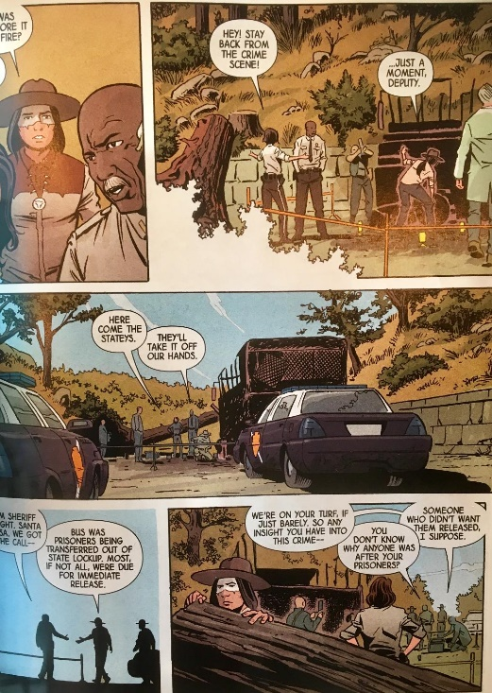
The second trait of naivety is simplicity: Native peoples are frequently stereotyped as being akin to animals and ‘primitive children – in a rude state of nature they are nobly innocent’ (Bird 3). “Benevolent” terms such as ‘innocent’ ‘indicate a lesser intelligence’ (Kilpatrick xvii). Despite the above depictions of Red Wolf as lacking the capacity for “higher” thinking regarding tactics and humour, he is never presented as outright dumb. Indeed, in scenes such as that in figure 15, he is even presented as incredibly capable and intelligent, and more so than the police officers who are supposedly in charge of the situation. The non-Native officers show their lack of understanding, or perhaps lack of willingness to understand Red Wolf by musing that he is ‘not right in the head’, exhibit their incompetency by assuming that the crime was the work of a rival gang, and demonstrate their ignorance by referring to him as ‘Apache Joe’ (RW 49-51). The latter is worth further consideration, as this homogenising and outright racist way of referring to Red Wolf is spoken by a police officer, through which the comic could be commenting on the institutional racism within the criminal justice system and speaking to the Black and Native Lives Matter movements, which received increasing visibility around the comic’s publication. Indeed, as mentioned before, Native Americans are incarcerated at 38% higher than the national rate, at ‘twice the rate of the greater U.S. population [and] receive longer sentences’ (Tighe 12), due to ‘differential treatment by the criminal justice system, lack of access to adequate counsel and racial profiling’ (Tighe 12). In addition, the other officers in the scene take no notice of this racist utterance, implying the prevalence of this attitude and even the normalisation of it. Thus, the inclusion of this comment not only adds to the depiction of the officers as egregious, but could also be a fairly radical commentary on police brutality, racial profiling, and the US politics of 2016 more broadly. This interpretation seems even more likely if we consider that the comic appears to use this racism to educate their reader, by having Red Wolf correct the officer instead of answering their question, and he does so without apology or hesitation. Red Wolf explains that he is Cheyenne, not Apache, and he teaches the officers and thus the reader the correct word for his cultural background: Heevahetaneo'o, meaning ‘Cheyenne of the South’ (MooT 52). This further counters the officer’s homogenisation by emphasising the diversity amongst Native American cultures, as Red Wolf demonstrates that there is a difference not only between Cheyenne and Apache, but also between Northern and Southern Cheyenne.
Figure 15: Red Wolf surveying the crime scene (MooT 51)
In comparison to this incompetency of the officers, Red Wolf is given all the agency over this scene: in the space of the page in which the above racist comments take place, Red Wolf silently walks around the scene, surveys it from different angles, and corrects the white detective’s assumption (figure 15). Red Wolf explains that there were actually just three men, not an entire gang, and he is able to track their movement, where they went, what shoes they were wearing, and recognise that one of them had a limp. When asked how he knows all this information, Red Wolf simply replies that he ‘looked’ (MooT 52), implying the ease with which he is able to interpret the environment. This reply also suggests that he believes this ability to be easy and simple, especially as he does not feel the need to explain exactly how he has come to these realisations, perhaps assuming the answer is obvious. Thus, the non-Native officers are left confused and appearing incompetent.
On the other hand, this competency stems from another stereotypical portrayal: the “Ecological Indian”, who possesses innate tracking abilities and a proficiency in reading the environment (Sheyahshe 55-57; 79; 89). This ability is somewhat appropriate for Red Wolf, whose animal namesake is indeed an expert tracker (Marshall Cavendish 2398-2408), but the consistency with which this ability is randomly and unjustifiably allocated to Native characters overshadows this justification with its animalising implications. The tracking ability plays on Native Americans’ ‘presumed closeness to nature’ (Krech 22; for more on the Ecological Indian, see Krech’s full text) and animalises them through the association of tracking with predatory animals.
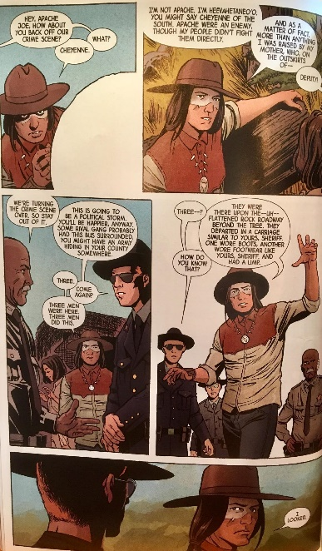
Despite this problematic ability, the scene does continue to show Red Wolf’s competency, capability, and agency through the imagery. The middle right panel of figure 16 shows Red Wolf at the front and centre, and the bottom panel shows him positioned ahead and looking back at the officers; his literal position in front of the others reflects his psychological position as “ahead” of them; he is leading the way in discovering information that will help to track down the attackers, whilst they are still debating irrelevant theories. Red Wolf is also depicted using arm gestures to explain his knowledge to the officers (middle right of figure 16), which is reminiscent of the way one might attempt to explain something difficult to a small child. His expression is one of concentration and his extended arms give the impression of control, as he literally appears to grasp the scene in his arms. In contrast, the supposed experts in the background have body language and expressions of confusion: the Sheriff’s eyes are narrowed, the lines on his forehead indicate that he is frowning, and he is standing with his hands on his hips, all of which can indicate inquisitiveness or assertiveness (Parvez). The former would suggest that the sheriff did not pick up any of the information that Red Wolf gathered and is curious as to how he did so. The latter could indicate a feeling of inferiority; Red Wolf has proved himself to be more capable than the Sheriff, who may be attempting to compensate for this challenge by taking up an assertive stance. Similarly, the officer on the left looks surprised and somewhat gormless, with his arms hanging uselessly and passively at his side, but also slightly outstretched as if he has been stopped mid-action, suggesting his incomprehension. Finally, the officer in the background is fairly expressionless; his face looks somewhat “blank”, also indicating that he does not understand what Red Wolf is explaining. This scene, then, certainly destabilises the notion of Native people as ‘incompetent’ (Green 327) and gives Red Wolf agency over his own story.
Figure 16: Red Wolf explains his knowledge to the officers (MooT 52)
However, in Occupy Avengers 1, Red Wolf begins to enforce stereotypes of simplicity. He appears incapable of distinguishing genuine questions from expressions of disbelief, as Barton exclaims, ‘Wait… what…?’ and Red Wolf explains that life-model decoys are ‘highly sophisticated androids’ (O1 57). Although Red Wolf’s response indicates his understanding of this particular piece of technology, his inability to recognise Barton’s speech as a marker of disbelief depicts him as unable to inhibit the literal interpretations in order to see the broader, more accurate picture of what the words indicate. According to linguistic theorists such as Wittgenstein, some language is context-sensitive; that is, the meaning of some words, phrases, and grammar depends on the context in which they are spoken (Wittgenstein 43), and thus their meaning is deduced by understanding the situation as a whole. Red Wolf’s misunderstanding of Barton’s exclamation as an abbreviated interrogative, then, also indicates his lack of understanding of the situation, his inability to read Barton’s shock, and his inability to recognise the information gathered as shocking.
Furthermore, in the following conversation, the depiction of Silas and Frank also falls into several stereotypes: ‘Whatta you think they’re sayin’? / Bad guy stuff, bro. / Bad guy stuff? / Yeah, it’s always bad guy stuff – they’re laughing about their plans coming to frutation. / You mean fruition. / That too.’ (OA1 29). The phrase ‘bad guy stuff’ is vague and informal, and demonstrates a lack of real knowledge, in addition to implying a sense of innocence and simplicity through the connotations of “bad guys” vs “good guys” ; that is, the child-like tendency to see the world as divided into “good” and “bad”. On the other hand, comics, especially the superhero genre in which these characters are situated, have traditionally enforced (or been perceived to enforce) such a black-and-white view of the world, with characters categorised as either heroes or villains. Silas and Frank’s perception, then, could function as a clever, somewhat fourth-wall-breaking commentary on the genre, and perhaps even a critique of the genre’s simplification and categorisation of people as good or bad. However, even if this is the case, the prevalence of the “stupid Native” stereotype still makes this phrasing problematic, and this is reinforced by Silas’ confusion over the words fruition and frutation. This confusion makes him appear illiterate and attempts to provide a sense of comedy at his expense, thus using the character as a form of comic relief. This step backwards between Red Wolf’s solo comic and the Occupy story could be explained by the lack of a Native American consultant in the latter; Jeffrey Veregge acted as designer and consultant on the Man Out of Time story, but Walker’s writing did not benefit from any such input.
The presentation of Silas and Frank as simple is rectified slightly in Occupy Avengers 2, as their conversations become far more substantial whilst keeping their use of modern contractions and slang. For example, Frank quotes a famous Native American saying: ‘Today is a good day to die’ (OA2 85), which, although debated, is most often attributed to Crazy Horse (Kramer 169), and they also refer to Custer (George Armstrong), who was a US officer in the American Indian Wars and was defeated by Crazy Horse (Brimmer 32), demonstrating a connection to and awareness of their culture. The cousins also reference several important texts: In the Spirit of Crazy Horse (OA1 26) by Peter Matthiessen, and Custer Died for your Sins (OA1 38) by Vine Deloria Jr.. These texts explore and outline injustices towards Native Americans, both historically and in the modern day, also indicating knowledge of their culture, political awareness, and suggesting that they are well-read. Moreover, this intertextuality functions as more than merely a demonstration of their erudition; they also hold the potential to teach the reader about the erased history and ignored present of Native American communities, by directing the reader to these resources. The inclusion of Matthiessen’s text is a particularly bold statement on the necessity of hearing the Native Americans’ side of the story, as the book was hugely controversial and a lawsuit was filed against Matthiessen and his publisher by Governor William Janklow and FBI agent David Price, who accused him of telling a ‘one-sided’ account of Leonard Peltier’s story and of the FBI’s conflict with the American Indian Movement (Mehren; McDowell; Mitgang). Thus, these intertextual references act as much-needed reminders of Native American history and as counter-narratives to the mainstream, white-American versions of events.
The comic goes on to do this even more explicitly when Silas and Frank directly reference events in Native history, such as Frank’s question in Occupy Avengers 2: ‘You ever hear of Wounded Knee?’ (OA2 82). Here, Frank directly references the Wounded Knee massacre of 1890, ‘where 120 men and 230 women and children were encamped in a military controlled area and then strafed by carbines and shrapnel cannons’ (Roberts 56), killing nearly 300 of the 350 people (Brown 444). The other characters ignore Frank’s question (perhaps assuming it is rhetorical), but if we also consider that Frank is looking through the panel directly at the reader, rather than at the other characters (figure 17), it seems to imply that this question is actually directed at the reader. Frank’s question, then, acts not only as a reminder of this often-omitted colonial horror, but also comments on and critiques this omission itself by questioning the reader’s knowledge and challenging us to learn their history, in turn destabilising the category of the naïve, simple Native.
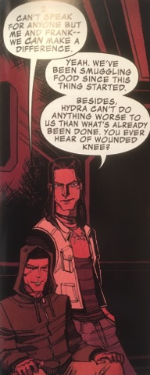
Moreover, Frank’s statement that ‘Hydra can’t do anything worse to us than what’s already been done’ is a haunting reference to the genocide and dispossession committed by settlers against the Native Americans (Dippie; Marks; Roberts 51, 182; Sivasundaram 157; Peterson 7; Gruen and Weil 480; Deloria, Playing 4; Martin 63; Seshadri 7). At this point in the comic, the evil Hydra have taken control of the United States of America, and are committing genocide both through direct violence and by cutting off access and food supplies (OA2 69). Whilst such an apocalyptic scenario is new and terrifying to most characters, Silas and Frank remind the reader that both direct and indirect genocide is nothing new to Native communities. In addition to the violent holocaust of the Native population of America (Jaimes 3) and the forced sterilisation of their people (Jaimes and Halsey 323), the US government took control of ‘Indian land, lives, and resources through such legislation as the General Allotment Act […], the 1924 Indian Citizenship Act, and the Indian Reorganisation Act of 1934’ (Jaimes and Halsey 323). Native populations were also depleted by the introduction of European infectious diseases (McBrien 120) and the malaria and tuberculosis caused by ‘malnutrition, lack of sanitation, overcrowded labor settlements, and lethal exploitation’ (McBrien 120; see also Packard 55; Arnold 77). Indeed, Native populations continue to suffer overt, subtle, and institutional discrimination (Tighe 10) that has resulted in them being ‘the most economically impoverished ethnic group in the United States’ (Tighe 1); they have been forcibly removed from their land, confined to reservations, their access to resources has been restricted, they have fewer educational and employment opportunities, suffer increased levels of homelessness, are subject to more violent crimes than any other group, and experience the highest rate of incarceration (Tighe 1). Frank’s brief comment, then, alludes to this long history and the continuing reality of discrimination and suffering, through which the cousins are further shown to be well-read and well-versed in Native history. Therefore, the end of the second volume does deconstruct the category of Native simplicity through the Fireheart cousins, who act as teachers to the reader whilst still talking like modern teenagers rather than caricatures.
Figure 17: Silas and Frank (OA2 82)
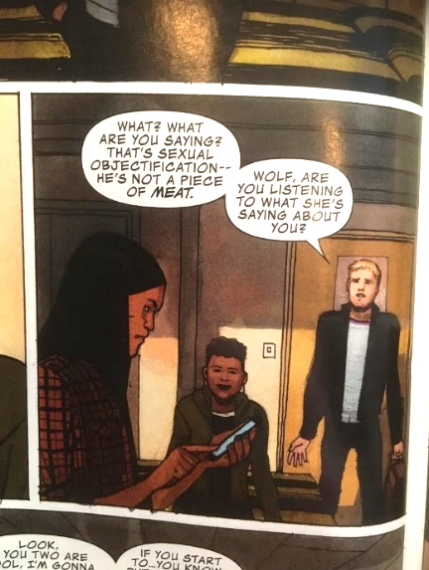
Red Wolf’s apparent simplicity is also challenged somewhat, as he has a smart phone (figures 18 and 19), which he uses to google things about the modern world that he does not understand, from which we can assume that he is actively learning. Indeed, the writer of Occupy Avengers, Walker, stated that he intended to develop ‘Red Wolf as this guy who has his smartphone with him at all times’ (Walker in Richards) and is ‘constantly learning’ about the world around him (Walker in Arrant). Furthermore, Walker’s statement that Red Wolf’s phone is ‘one of his first weapons’ (Walker in Arrant) suggests that knowledge and understanding are becoming a key strength of his. Evidently, Red Wolf’s adoption of a smart phone is intended to be an empowering move that allows him to learn information for himself rather than remaining clueless or relying on other characters to explain things to him; in some ways, it gives the character more agency, but again this development coincides with his increasing Americanisation and therefore takes away from this apparent progress.
Figure 19: Red Wolf with his phone (OA2 7)
Figure 18: Red Wolf with his smart phone (OA2 7)

The third trait that demonstrates naivety and perceived animality is the presentation of Native characters as hapless. The white hero is seen as ‘the protector of the helpless red man’ (Sheyahshe 39) and the Native sidekick is dutifully subservient to him (Sheyahshe 9). This ‘paternalistic attitude’ (Sheyahshe 39) is reflective of the colonial ‘view that indigenous people need to be saved from their animal-like existence by the knowledge of the West’ (Green 328), when in reality ‘forced assimilation by law was instituted as a federal policy’ (Cook-Lynn 5). This attitude is still prevalent in the form of the “white saviour complex”, which refers to Caucasian people’s tendency to present themselves as “saving” or “helping” people in third-world countries whilst actually serving their own interests (Bakar), and these attitudes are still too often reflected in the media.
Man out of Time successfully destabilises this trope. Whilst colonists were (and even contemporary Western society is) ‘sure that the Indians needed them’ (Pearce 8), Red Wolf is not depicted as needing any Caucasian hero. On the contrary, Red Wolf is persistently shown as the saviour of both the sheriff and the deputy. For example, when they are surrounded by drug dealers shooting at them, Red Wolf manages to tackle the gunman just before he shoots the sheriff in the head (figure 20). Here, Red Wolf is drawn leaping from the roof and descending on the gunman with his arms raised despite being handcuffed. The moment captured in this panel makes Red Wolf look as though he is flying against a bright blue sky and the reader is made to look up at him as he saves the sheriff’s life. These details present him as a hero; someone to look up to literally and metaphorically, rather than as a victim in need of saving. This trend is continued throughout the comic as Red Wolf retrieves an escape d criminal (MooT 60-61), saves Deputy Ortiz from a deadly snake (MooT 68), defeats the time travelling villain all by himself, and again rescues Ortiz from a gang with the help of a pack of wolves (MooT 114-115; 119-120). At no point in the comic does a white character come to his rescue, nor come to the rescue of any of the people of colour; Red Wolf is the saviour, and the white characters are delegated to the roles of villain, clueless police officer, or weak-willed government official – a refreshing subversion of the usual role allocation.
Figure 20: Red Wolf saving Sheriff Knight (MooT 39)
Occupy Avengers 1, on the other hand, was criticised for stabilising the hapless Native trope by glorifying the white saviour complex (Schmidt). The first issues do indeed take agency away from Native characters, as Barton shows up and intends to save the reservation by discovering the source of the water contamination – something the Native people whom it affected were apparently unable to do (OA1 42). Marvel appear to have responded to this criticism to some extent, as it is Silas and Frank who discover the water pumping station in the second issue. However, this situation is stunted by two problems: firstly, the cousins appear to stumble upon this discovery by accident whilst following Red Wolf and Barton; secondly, and more concerningly, the water supply for the reservation had been contaminated for five years (OA1 4). Both of these problems deny agency to the Native characters, especially through the Native locals’ apparent inability to notice an enormous water station positioned on tribal land and their mere acceptance of their water being contaminated for half a decade. This enforcement of the white saviour trope thus interrupts this story’s potential to be a refreshing depiction of problems faced by real Native populations and a deep commentary on the Standing Rock protests that were occurring during the writing and publication of these issues.
However, the comic does go on to destabilise the depiction of the helpless Native and give the character more agency. Red Wolf is referred to as Barton’s ‘guardian angel’ and saves him from imminent death (OA1 16), which indicates that Barton would have failed his mission to save the reservation’s water supply if not for the help of a Native character. This phrasing, however, does carry some problems. Firstly, the concept of a guardian angel places a very Christian lens on the Native character and could be seen as an attempt to Christianise and “white-wash” him. Even though the phrasing is part of Barton’s own thoughts, and may reflect his own Christian perspective, perhaps it may have been more appropriate to choose a Native concept – even “Spirit Guardian” would be more appropriate to Cheyenne animist beliefs. In addition, the concept of a guardian angel describes a being who serves the one they guard; whose whole purpose is to protect them, thus implying that Red Wolf is there to serve Barton, rather than just to exist as a Native character in his own right. Finally, the comparison of Red Wolf to an angel removes him from the realm of human and ascends him into the spiritual realm, which reflects another stereotypical portrayal of Native Americans as inherently and unwaveringly spiritual beings (see Sheyahshe’s discussion of the ‘Instant Shaman’ trope, 55-78). Thus, the comic’s attempt to subvert the trope of the hapless Native falls into other stereotypes and actually perpetuates the idea of the subservient sidekick in this instance.
The comic does a better job of deconstructing the stereotype in regards to Silas and Frank: the cousins save Barton, Red Wolf, and themselves from Hydro Man by using a taser. This scene firstly counters the “white saviour” vs “helpless Native” stereotype by presenting two Native characters as the saviours of both another Native and a white character, and by presenting them as their own heroes. The comic thus shows that Silas and Frank do not, in fact, need saving or protecting by any white character; they are more than capable of looking after themselves and other people. Moreover, their victory over Hydro Man does not stem from any physical violence or brute force; Silas’ use of the taser to incapacitate a water-based mutant demonstrates a high level of critical thinking, inventiveness, and cleverness. In this way, the cousins are far removed from the ‘child-like dupe’ stereotype that Wright outlines (‘Interview’ 10) and the problematic presence of the white saviour complex from earlier in the issue is now subverted.
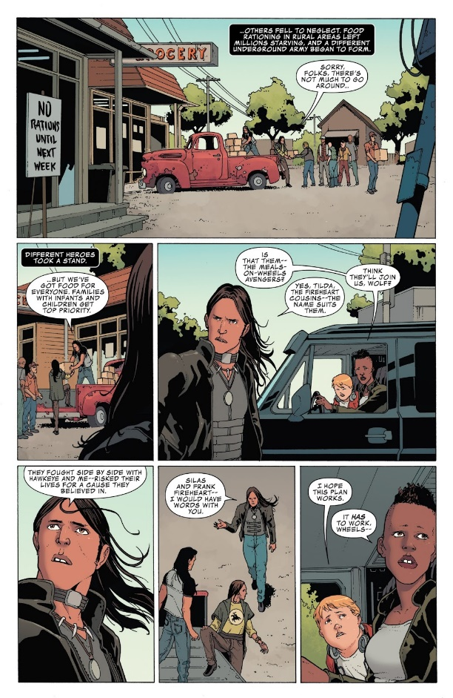
Occupy Avengers 2 continues to improve in its deconstruction of the hapless stereotype and continues to present Silas and Frank as clever and capable in scenes such as the one in figure 21, which shows the cousins organising and handing out food supplies in their local area after hijacking a Hydra truck. This drawing, and especially the placement of the cousins on top of the truck and therefore raised above the heads of the crowd, presents these Native characters as capable heroes and leaders of entire and multi-ethnic communities, as the crowd does not solely consist of Native peoples, but presents the reader with a mixture of white people and people of colour. Their suitability as community leaders is further shown when we get to witness one of their raids and Silas says to the crowd, ‘We’re here to liberate this food caravan and give it back to the people that need it most – you, your families and your communities’ (OA2 69). This mini speech presents the cousins as being in control and as being valiant leaders: they could have easily used their prowess to store food and supplies for themselves, their team, or their own Native community, but instead they risk their lives in order to help everyone in the area. This presentation of their capability is emphasised further when they are told that they ‘need to lead another raid on one of Hydra’s food collection operations’ (OA2 84). The verb ‘need’ indicates the importance of their job and how crucial they are to the plan to take down Hydra, and the fact that they are “leading” the raid further demonstrates their competency, cleverness, and agency, as well as implying a level of expertise when it comes to missions that require meticulous planning. This volume, then, does a good job at destabilising the hapless Native stereotype by successfully presenting Silas and Frank as capable heroes rather than hapless victims.
Figure 21: Silas and Frank distributing food (OA2 69)

The fourth and final trait is the position of sidekick; indeed, Native Americans ‘were most often in subordinate positions as laborers, sidekicks, or faithful Indian companions’ (Pewewardy, Studies 12; see also Savage 7). Whilst this stereotype may be well-meaning and certainly a step up from the “bloodthirsty savage”, it is still, as Wright points out, degrading (‘Interview’ 10). Red Wolf’s own comic book does a good job of destabilising the Native as sidekick trope, not only by giving him his own comic book (which is a huge step for Marvel comics and for Native comics fans everywhere), but also by portraying him as a sheriff and thus the leader of the community (as discussed in Chapter 1). Whilst he does work alongside Sheriff Knight and Deputy Ortiz in a technically subordinate position, he is consistently shown to be the one in control of the story and with agency over the situations. As we have seen, it is Red Wolf who saves Deputy Ortiz from a deadly snake (MooT 68), defeats the time travelling villain (MooT 114-5; 119-120), realises something is wrong when the Sheriff gets bitten by the snake (MooT 64), recognises the man responsible (MooT 68), finds the caravan where the snake handler lives (MooT 89), and so on; it is without a doubt his story and the creators do not allow him to be overshadowed by any non-Native hero.
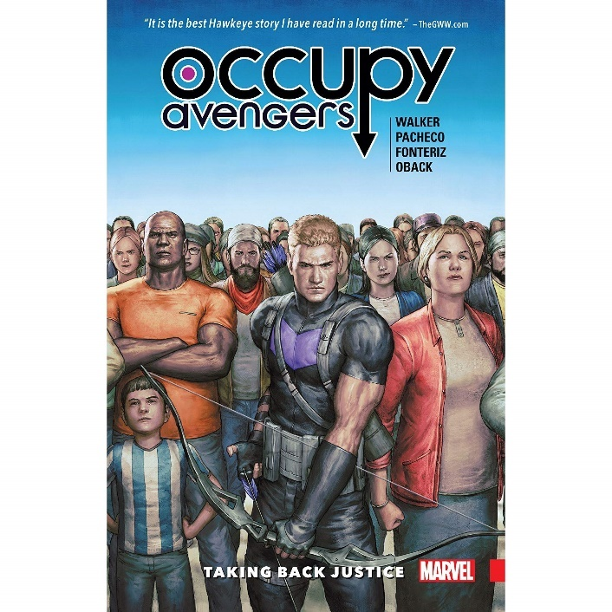
Moving into the 2017 Occupy Avengers, the depiction of Red Wolf begins to stabilise this category of ‘the White Man’s Helper’ (Green 327), as he is depicted as Barton’s sidekick (Cundle). For example, Red Wolf’s appearance in Occupy Avengers 1 aids Barton’s investigation of the water contamination, by acting as an escort of types in order for Barton to view the reservation and talk to the Natives affected, which would otherwise have been difficult as they do not usually welcome strangers (OA1 4). Thus, Red Wolf’s involvement in the plot reflects the tendency for Native characters to be used as ‘plot devices’ to ‘move the story along and make the central character (most always a white man) more heroic’ (Sheyahshe 9). Perhaps the most prominent example of this delegation of him as a secondary character is the cover page of the first volume, which depicts Hawkeye standing amongst a group of people, but Red Wolf is nowhere to be seen despite his prominence in the storyline and comic itself (figure 22). Barton is positioned at the front of a large and diverse crowd, which alongside the subtitle, ‘Taking Back Justice’, implies the notion of “people power”. However, this empowering implication is thwarted somewhat by the clear dominance of Barton in the image. Whilst the background figures stand forwards and appear confident and defiant, Barton’s body is slanted, bringing his muscular arm and weapon into the focus. His bow also stretches across the image in front of the other people, implying that it is Barton and his abilities that will be the focus, rather than the concept of people power that the title implies.
Figure 22: Barton on the cover page (OA1)
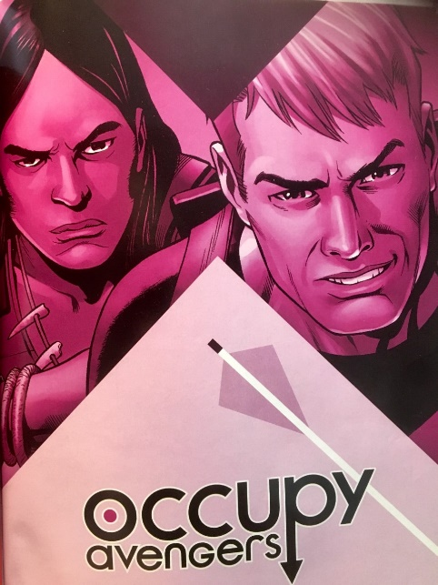
Furthermore, Barton’s arm and bow mirror the arrow that extends out of the ‘p’ in the title, which is pointing down directly to Barton’s bow-wielding arm. The arrow in the ‘p’ itself also exerts the prominence and importance of the character, as he is known for his use of a bow and arrow. This cover is extremely misleading, as at no point in the Occupy Avengers storylines does Barton lead or even act as part of a large crowd of ordinary people: the characters who do this are, as we have seen, Red Wolf, Silas, and Frank. Therefore, whilst the notion of people power that the subtitle claims the comic embodies is attributed to Barton on the cover page, it is actually the Native characters who are omitted from this spectacle that encourage and embody this notion. In addition, whilst Red Wolf appears roughly as much as Barton, he is implied to be subordinate to the white character through his omittance on the cover page. The secondary cover of the first volume does a better job of equal representation (figure 23), but still Red Wolf is implied to be less significant as he is positioned behind Barton and is partially covered up by his shoulder. The later issue covers continue this trend: Red Wolf is not omitted from them – indeed, he is included in every issue cover with Barton – but he is always placed at least slightly to the side or positioned behind him, demonstrating the continuity of his delegation as secondary to the white hero and of his lack of agency over the story.
Figure 23: Red Wolf and Barton on the secondary cover (OA1)

Conclusion.

In this study, I have examined how the depiction of Native Americans in the Red Wolf story arcs both destabilises and further constructs the categorisation of Native characters as either Bloodthirsty Savages or as Naïve Sidekicks in order to establish continuing issues with the representation of Native peoples and to acknowledge any progress made in the comics medium. In the two chapters, this study has shown which aspects of these categories remain and which have been deconstructed by the comics. The Mighty Avengers stabilises lawlessness, violence, and anger in the first category, and does not interact with the second, which reflects its time period and the prevalence of the Savage category over the slightly newer Sidekick stereotype. Red Wolf: Man out of Time does not stabilise any of the aspects of the Bloodthirsty Savage or of the Naïve Sidekick. More prominently, this comic deconstructs and even actively criticises the lawlessness and violence tropes in the first chapter, and the simplicity, haplessness, and the sidekick aspects of the second category. Occupy Avengers 1: Taking Back Justice stabilises the anger aspect of the Savage and all four of the Naïve Sidekick tropes. However, it simultaneously deconstructs the hapless stereotype in the second, and also deconstructs the violence trope in the first chapter. Finally, Occupy Avengers: In Plain Sight stabilises the violence in the first chapter, and the lack of higher thinking in the second. The comic also deconstructs the anger and violence tropes of the Bloodthirsty Savage, and the lack of higher thinking, simplicity, and haplessness of the Naïve Sidekick.
Overall, the Mighty Avengers from 1970 stabilises all three of the Savage traits, and destabilises none; Red Wolf from 2016 stabilises none and destabilises (and actively criticises) five; Occupy Avengers 1 stabilises five and destabilises two; and Occupy Avengers 2 stabilises two and destabilises five.
By examining the representation of Red Wolf across three contemporary comics from 2016 and 2017 with the occasional comparison to the character’s 1970 debut, this study has discovered an inconsistent improvement in the application of racist and dehumanising categorisations. Red Wolf’s solo comic from 2016 certainly appears to most reflect the slow but steady real-life progress regarding Native rights and the recognition of their historical and continuing oppression with movements such as Native Lives Matter and declarations such as UNDRIP (Taonui), by criticising the societal and ingrained racism faced by indigenous communities. A few aspects of the problematic categorisation of Native peoples still remain, such as the presence of an innate tracking ability, but generally this comic sets a good example for how future depictions of Native characters can destabilise these categories and present their characters as fully and complexly human, rather than as caricatures. Overall, Red Wolf has the most agency in this comic and is never presented as bloodthirsty or naive. This generally successful deconstruction of the categories and rejection of Native animality can be attributed to the presence of Jeffrey Veregge as a Native American consultant during the creation of the comic, especially considering the inconsistency of the following 2017 Occupy Avengers comics, whose lack of any Native consultant is sometimes apparent. Certainly, some aspects of these categories appear more present in the Occupy comics, such as the white saviour complex, the native as sidekick trope, and the depiction of native anger and brutality. Some of these problematic depictions from the first volume are rectified by the second thanks to criticism from readers, although one cannot help but think that the presence of a Native consultant (or writer or illustrator) could have prevented these issues from arising in the first place. Other aspects, unfortunately, become more prominent, such as Native aggression, but Walker’s Occupy comics do have some shining lights: the intertextual references are a particularly good example of how to interact with real-world issues, as well as how to bring attention to Native writers and raise awareness of the historical and continuing oppression of Native peoples.
By examining the comic in relation to these categories, it becomes clearer exactly where and how contemporary depictions of Red Wolf still contribute to and stabilise out-of-date stereotypes. This methodology made recognising the stabilisation and deconstruction of these categories much easier and aided my analysis by creating a clear framework grounded in existing scholarship with which to work. The first chapter focusing on the Bloodthirsty Savage category is notably shorter than the second that examines the Naïve Sidekick trope, and this disparity in itself reveals a shift in the representation of Native characters. The shorter length of the first chapter is due to the fewer instances in which the Red Wolf depictions refer to the Bloodthirsty Savage stereotype, and this is a very positive finding, as it indicates the decreasing reliance of writers on these racist tropes through fewer instances of their stabilisation and through a lesser need to destabilise them. In comparison, the longer second chapter indicates the continuing interaction of comics with the Naïve Sidekick tropes. This interaction is both stabilising and destabilising, but all references indicate the prevalence of the stereotype in contemporary media, whereas the fewer references (even destabilising ones) to the Bloodthirsty Savage show how far society overall has moved away from this stereotype. Indeed, by examining the specific aspects of these categories, it has become clear that the two most prevailing aspects are anger and the position of sidekick, both of which are only destabilised by one comic. The recognition of these areas as the most persistent will hopefully make writers more aware of the ways in which their depictions can inadvertently construct racist and dehumanising categories and allow more focus to be put into destabilising and criticising these aspects in future comics. This does not mean that the other five aspects are to be ignored; indeed, all tropes must be critically examined and all creators must work to destabilise them, but the slight decline in the palpable racism of the Bloodthirsty Savage in comparison to the Naïve Sidekick is certainly a positive step in the right direction.
With this in mind, it also becomes clear that the key to better representation of Native characters in comics is writers’ awareness of the historical and problematic categorisation of Natives and understanding of how they contribute to and stabilise racist stereotypes. Much of the racism that appears in these otherwise progressive stories is more benign and societally ingrained, and so is perhaps less recognisable to white writers and artists. Considering this, the presence of Native writers, illustrators, or consultants at the very least is crucial in order to achieve consistent progress in the representation of Native characters. By demonstrating the above, I hope to contribute to this= better representation by aiding the understanding of racist categories and how they continue to prevail more subtly in contemporary comics; hopefully by recognising the ways in which these comics construct racist stereotypes, future writers will be better able to steer clear of contributing to these pejorative depictions.
There are many more categorisations of Native characters that play a part in contemporary representations: the romantic, ecological, and extinct Native are all common portrayals that require critical examination but that exceed the capacity of this study. Writers such as Pewewardy (Studies 5; 16), Deloria (Playing 4), Stedman (89-90), Anderson (302), Kilpatrick (xviii), Krech (19), Bird (3; 4; 10), and Lent (211-219; 224-225) create a detailed outline of the Romanticised Native from which a thorough analysis could take place, whilst Stedman (247), Pewewardy (Studies 19), Leask (Not so; Slurs), Brodeur, Bird (4), Steele (46), and Lent (222) create a foundation from which to study the Extinct Native category. Lastly, the Ecological Native can be analysed according to Roberts (182), Kilpatrick (xvii-xviii), Green (328), Schlesier (9-12), and especially Krech, whose book, The Ecological Indian is a fantastic study on this supposedly complimentary stereotype. In addition, there are plenty more Native characters that deserve academic attention: Dani Moonstar and Bishop are prime examples of complex and continuously present indigenous characters that the field of comics studies would benefit from researchers examining. As we can see, plenty more work needs to be done holding creators accountable for their depictions of Native characters, and there is plenty more opportunity for further analysis of the role of these categories, and others, in popular comics.

Works Cited.

Aldama, Frederick Luis. Multicultural Comics: From Zap to Blue Beetle. Austin: University of Texas Press, 2010.
Anderson, Kay. “The Beast Within: Race, Humanity, and Animality.” Environment and Planning D: Society and Space 18 (2000): 301-320.
Arnold, David. The Problem of Nature. Oxford: Blackwell Press, 1996.
Arrant, Chris. Occupy Avengers is Avengers A-Team, Fighting Alongside Blue Collar America. 1 November 2016. Web. 29 July 2019. <https://www.newsarama.com/31817-occupy-avengers-is-avengers-unauthorized-grassroots-superhero-team.html>.
Bakar, Faima. What is a white saviour complex?. 6 March 2019. Web. 23 July 2019. <https://metro.co.uk/2019/03/06/what-is-a-white-saviour-complex-8793979/>.
Bar-Tal, Daniel, and Yona Teichman. Stereotypes and Prejudice in Conflict: Representations of Arabs in Israeli Jewish Society. New York: Cambridge University Press, 2005.
Bataille, Gretchen M., and Charles L. P. Silet. The Pretend Indians Images of Native Americans in the Movies. Ames: Iowa State University Press, 1980.
Beattie, James. “Essay on Laughter and Ludicrous Composition.” Essays, 3rd edition. Ed. by E. & C. Dilly and W. Creech. London: 1779, 297-452.
Bekoff, Marc. Animals Don’t Laugh, Think, Get Depressed, or Love Declares a Psychiatrist. 03 September 2012. Web. 3 July 2019. <https://www.psychologytoday.com/gb/blog/animal-emotions/201209/animals-dont-laugh-think-get-depressed-or-love-declares-psychiatrist>.
Berger, John. About Looking. London: Bloomsbury, 2015.
Berger, Martin A.. Sight Unseen: Whiteness and American Visual Culture. Berkeley: University of California Press, 2005.
Berkhofer, Jr. Robert F.. The White Man’s Indian: Images of the American Indian from Columbus to the Present. New York: Vintage Books, 1979.
Bhabha, Homi. “Of Mimicry and Man: The Ambivalence of Colonial Discourse.” Discipleship: A Special Issue on Psychoanalysis 28 (Spring 1984): 125-133.
Bird, S. Elizabeth. “Introduction: Constructing the Indian, 1830s-1990s.” Dressing in Feathers: The Construction of the Indian in American Popular Culture. Ed. S. Elizabeth Bird. Colorado: Westview Press, 1996, 1-12.
Brimmer, Larry Dane. Chief Crazy Horse: Following a Vision. New York: Marshall Cavendish, 2009.
Brodeur, Nicole. S’Klallam artist helps revive Native comic book hero Red Wolf. 2 October 2015. Web. 9 July 2019. <https://www.seattletimes.com/entertainment/sklallam-artist-helps-revive-native-comic-book-hero-red-wolf/>.
Brown, Dee. Bury My Heart at Wounded Knee: An Indian History of the American West. New York: Henry Holt, 1970.
Byrne, John, et al. Alpha Flight #19. New York: Marvel Comics, 1985.
Byrne, Richard W.. “Primate Cognition: Evidence for the Ethical Treatment of Primates.” Attitudes to Animals: Views in Animal Welfare. Ed. by Francine L. Dolins. Cambridge: Cambridge University Press, 1999, 114-125.
Cardak, Osman. “Students’ ideas about dangerous animals.” Asia-Pacific Forum on Science Learning and Teaching 10.2.8 (December 2009): 1-15.
Cook-Lynn, Elizabeth. Anti-Indianism in Modern America: A Voice from Tatekeya's Earth. Urbana: University of Illinois Press, 2001.
Cundle, Tim. Occupy Avengers: Taking Back Justice – David F. Walker, Carlos Pacheco, Rafael Fonteriz, Sonia Oback & Wil Quintana (Marvel). 7 July 2017. Web. 9 July 2019. <http://massmovement.co.uk/occupy-avengers-taking-back-justice-david-f-walker-carlos-pacheco-rafael-fonteriz-sonia-oback-wil-quintana-marvel/>.
Cunneen, Chris. “Riot, Resistance and Moral Panic: Demonising the Colonial Other.” Outrageous! Moral Panics in Australia. Ed. S. Poynting and G. Morgan. Hobart: ACYS Publishing, 2007, 20-29.
Dawkins, Marian Stamp. “Animal Minds and Animal Emotions.” American Zoology 40.6 (December 2000): 883-888.
Deckers, Lambert, and Robert Thayer Buttram. “Humor as a response to incongruities within or between schemata.” Humor: International Journal of Humor Research 3.1 (January 1990): 53-64.
Defoe, Daniel. Robinson Crusoe. Oxford: Oxford University Press, 2008.
Deloria, P.J. Playing Indian. New Haven: Yale University Press, 1998.
Deloria, Vine Jr.. Custer Died for your Sins: An Indian Manifesto. Norman: University of Oklahoma Press, 1988.
Derrida, Jacques. The Animal That Therefore I Am. Ed. Marie-Louise Mallet. Trans. David Wills. New York: Fordham University Press, 2008.
Dippie, Brian W.. The Vanishing American. Lawrence: University Press of Kansas, 1982.
Douglas, Bronwen. “Foreign Bodies in Oceania.” Foreign Bodies: Oceania and the Science of Race 1750-1940. Ed. by Chris Ballard and Bronwen Douglas. Australia: ANU E Press, 2008, 3-30.
Drum, Nicole. Study Shows Comic Book Revenues Are at an All-Time High. 4 May 2019. Web. 23 July 2019. <https://comicbook.com/comics/2019/05/04/comic-book-revenues-all-time-high-2018-/>.
Dunn, Dan, et al. Red Ryder. New York: Dell Comics, 1941.
Edmonson, Nathan, et al. Red Wolf: Man out of Time. New York: Marvel Comics, 2016.
Ekman, Paul. “Basic Emotions.” Handbook of Cognition and Emotion. Ed. by Tim Dalgleish and Mick Power. West Sussex: John Wiley & Sons, 1999, 45-60.
Feest, Christian F.. “Europe’s Indians.” Society 27.46 (May/June 1990): 46-51.
Frazetta, Frank. White Indian #12. New York: Magazine Enterprises, 1954.
Freud, Sigmund. “On the Physical Mechanism of Hysterical Phenomena: A Lecture.” Complete Psychological Works of Sigmund Freud. Ed. by ‎James Strachey and ‎Anna Freud. London: Hogarth Press, 1971, 27-39.
Friar, Ralph E., and Natasha A. Friar. The Only Good Indian: The Hollywood Gospel. New York: Drama Book Specialists, 1972.
Giago, T. I Hope the Redskins Lose. 27 January 1992. Web. 3 July 2019. <https://www.newsweek.com/i-hope-redskins-lose-197832>.
Gibson, Janet M.. Psychologists actually see humour as a character strength. 7 October 2016. Web. 9 July 2019. <https://www.sbs.com.au/topics/science/humans/article/2016/10/07/psychologists-actually-see-humour-character-strength>.
Gobineau, Arthur Compte de.. The Moral and Intellectual Diversity of Races. New York: Garland, 1984.
Goff, Phillip Atiba, Jennifer L. Eberhardt, Melissa J. Williams, and Matthew Christian Jackson. “Not Yet Human: Implicit Knowledge, Historical Dehumanization, and Contemporary Consequences.” Journal of Personality and Social Psychology 94.2 (2008): 292-306.
Green, MK. “Images of Native Americans in advertising: Some moral issues.” Journal of Business Ethics 12 (1993): 323-330.
Gruen, Lori, and Kari Weil. “Animal Others—Editors’ Introduction.” Hypatia 27.3 (2012): 477-487.
Gunther, Kristen. Nature Is Violent, And it’s the height of human narcissism to think we could change that. 15 December 2015. Web. 26 July 2019. <https://www.vice.com/en_us/article/qkjpwp/nature-is-violent>.
Hakluyt, Richard. The Principle Navigations. Glasgow, 1904.
Handel, Steven. Classification of Emotions. 24 May 2011. Web. 19 July 2019. <http://www.theemotionmachine.com/classification-of-emotions/>.
Hanson, Jeffery R. and Linda P. Rouse. “Dimensions of Native American Stereotyping.” American Indian Culture and Research Journal 11.4 (1987): 33-58.
Hardy, C. “A brief history of ethnicity in the comics.” Ethnic images in the comics: An exhibition in the Museum of the Balch Institute for Ethnic Studies. Ed. by C. Hardy and G.F. Stern. Philadelphia: Balch Institute for Ethnic Studies, 1986, 7-10.
Harris, Mark Wayne, and Dennis Francis. Street Wolf #1. California: Blackthorne Publishing, 1986.
Harvey, Sean P. “Must Not Their Languages Be Savage and Barbarous Like Them?.” Journal of the Early Republic 30.4 (2010): 505-532.
Horn, Maurice. The World Encyclopedia of Comics. New York: Chelsea House, 1976.
Hurley, Matthew M., Daniel Dennett, and Reginald B. Adams. Inside Jokes: Using Humor to Reverse-Engineer the Mind. Cambridge: MIT Press, 2011.
Jackson, Zakiyyah Iman. “Animal: New Directions in the Theorization of Race and Posthumanism.” Feminist Studies 39.3 (2013): 669-685
Jahoda, Gustav. Images of Savages: Ancient Roots of Modern Prejudice in Western Culture. New York: Routledge, 1999.
Jaimes, M. Annette, and Theresa Halsey. “America Indian Women at the Center of Indigenous resistance in contemporary north America.” The State of Native America: Genocide, Colonization, and Resistance. Ed. M. Annette Jaimes. Boston: South End Press, 1992, 311-344.
Jaimes, M. Annette. “Introduction: Sand Creek, The Morning After.” The State of Native America: Genocide, Colonization, and Resistance. Ed. M. Annette Jaimes. Boston: South End Press, 1992, 1-12.
Kant, Immanuel. Critique of Judgment. Trans. James Creed Meredith. Oxford: Clarendon Press, 1911.
Keiser, Albert. The Indian in American Literature. New York: Octagon Books, 1970.
Kierkegaard, Søren. Concluding Unscientific Postscript to Philosophical Fragments. Trans. D. Swenson and W. Lowrie. Princeton: Princeton University Press, 1941.
Kilpatrick, Jacquelyn. Celluloid Indians: Native Americans and Film. Lincoln: University of Nebraska Press, 1999.
Kincheloe, Joe. “The Ponderosa and the Enterprise: Go up, young man, to the final frontier.” Teaching Toward the 24th Century: Star Trek as social curriculum. Ed. K. Anijar. New York: Falmer Press, 2000, vii-xii
Kramer, Kenneth Paul. The Sacred Art of Dying: How World Religions Understand Death. New York: Paulist Press, 1988.
Krech, Shepard III. Myth and History: The Ecological Indian. New York: Norton & Co., 1999.
Kubert, Joe. Tomahawk. New York: National Periodical Publications, 1950.
Kuhnke, Elizabeth. Body Language for Dummies. West Sussex: John Wiley & Sons, 2007.
Kukkonen, Karin. Studying Comics and Graphic Novels. West Sussex: Wiley Blackwell, 2013.
Lansdale, Joe R., Timothy Truman, and Rick Magyar. The Lone Ranger #1-4. New York: Topps Comics, 1994.
Leask, James. Not So New, Not So Different: On Red Wolf and Indigenous Representation in the New Marvel. 5 June 2015. Web. 9 July 2019. <https://comicsalliance.com/all-new-all-different-red-wolf-marvel/>.
Leask, James. Slurs, Caricatures and Erasure: The State of Marvel Comics’ Treatment of Indigenous Characters. 6 June 2016. Web. 9 July 2019. <https://comicsalliance.com/marvel-comics-indigenous-characters-representation/>.
Lent, Peter van. “’Her Beautiful Savage’: The Current Sexual Image of the Native American Male.” Dressing in Feathers: The Construction of the Indian in American Popular Culture. Ed. S. Elizabeth Bird. Colorado: Westview Press, 1996, 211-227.
Mantlo, Bill, et al. Alpha Flight #37. New York: Marvel Comics, 1986.
Marks, Paula Mitchell. In a Barren Land: American Indian Dispossession and Survival. New York: William Morrow, 1998.
Marshall Cavendish. Encyclopedia of Mammals 16. Malaysia: Marshall Cavendish Co., 1997.
Martin, Joel W.. The Land Looks After Us: A History of Native American Religion. Oxford: Oxford University Press, 2001.
Matijasic, Thomas D.. “Reflected Values: Sixteenth-Century Europeans View the Indians of North America.” American Indian Culture and Research Journal 11.2 (1987): 31-50.
Matthiessen, Peter. In the Spirit of Crazy Horse. London: Penguin Books, 1992.
McBrien, Justin. “Accumulating Extinction: Planetary Catastrophism in the Necrocene.” Anthropocene or Capitalocene? Nature, History, and the Crisis of Capitalism. Ed. Jason W. Moore. Oakland: PM Press, 2016, 116-137.
McDowell, Edwin. Court Battle Over Book: Viking and a Governor. 28 May 1983. Web. 23 July 2019. <https://archive.nytimes.com/www.nytimes.com/books/99/04/11/specials/matthiessen-court.html>.
McKay, Robert, and John Miller. Werewolves, Wolves and the Gothic. 13 September 2017. Web. 26 July 2019. <https://www.uwp.co.uk/werewolves-wolves-and-the-gothic/>.
Meagher, Fred. Straight Arrow. New York: Magazine Enterprises, 1950.
Mehren, Elizabeth. Suit Against ‘Spirit of Crazy Horse’ Ends. 16 November 1990. Web. 23 July 2019. <https://www.latimes.com/archives/la-xpm-1990-11-16-vw-4902-story.html>.
Mehta, Binita, and Pia Mukherji. Postcolonial Comics: Texts, Events, Identities. Oxon: Routledge, 2015.
Mitgang, Herbert. Crazy Horse Author Is Upheld in Libel Case. 16 January 1988. Web. 23 July 2019. <https://archive.nytimes.com/www.nytimes.com/books/99/04/11/specials/matthiessen-crazy.html>.
Moench, Doug, et al. Marvel Two-In-One Annual Vol 1 #6. New York: Marvel Comics, 1981.
Moore, John Francis, et al. X-Force, vol. 1, #1. New York: Marvel Comics, 1997.
Moyer, Justin Wm.. Adam Sandler’s ‘Ridiculous 6’ insulted some Native Americans. Now it’s Netflix’s ‘No. 1’ movie. 7 January 2016. Web. 23 July 2019. <https://www.washingtonpost.com/news/morning-mix/wp/2016/01/07/adam-sandlers-ridiculous-6-insulted-some-native-americans-now-its-netflixs-no-1-movie/>.
MPR News Staff. From the archives: Story of 1992 Super Bowl protest could have been written today. 8 February 2017. Web. 23 July 2019. <https://www.mprnews.org/story/2017/02/07/history-1992-super-bowl-mascot-protest>.
Noisecat, Julian Brave. Take down monuments to Native American oppression. 3 July 2017. Web. 3 July 2019. <https://www.hcn.org/articles/tribal-affairs-the-forgotten-history-of-racial-oppression-against-native-americans>.
O'Neill, G. Patrick. “The North American Indian in Contemporary History and Social Studies Textbooks.” Journal of American Indian Education (May 1987): 22-28.
Olmsted, Audrey P.. “Words Are Acts: Critical Race Theory as a Rhetorical Construct.” Howard Journal of Communications 9 (1998): 323-331.
Packard, Randall. The Making of a Tropical Disease. Baltimore: Johns Hopkins University Press, 2011.
Parrot, W. Gerrod. Emotions in Social Psychology. Philadelphia: Psychology Press, 2001.
Parvez, Hanan. Meaning of the 'hands on hips' body language gesture. May 2015. Web. 23 July 2019. <https://www.psychmechanics.com/2015/05/body-language-hands-resting-on-hips.html>.
Pearce, R. H.. Savagism and Civilization: A study of the Indian and the American mind. Berkeley: University of California Press, 1988.
Peterson, Christopher. Bestial Traces: Race, Sexuality, Animality. New York: Fordham University Press, 2013.
Pewewardy, Cornel, “From Subhuman to Superhuman: The Evolution of American Indian Images in Comic Books.” American Indian Stereotypes in the World of Children. Ed. by Arlene Hirschfelder et al. Lanham: Scarecrow Press, 1999, 193-198.
Pewewardy, Cornel. “From Subhuman to Superhuman: Images of First Nations Peoples in Comic Books.” Studies in Media & Information Literacy Education 2.2 (2002): 1-23.
Plutchik, Robert. “A General Psychoevolutionary Theory of Emotion.” Theories of Emotion. Ed. by Robert Plutchik and Henry Kellerman. New York: Academic Press, 1980, 3-33.
Pomedli, Michael. Living With Animals: Ojibwe Spirit Powers. Toronto: University of Toronto Press, 2014.
Pulitano, Elvira. Toward a Native American Critical Theory. London: University of Nebraska Press, 2003.
Richards, Dave. Exclusive: Walker Explains "Occupy Avengers'" Real-World Ties, Reveals First Team Member. 9 August 2016. Web. 23 July 2019. <https://www.cbr.com/exclusive-walker-explains-occupy-avengers-real-world-ties-reveals-first-team-member/>.
Ridiculous 6. Dir. Frank Coraci. Perf. Adam Sandler, Terry Crews. Netflix, 2015. Online.
Roberts, Mark S.. The Mark of the Beast: Animality and Human Oppression. Indiana: Purdue University Press, 2008.
Ryan, Derek. Animal Theory: A Critical Introduction. Edinburgh: Edinburgh University Press, 2015.
Saunders, Catherine, et al. Marvel Year by Year: A Visual Chronicle. London: Marvel, 2014.
Savage, William W. Jr.. Commies, Cowboys, and Jungle Queens: Comic Books and America, 1945-1954. Boston: Wesleyan University Press, 1998.
Schilling, Vincent. Native Actors Walk off Set of Adam Sandler Movie After Insults to Women, Elders. 23 April 2015. Web. 23 July 2019. <https://newsmaven.io/indiancountrytoday/archive/native-actors-walk-off-set-of-adam-sandler-movie-after-insults-to-women-elders-ow8Q1448EUenijZ2JV5alA/>.
Schlesier, Karl H.. The Wolves of Heaven: Cheyenne Shamanism, Ceremonies, and Prehistoric Origins. Norman: University of Oklahoma Press, 1987.
Schmidt, Robert. Occupy Avengers, Vol. 1: Taking Back Justice: Community Review. 17 November 2017. Web. 9 July 2019. <https://www.goodreads.com/en/book/show/32492330-occupy-avengers-vol-1>.
Schopenhauer, Arthur. The World as Will and Idea, 6th edition. Trans. R. B. Haldane and J. Kemp. London: Routledge, 1907.
Seshadri, Kalpana Rahita. HumAnimal: Race, Law, Language. Minneapolis: University of Minnesota Press, 2012.
Shepard, Paul. The Others: How Animals Made Us Human. Washington: Island Press, 1997.
Sheyahshe, Michael A.. Native Americans in Comic Books: A Critical Study. North Carolina: McFarland & Co., 2008.
Sivasundaram, Sujit. “Imperial Transgressions: The Animal and Human in the Idea of Race.” Comparative Studies of South Asia, Africa and the Middle East 35.1 (May 2015): 156-172.
Stedman, Raymond Williams. Shadows of the Indian: Stereotypes in American Culture. Norman: University of Oklahoma Press, 1989.
Steele, Jeffrey. “American Indians in Nineteenth-Century Advertising.” Dressing in Feathers: The Construction of the Indian in American Popular Culture. Ed. S. Elizabeth Bird. Colorado: Westview Press, 1996, 45-64.
Strömberg, Fredrik. Black Images in the Comics: A Visual History. Washington: Fantagraphic Books, 2003.
Suls, Jerry. “A Two-Stage Model for the Appreciation of Jokes and Cartoons: An Information-Processing Analysis.” The Psychology of Humor. Ed. Jeffrey Goldstein and Paul McGhee. New York: Academic Press, 1972, 81-99.
Suls, Jerry. “Cognitive Processes in Humor Appreciation.” Handbook of Humor Research. Ed. Paul McGhee and Jeffrey Goldstein. New York: Springer-Verlag, 1983, 39-58.
Taonui, Rawiri. UNDRIP at 10: Are We Making Progress in the Global Fight for Indigenous Rights?. 19 September 2017. Web. 23 July 2019. <http://www.internationalaffairs.org.au/australianoutlook/undrip-making-progress-indigenous-rights/>.
Thomas, Roy, and John Buscema. Mighty Avengers: The Coming of Red Wolf. New York: Marvel Comics, 1970.
Tighe, Scott. ““Of Course We Are Crazy”: Discrimination of Native American Indians Through Criminal Justice.” Justice Policy Journal 11.1 (Spring 2014): 1-38.
Versaci, Rocco. This Book Contains Graphic Language: Comics as Literature. London: Continuum, 2007.
Versluis, Arthur. Native American Traditions. Dorset: Element, 1994.
Waldau, Paul. Animal Studies: An Introduction. Oxford: Oxford University Press, 2013.
Walker, David, et al. Occupy Avengers 1: Taking Back Justice. New York: Marvel Comics, 2017.
Walker, David, et al. Occupy Avengers 2: In Plain Sight. New York: Marvel Comics, 2017.
Wein, Len, et al. Giant X-Men #1. New York: Marvel, 1975.
Wittgenstein, Ludwig. Philosophical Investigations, 4th edition. Trans. & Ed. P.M.S. Hacker and Joachim Schulte. Oxford: Wiley Blackwell, 2009.
Wolfe, Cary. Before the Law: Humans and Other Animals in a Biopolitical Frame. Chicago: Chicago University Press, 2012.
Worden, Daniel. “Introduction.” The Comics of Joe Sacco: Journalism in a Visual World. Ed. by Daniel Worden. Jackson: University Press of Mississippi, 2015, 3-18.
Wright, Bradford W.. “Interview.” Quoted in Michael A. Sheyahshe. Native Americans in Comic Books: A Critical Study. North Carolina: McFarland & Co., 2008.
Supplementary Bibliography.

Anderson, M. Kat. Tending the Wild: Native American Knowledge and the Management of California’s Natural Resources. Berkeley: University of California Press, 2006.
Cowsill, Alan. Marvel Avengers: The Ultimate Character Guide. New York: Marvel, 2015.
Delaney, Samuel R.. Shorter Views: Queer Thoughts and The Politics of the Paraliterary. London: Wesleyan University Press, 1999.
Duncan, Randy, Matthew J. Smith, and Paul Levitz. The Power of Comics: History, Form, and Culture, 2nd edition. London: Bloomsbury, 2015.
Dupré, John. Humans and Other Animals. Oxford: Oxford University Press, 2006.
Glendinning, Simon. “Heidegger and the Question of Animality.” International Journal of Philosophical Studies 4 (1996): 67-86.
Groensteen, Thierry. The System of Comics. Trans. Bart Beaty and Nick Nguyen. Jackson: University Press of Mississippi, 2007.
Ham, Jennifer, and Matthew Senior. Animal Acts: Configuring the Human in Western History. London: Routlege, 1997.
Heer, Jeet, and Kent Worcester. A Comics Studies Reader. Jackson: University Press of Mississippi, 2009.
Horn, Maurice. Comics of the American West. New York: Winchester Press, 1977.
Ingold, Tim. Companion Encyclopedia of Anthropology: Humanity, Culture and Social Life. London: Routledge, 1994.
Lente, Fred Van, Ryan Dunlavey, and Adam Guzowski. The Four Color Comics Book History of Comics: Birth of a Medium. California: IDW Publishing, 2017.
Lente, Fred Van, Ryan Dunlavey, and Adam Guzowski. The Four Color Comics Book History of Comics: Comics for All. California: IDW Publishing, 2018.
Lumsden, Stephanie. From Wilderness to Raw Material: How the Dispossession of Native Land Enables the Prison Industrial Complex. 3 March 2017. Web. 30 September 2018. <https://csw.ucla.edu/2017/03/03/wilderness-raw-material-dispossession-native-land-enables-prison-industrial-complex/>.
McCance, Dawne. Critical Animal Studies: An Introduction. Albany: State University of New York Press, 2013.
McCloud, Scott. Understanding Comics: The Invisible Art. New York: Harper Collins, 1993.
Merskin, Debra. “Winnebagos, Cherokees, Apaches, and Dakotas: The Persistence of Stereotyping of American Indians in American Advertising Brands.” Howard Journal of Communication 12.3 (2001): 159-169.
Noske, Barbara. Humans and Other Animals: Beyond the Boundaries of Anthropology. London: Pluto Press, 1989.
Sheehan, Bernard. Savagism and Civility: Indians and Englishmen in Colonial Virginia. Cambridge: Cambridge University Press, 1980.
Sheehan, James J., and Morton Sosna. The Boundaries of Humanity: Humans, Animals, Machines. Berkeley: University of California Press, 1992.
Taylor, Colin F.. The Plains Indians: A Cultural and Historical View of the North American Plains Tribes of the Pre-Reservation Period. Twickenham: Tiger Books, 1997.
Taylor, Nik. Humans, Animals, and Society: An Introduction to Human-Animal Studies. New York: Lantern Books, 2013.
Wolch, Jennifer, ad Jody Emel. Animal Geographies: Place, Politics, and Identity in the Nature-Culture Borderlands. London: Verso, 1998.
Woodward, Wendy, and Susan McHugh. Indigenous Creatures, Native Knowledges, and the arts: Animal Studies in Modern Worlds. Switzerland: Palgrave Macmillan, 2017.
Wright, Bradford W.. Comic Book Nation: The Transformations of Youth Culture in America. Baltimore: Johns Hopkins University Press, 2001.

For example, Crazy Horse, Black Elk, Lame Deer, Fools Crow, Sitting Bull, White Eagle, Standing Bear, White Antelope, etc.
These examples could be considered a kind of nobility, and thus in danger of falling into the category of “noble savage”, but this category is beyond the scope of this project and best left for another time.
I would like to note that the phrases “bad guy” and “good guy” are androcentric and I do not promote the exclusion of women that these phrases reflect, but the use of these terms is appropriate in this particular context.

