Eroding the Boundaries - Frêmok and the Experimental in Comics Narratives

Imagine comics as poetry, as theater, projected from a platform to an audience, asking us to mindfully construct a narrative from our response to a presented visual experience. From William Shakespeare’s As You Like It, Act II, Scene VII – “All the world’s a stage, and all the men and women merely players; they have their exits and entrances, and one man in his time plays many parts….”. Comics and graphic novels, through their unique perspective of observing and controlling the illusion of time, allow an audience to participate in the narrative in any manner. Depending on its construct, a comic can simultaneously permit an audience to view past, present and future. If the work has no dialogue, the audiences’ personal set of experiences and biases can inform the editorial content and complete the circuit of the viewing experience. Consider the seminal work “Here”, by Richard McGuire; it was originally published in Raw magazine in 1989 and reimagined as a book published by Pantheon in 2014. This strip, originally told in 36 panels, changed the language of the comics art form and permitted artists to redefine not only visual narrative, but to conceptually manipulate the perception of time. In this work a single frame represents a place in time. Other frames within are superimposed take you simultaneously to events in that place from years past, present and future.
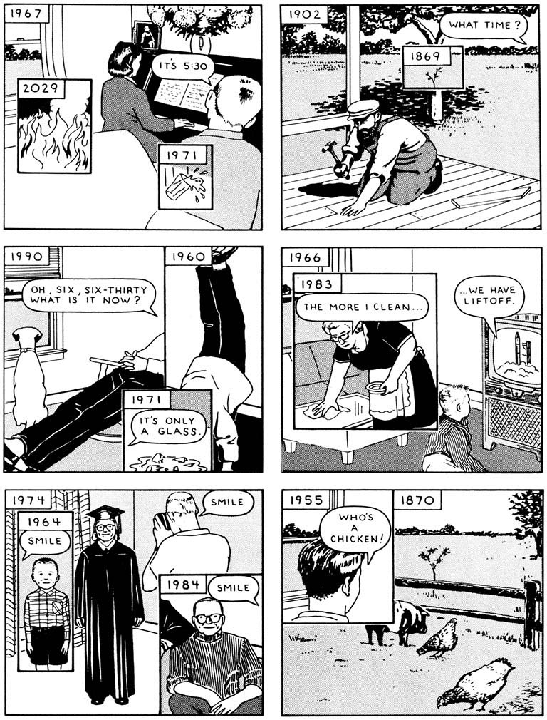

Courtesy Richard McGuire

The Brussels based art collective Frêmok was created by former students at St. Luc Bruxelles, the first European art school to have a curriculum singularly devoted to Comics. Influenced by art historian and semiotician Michel Ceder, they believed that the art form of comics is greatly enhanced by being in relationship to other art forms rather than being general entertainment. And they have done so with great focus, creating work that is experimental and thought provoking the creators at the Brussels collective Frêmok look at drawing as a language; the work is presented not just as printed material, but as projects. We tend to trust written and spoken language more than pictures. Yet the context of Frêmok projects tend to surround us with images as language, in both printed material as well as installation and exhibition. The work presented by the artists and writers of the Frêmok collective presents us with narratives reflecting the human condition, sometimes quietly and sometimes demonstrably. Frêmok presents its comics as parataxis, scenes or elements which are presented in juxtaposition with no particular order or hierarchy. The work asks the reader to create associations that challenge our normal perceptions of the world around us. Presented in this way, their comics evoke memory, whether accessed through images or through verbal structuring. And memory is always a flexible thing in our minds, affected by our disposition at a particular moment in time. And that can be uncomfortable.

Traditionally, Belgian and French publishers present publications to audiences similarly to American publishers, with defined printing formats and page counts. 48-page oversized hardcover volumes, with serialized adventures of familiar characters have long been the standard and are ubiquitous to the Franco-Belgian cultural landscape. At Frêmok, the disposition of the art and story define the format by which the publications are issued. And they can be various and sublime. The art doesn’t follow the conventions traditionally employed in comic books or graphic novels. The creators experiment widely with the methods by which they create images. It might be akin to Modernism in the fine arts, breaking with the past to create new forms of expression. Frêmok has set the standard for some of the most visually compelling work in the field, while telling stories often without defined scripts or narrative applications. The books make the audience work hard to participate in the experience of reading and comprehending the narrative, but the graphic visuals are a reward for the effort.

The 2010 publication Par Les Sillons (By the Furrows) by Vincent Fortemps, conveys the collective memory of a rural landscape. It is a place where human occupation has manipulated and worked the earth, plowing furrows to plant crops. The land has provided sustenance for generations of families and is cared for through the beautiful repetition of planted fields, a repetitive, aesthetically appealing harmony of rows which provide the nourishment for living our lives. It is a place in which wildlife endures and flourishes, trees have existed for generations, spreading seeds that provide the continuity of nature. It is also a place that bears the scars of furrows created by humanity through the horrors and devastations of war. Trenches were dug to provide protection from the aggression of gun fire, and to create staging areas for violent provocation; pits and furrows exist as the aftermath of bombs and evoke the memory of loss of life and property. Vincent Fortemps has addressed this contradiction with work of expressive chiaroscuro, reminiscent of the powerful German Expressionist printmakers. As artist Otto Dix created in black and white prints the ruthless and harsh depictions of German society and the brutality of war during the Weimar Republic, so too does Vincent Fortemps expressively work in black and white to give us a distinct impression of our memory and reality. Fortemps works on sheets of transparent acetate. It is a surface that permits a multivalent approach to looking and seeing. Metaphorically, the surface is a clear window, directing our viewing experience to the landscape of past and present. There are no words in this volume, just the juxtaposition of solitary and paired images on a page, suggesting that we form our narrative perceptions simply by looking; content is formed by our accumulated experiences and memories as human beings. Utilizing waxy lithography pencils, he aggressively draws his pictures. They dance with energy and life. Through layering of tone, blending and lifting the pigment with oil, incising the acetate with etching needle, pushing the pigment into the scribed line, subtracting form by scraping away the crayon with razor blades, he gradually builds a chiaroscuro universe where the drawn evocation has the status of truth. In some images, the lifting of pigment leaves vague imagery and impressions, suggesting faded memories and dreams. The textured surface is beautiful and reminds us of the same scarification that the land holds and conceals from generations of activity, while also evoking the human landscape of melancholy, loneliness and love. Today, we walk through landscapes in Europe that were killing fields during the World Wars I and II, and with the exception of what we have heard or read, we barely notice the subtle shifts in topography caused by the horrific events. They are an ephemeral memory. The tactile obfuscation of Fortemps’ surfaces avoids the clarity of defined visual experience. Yet they encourage one to look and see, and perhaps consider our own relationship to the world in which we live.
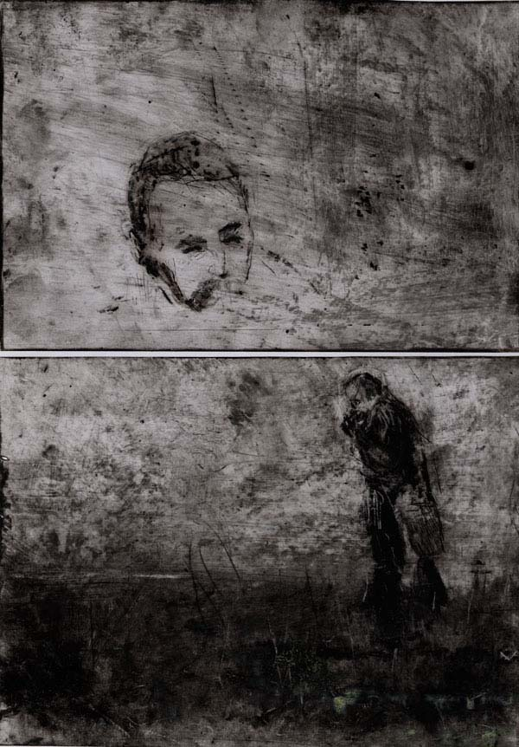
Image courtesy of Frêmok

The ability of artists and writers to effectively convey the desired drama and pathos necessary to their work is encouraged by the agency Frêmok provides to take the time one needs to tell the story. Pacing is critical to the evocation of suspense, of mood. Being limited to a standard album format of 48 pages necessarily hurries the story and negatively impacts conceptual strategies to build emotional impact. One need only to look at the wordless graphic novels of the 1920’s and 1930’s by artists like Lynd Ward and Otto Nückel to understand that many images collected together engender an emotional response that permit viewers to empathize and respond to content. The continuity and accumulation of images subtly suggest a coherence and logic through the repetition of stylistic approach. For example, artist Eric Lambé’s Le Fils du Roi (The King’s Son) is presented as a square book, measuring 13” x 13”. Eric Lambé is an extraordinarily talented artist, who is able to work in myriad styles to affect visual responses. The pages are either singular square images or divided into four equal square panels. Drawings are executed exclusively in blue and black ball point pen. Their visual complexity is heightened by layers of cross-hatching, giving the images the same sensibility as Op Art, with the impression of movement, hidden images, flashing and vibrating patterns.
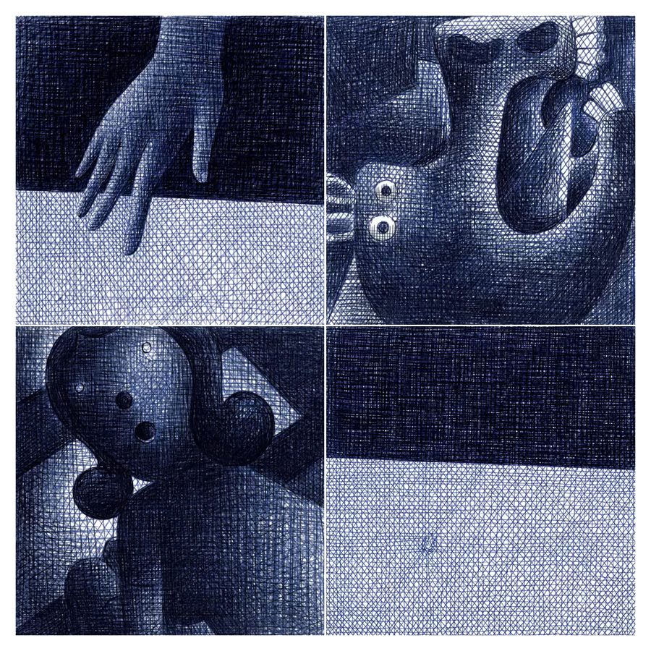
Courtesy Eric Lambé and Frêmok

Lambé observes common objects, and elements from paintings (Geurnica by Picasso, The Street by Balthus) and reimagines them in the construct of pure juxtaposition. The order of the drawings within the book presents the viewer with only one perspective of looking and interpreting this visual poem. Its size forces us to look at opposing pages to analyze content. Because there isn’t a specific story, the work can take on an entirely different aesthetic when it is presented on walls in a gallery. From this perspective a viewer has multiple ways of approaching the images. They can be seen collectively or individually, viewed from any direction. In comics, there is generally a singular way to read and view a work; yet Lambé is interested in manipulating the direction narrative suggests to the reader. He views his role as an artist as emphasizing the tension between text and image, thereby giving the reader an investment in the viewing experience. In their book Paysage Après la Bataille (Landscape After the Battle and winner of the Best Comic of the Year at Angoulême in 2016), writer Phillipe Pierpoint and artist Eric Lambé present us with an allegory of a young mother trying to cope with the loss of a child. This is a large work that uses very few words. It takes its time to move us through the story. At 420 pages, it asks the audience to thoroughly share in the painful experience of memory and loss, to grieve with the mother. The visual pacing purposely slows us down. Using metaphorical images that suggest emptiness, remoteness from the world and loneliness, the pictures quietly express life’s fragmentary nature, death, the processing of loss, the value of silence and escape. The characters in the book inhabit a trailer park, suggesting the idea of mobility, yet anchored in place. The occupants are the grieving mother, a retired couple, a retired boxer and huntsman and the camping attendant. The images are primarily painted in flat washes of gray that reinforce the sadness and quiet desperation the life the characters in the book lead. There is little detail to the images; it is as though we are to observe the characters and have empathy, but still remain detached. Occasionally, an image painted in color provides the reader with a sanguine glimpse of hope - what life can be when gradually being able to move on from grief. Lambé and Pierpoint ask us to view the juxtapositional relationship of images to form associations that support the emotional content of the narrative. Conceptually, there is a parallel to Jean-Paul Sartre’s No Exit, in which three deceased characters are punished by being locked together for all eternity in a room decorated in the style of Napolean III. Each of us has experienced that sense of being trapped in a place, whether physically or emotionally, and feeling as though there is no way to escape. Therefore, while the images in the book do not read linearly, we can be empathetic to the disposition of the content. While there is very little text in this work, one gets the sense that Peirpoint and Lambé tackle the felicitous issues of shared experience, that of loss and grief, stress and the suppression of emotion, and the desire to escape from unpleasant circumstances. This book is about the loss of a child. For the audience it can translate to any sense of loss or crisis, and how over the course of time we can transcend and live life wholly once more.

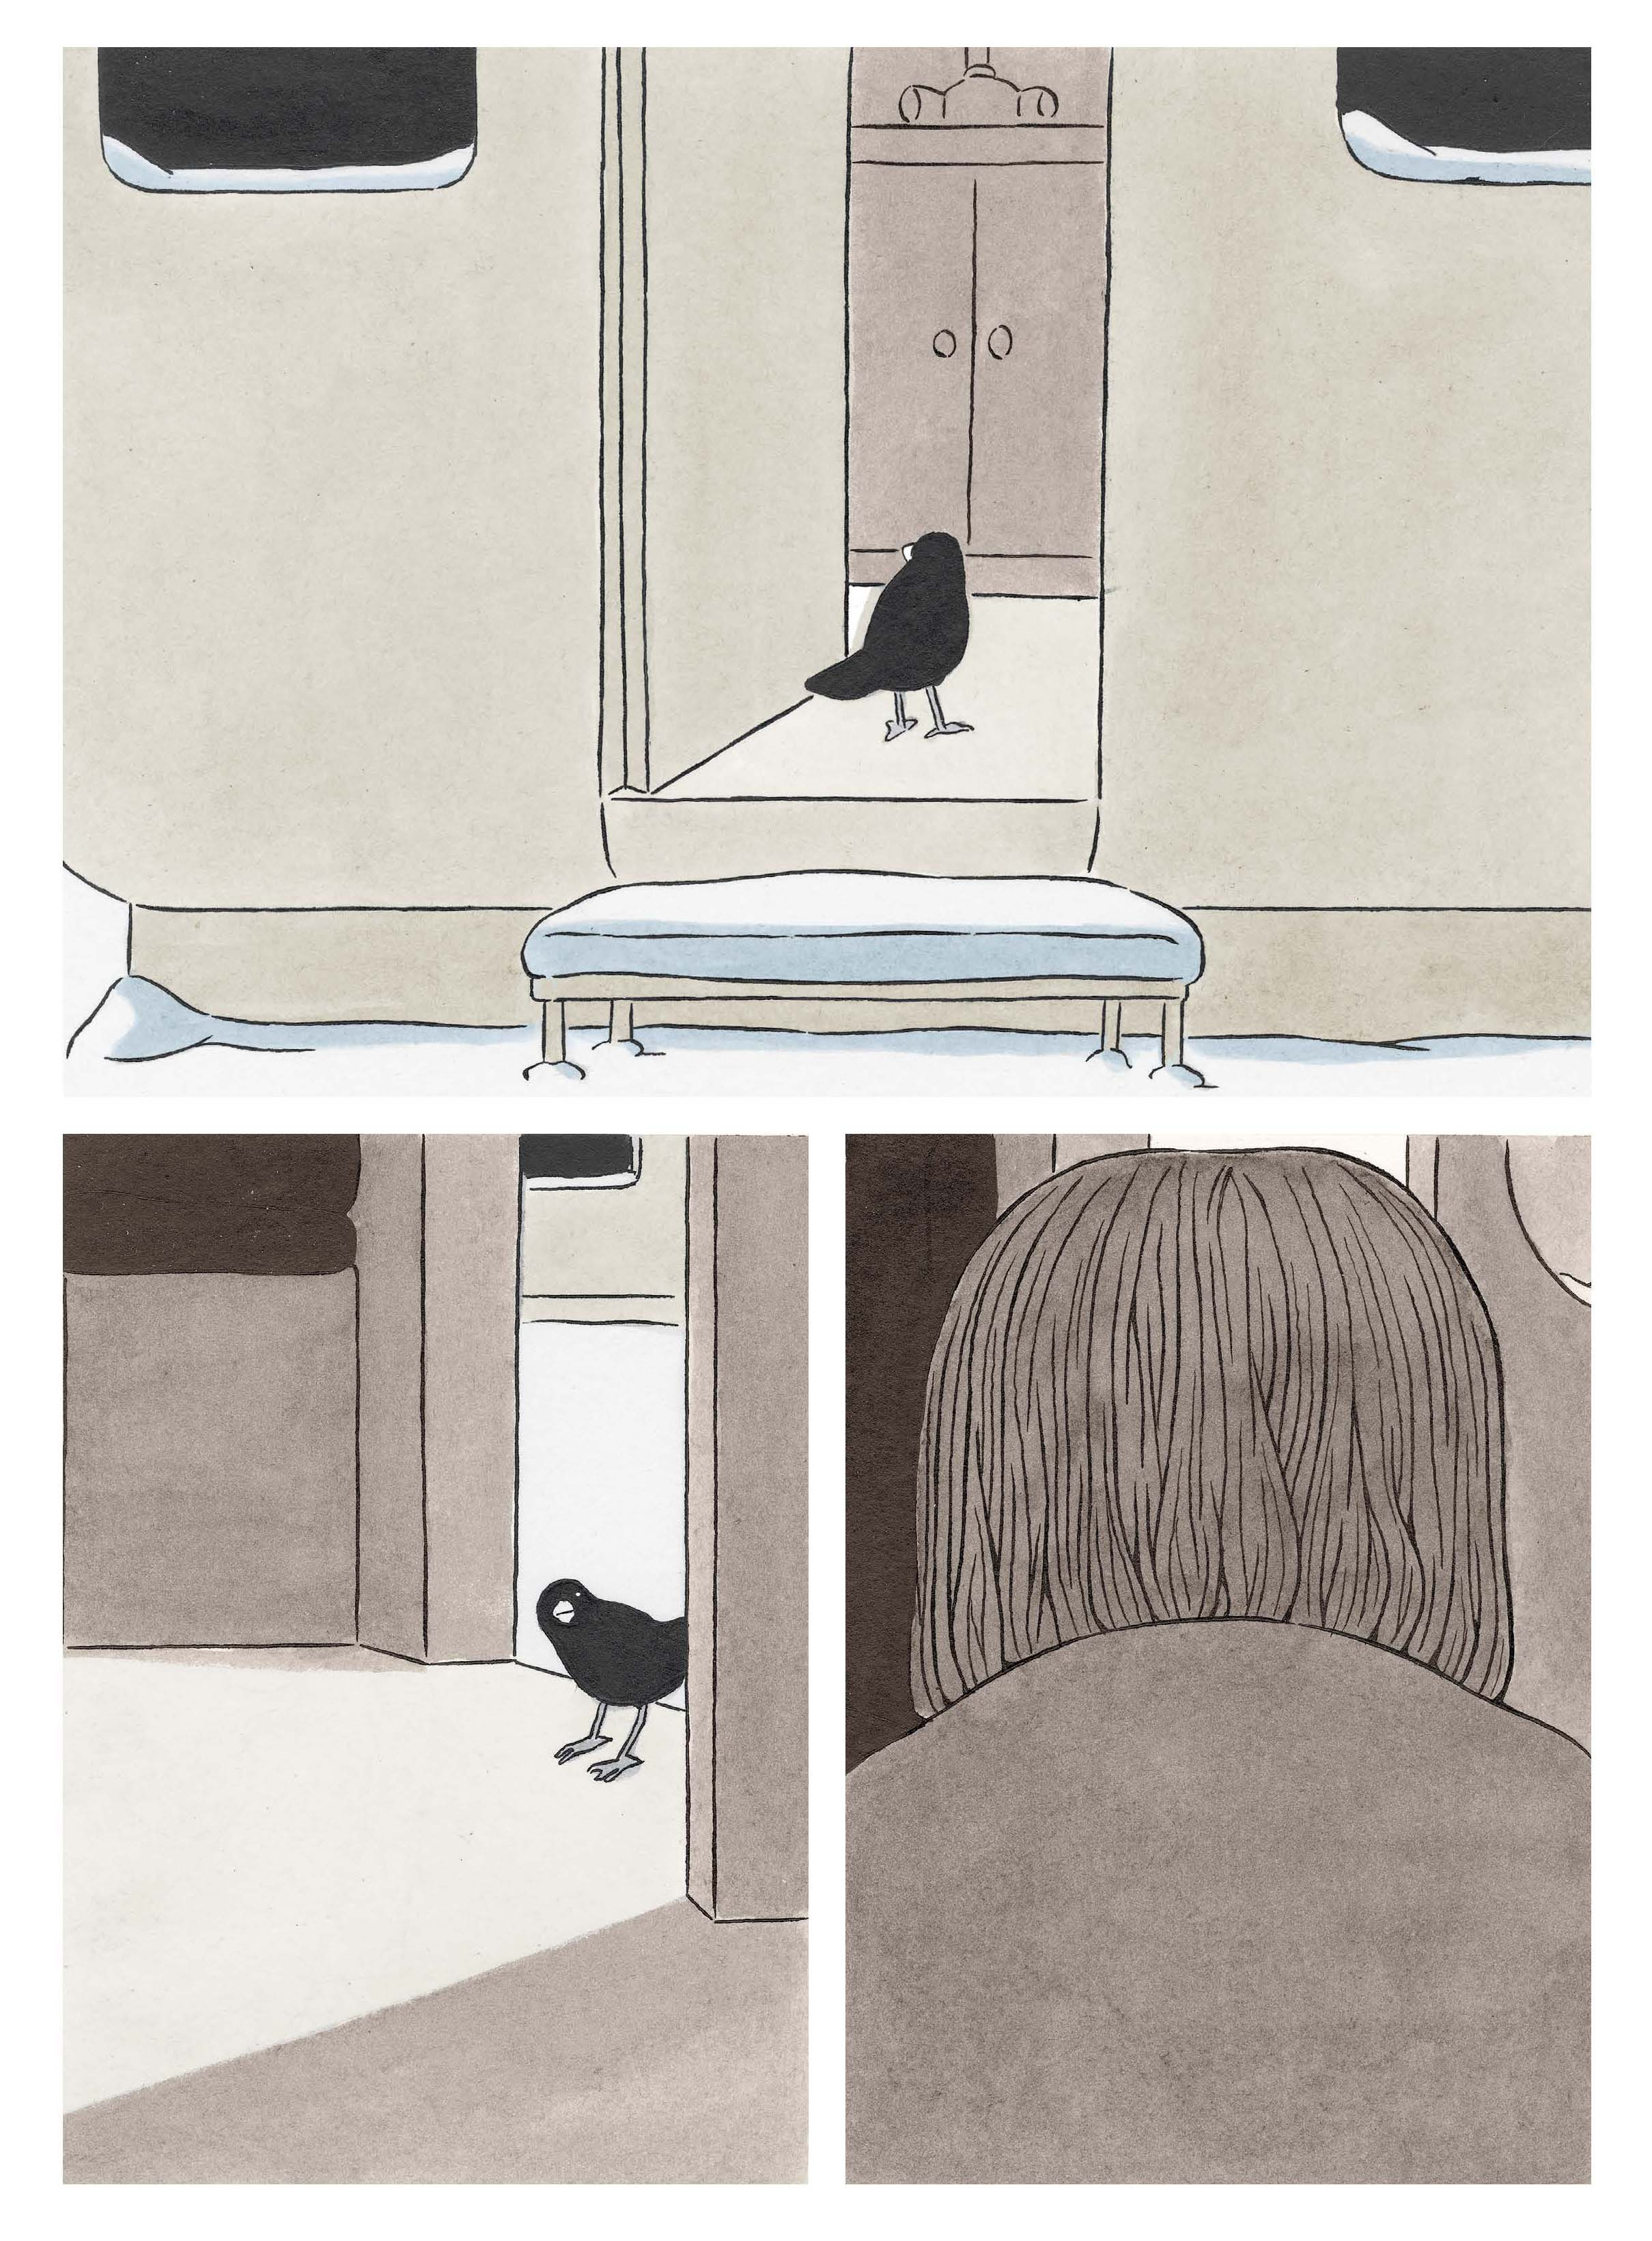

Courtesy Eric Lambé and Frêmok

A sense of loss or isolation is often a condition of living in large urban areas. The life of the city has continuity that is often in contradiction to the way individuals lead their lives in urban environments. The painter Edward Hopper made the city and its inhabitants the primary subject of his oeuvre. The city stands as a metaphor for the human condition; the relationship of an individual to the urban environment often conveys a sense of isolation. This is powerful content. Artist Michael Matthys uses the city of Charleroi, Belgium as the subject for his books Moloch and La Ville Rouge. In 2008, a Dutch newspaper named Charleroi as the ugliest city in the world, and the press seemed to piggyback on this assertion. Among Belgians, the former mining and steel town of Charleroi is generally viewed as derelict, poor and polluted. It has had one of the highest crime rates in the country and one in four inhabitants are unemployed. That impression takes a long time to overcome, even as the city has made distinct efforts over the past decade to gentrify and to assert itself as a cultural center within the country. The architecture of the city’s industrial past is a defining characteristic of its current personality. During the nineteenth century the region was the industrial powerhouse of the newly founded state of Belgium. Its coal and steel industries flourished until the mid-1950s when the majority were shut down, plunging the region into an economic depression that still affects the employment of the city’s citizens. Moloch was based on video that he shot in the Cockerill Sambre factory, a large steel mill on the shore of the Sambre River. The book itself is comprised of 254 etchings and aquatint prints, each printed in black ink. The process of printmaking is labor-intensive, with each plate having to be manipulated with etching needles, scrapers and burins to work the surface of the zinc or copper substrates. Acid resistant asphaltum coats areas of the plate to block the acid from etching into the surface of the material, and it is cleaned off with kerosene and degreased with ammonia and calcium carbonate. It is then coated with etching ink and wiped clean with tarlatan cloth; moistened paper is laid on top of the printing plate and it is run through an etching press, creating an impression on the paper. In this way, the process of creating the artwork, is a metaphor for the industriousness of the workers who labored in those steel mills. It’s physically hard and demanding work, and it’s dirty.

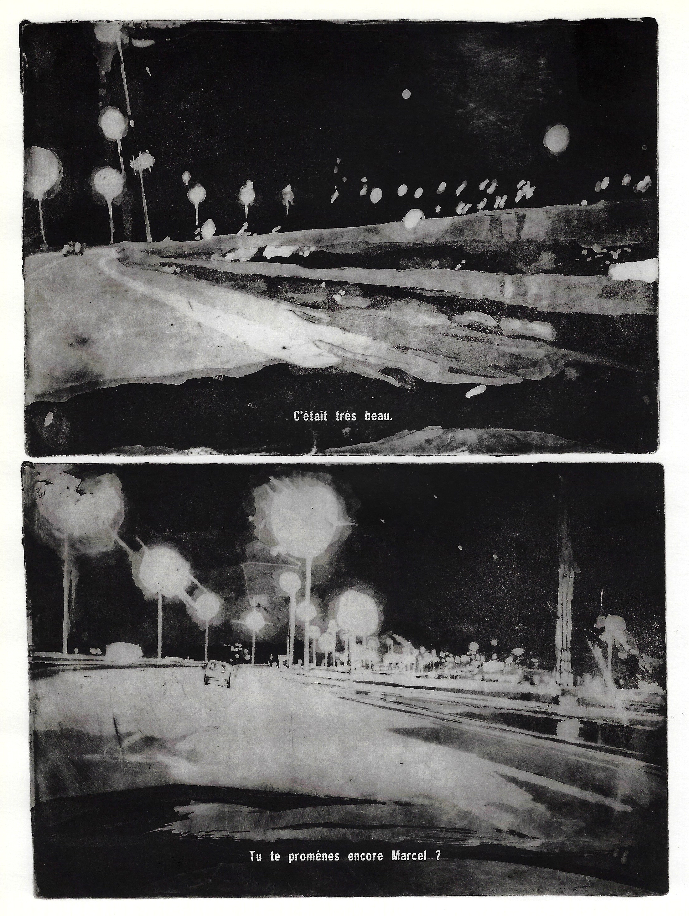

Courtesy of Frêmok

In his book La Ville Rouge, Matthys uses cow’s blood collected from the slaughterhouses of Charleroi to create starkly beautiful images of the city. There is no dialogue in this book; it is 309 paintings documenting the city, people, transportation systems and the highways that comprise the city of Charleroi. While there is no narrative, nor is one implied by the book’s layout, it invites the audience to participate in a tour of the city. It suggests the freedom of living in an urban environment, while the images of the beltway also suggest one being trapped within the city’s perimeter. Do the images convey the sense of a dying industrial city, or do they celebrate and honor the city’s past? The original paintings are quite large (several square feet) and are produced with cow's blood and then sealed with resin. Moreover, the visual effect is breathtaking and moving. The viscosity of the blood and resin, sometimes mixing with broad, gestural charcoal marks is reflected in the artist's brush strokes, which coagulating on the surface. In the book, the work looks as though it could have been completed with any type of aqueous media, yet it is in a museum or gallery that the work has a significant emotional impact.
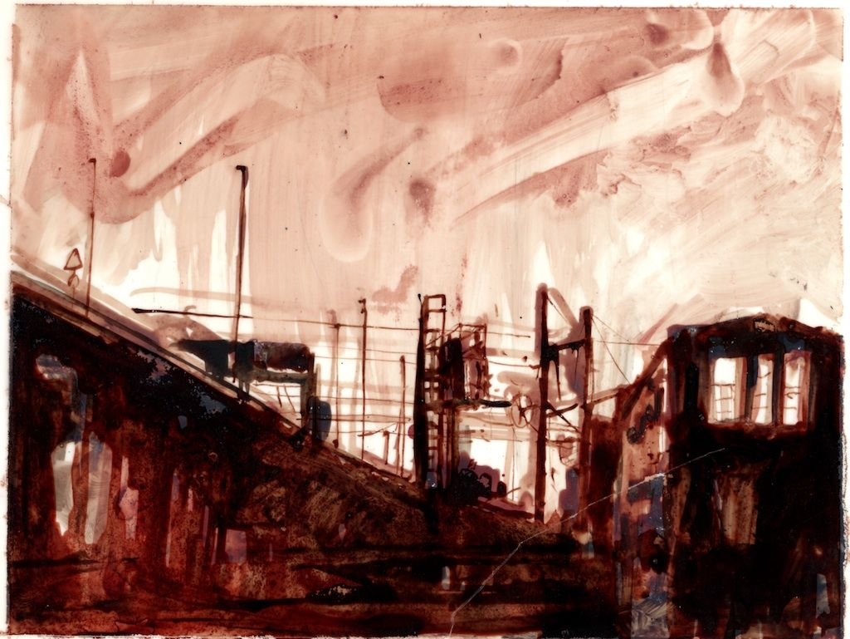
Courtesy of Frêmok

The sizes of the images are confrontational, and the brushwork invites close inspection of the expressive mark-making. As comics, the work is accessible to a particular audience. Conversely, in a museum and gallery setting that the work comes to life in a different manner. That audience is generally more discerning. The size of the work, the way in which it is laid out, creates other associations than the ones presented in published form.
Matthys' work has limited narrative content. His art is atmospheric and expressionistic and focuses on the environment and human condition of the area in which he lives, an historically industrial area of Belgium. In 2009, the Musée des Beaux-Arts in Charleroi featured an exhibition of Matthys’ work from these two publications. The prints from Moloch were featured on walls opposite from monitors playing loops of the video from which Matthys originally made the prints. Moving images, juxtaposed against rows of repeated prints, a contrast of black and white movement, and dark stills, mounted like multiples of photo booth observations. The effect was one of claustrophobic coolness, aloof yet voyeuristic. Contrasted with the large, bold paintings from La Ville Rouge, one gets a sense of what it’s like to have been raised and live in this region. Matthys knows this place and he empathizes with the honorable work of manual labor and proudly affirms his relationship to the legacy of the people who built Charleroi. Broadly conceptual art that speaks to the human condition is not traditionally the arena in which comics operate, yet the artists who work with Frêmok are concerned about broadening the visibility of the comics art form to experiment with narrative and its viability as a form of metaphorical suggestion. While not declaring a prescribed meaning to narrative and stories, the artists and writers set up situations by which an audience can interact and form the narrative themselves.

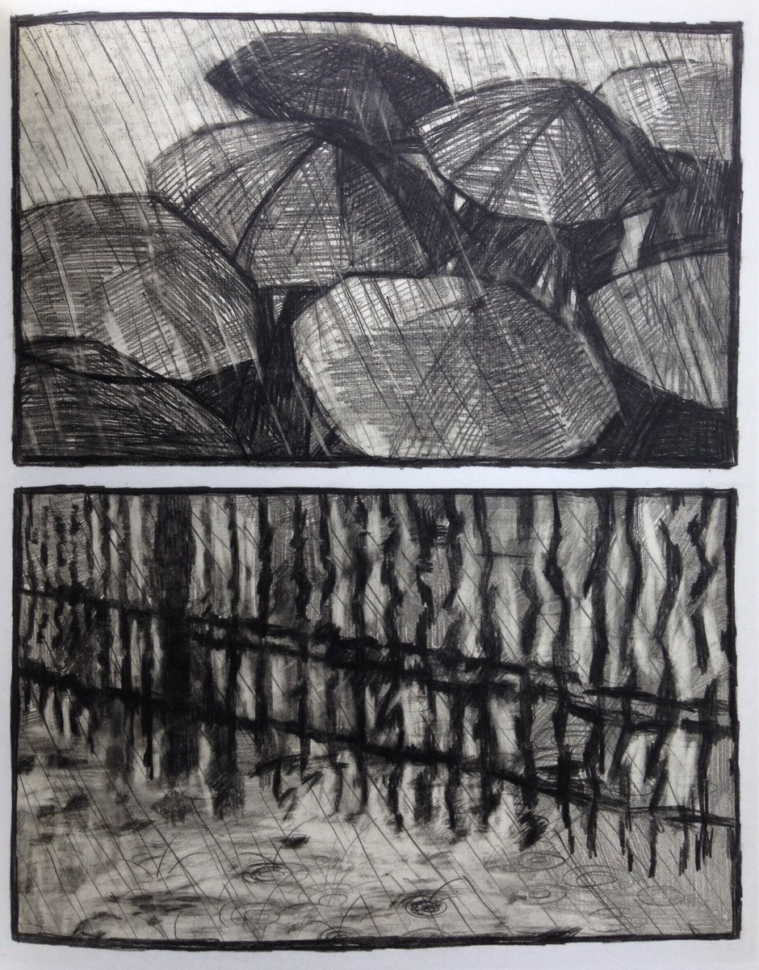
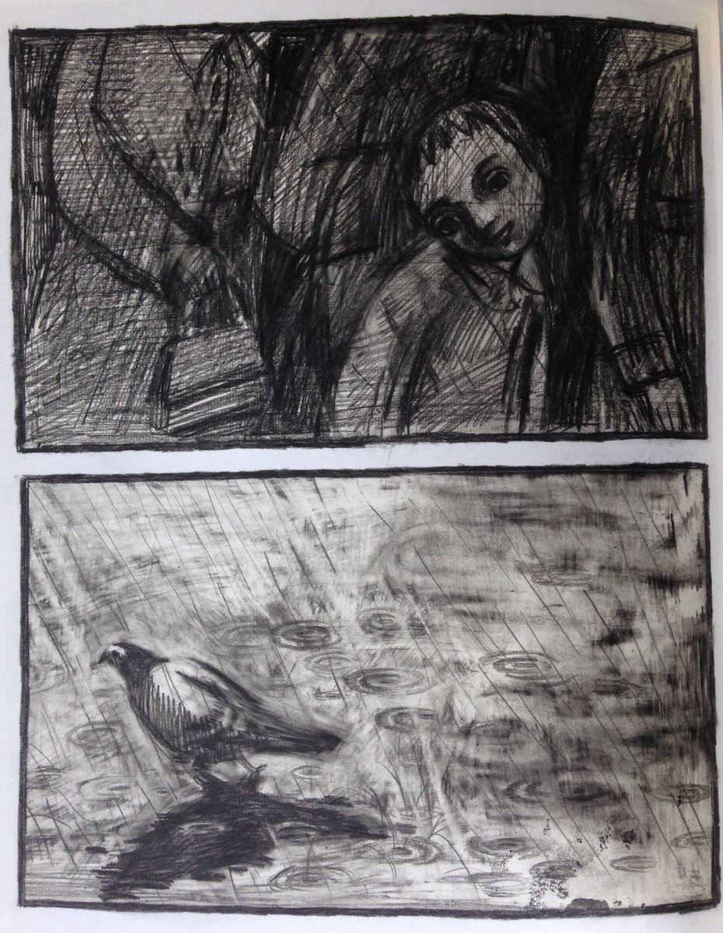
Few artists have as much skill at manipulating the architecture of comics than Dominique Goblet. Her styles freely adapt to the stories she’s trying to tell, and they are varied. However, there is something unique about her line quality of her work, no matter how she articulates her vision. Like many artists throughout history who have pushed autobiography through self- portraits, Rembrandt, Van Gogh, Schiele, to name a few, so has Goblet investigated her own life as the resource to making art. In Souvenir d’une Journée Parfaite (‘Recollection of a Perfect Day,’ 2001), she writes and draws of her relationship with her father, a fireman who has recently passed away. The book was a way for Goblet to work through her emotions and reflect upon his impact on her life shortly after his death. She illustrated the book in a manner that reflects sorrow and the obfuscation of clear memory. With very gestural black and white graphite drawings, Goblet has used a clear oil paint blending stick to smear the graphite and give the drawings a yellowish, pallid cast. The effect is to slightly blur the marks, implying the fleeting nature of clear memory over time.

Courtesy Dominique Goblet and Frêmok
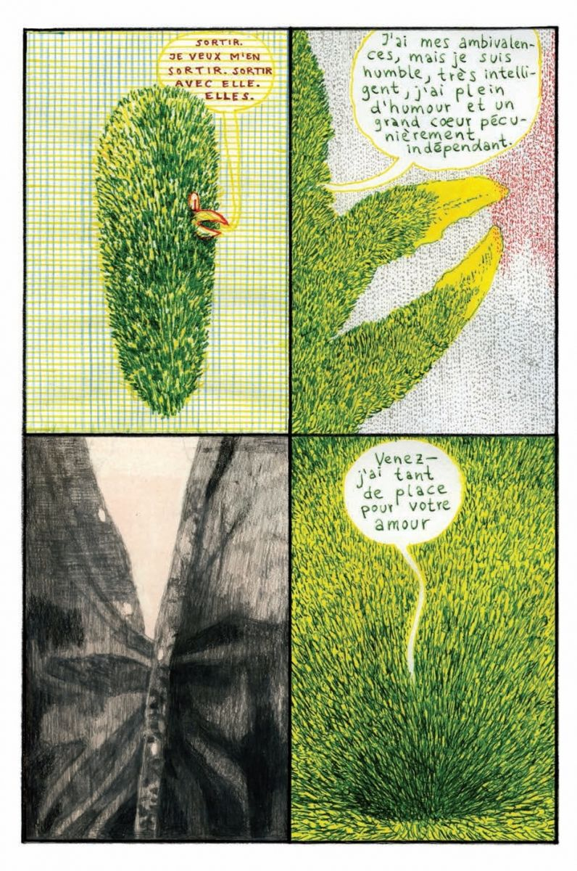
The astonishing book Plus Si Entente reflects Goblet’s inclination for collaboration. With writers and other artists. For this project, she worked with German illustrator Kai Peiffer to create a story about a mother and daughter who become estranged from each other and how they deal with their independence. The mother seeks solace through internet dating sites, the daughter is challenged by her memories and subconscious. The process of making the project involved each artist creating pages, which they would send to each other by mail between Brussels and Berlin. They each used the images and pages they created as a springboard for which the other could build upon or modify. The artwork is executed in a variety of techniques, from pointillism to linear to painterly, and brilliant full color saturation. Most pages are executed by one or the other, but to provide some linear continuity, images were cut up, spliced, and recombined. An occasional page was added to suggest a more seamless flow of content. Moreover, it created a narrative that is associated with a stream of consciousness, built upon the shared experience of each other’s thoughts and ideas. While that contributes to a slightly esoteric compilation, the exercise of shared editing and give and take provide a visual coherence. The visual flow and continuity between the two artists’ contributions began with distinct individual styles, and one could easily tell the difference in visual language. As the book progresses, one soon cannot tell the difference in the content.
Courtesy Dominique Goblet and Frêmok
It’s the kind of visual trust and familiarity that one might associate with a true partnership, one person so comfortable with the other that each can finish the other’s sentences. Goblet is a powerful image-maker. She describes her mark-making as “scratchy”, but it appears to be more about the process discovering a picture through the arduous manipulation of media. The work has a spontaneity to it that makes the audience feel as if they are participating in the conveyed action. Yet there is innate instinct for what works in the creation of content. In a series of images, Goblet seeks to find a way to render the brilliance of color embodied in the northern lights. Her solution was to render the color in green and yellow highlighting markers, which have a marvelous translucency, and to add details suggesting movement through the addition of blue, green and black lines created by a 4-color Bic pen. The results are wonderfully effective and can only come from the experience imbued from constant play and experimentation.

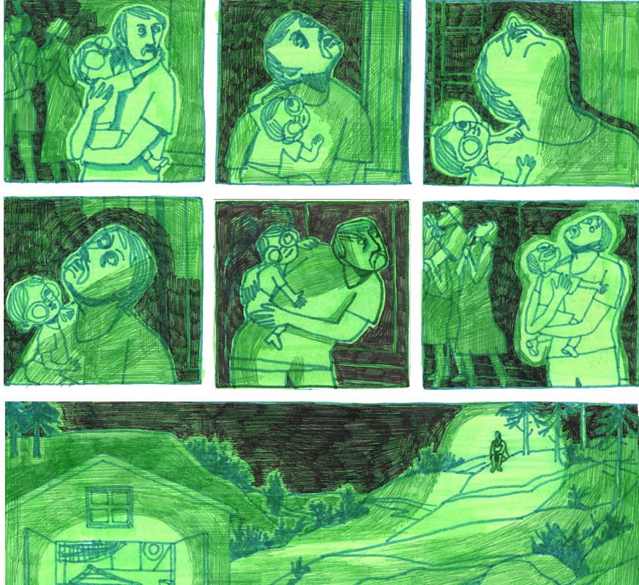
Courtesy Dominique Goblet
Her pushing the art form of comics includes recent work in narrative ceramics that will accompany another book project with Kai Pfeiffer, entitled Le Jardin des Candidats (The Garden of Applicants). Her most recent book project, L’Amour Dominical is a collaboration with Dominique Théate, an artist who was badly injured in a motorcycle accident as a teenager and suffered traumatic brain injury. It’s a story of an unlikely relationship, a fantasy love triangle between wrestler Hulk Hogan, a woman with a blue beard and a criminal orthodontist. This creation evolved over several years of Goblet and Théate working together, utilizing the journals that Théate has kept daily on his computer. His fascination with wrestling, love and language reinvention inspired him and Goblet to have conversations and drawing sessions together, eventually realizing this unlikely story. Due to his brain injury, Théate’s drawing technique is raw, reflecting Outsider Art or Art Brut, a term coined by French artist Jean Dubuffet. Paired with the writing in his journals, it makes for a fascinating combination. Goblet collaborates with Théate by interpreting the environment in which he has lived since his injury. Drawings of seasonal landscapes include the forests, mountains, roads and churches, and transcend the years of his experience in this location. As in the images from her book Souvenir d’une Journée Parfaite, the landscape is blurred, obscured from clarity as if being memories difficult to recall.
Collaborating with artists having developmental disabilities has long been a priority for Frêmok creators, particularly Dominique Goblet and artist/publisher Thierry Van Hasselt. They have partnered with the S Grand Atélier, a studio for artists with mental disabilities located in Vielsalm, Belgium. The studio organizes workshops and residency programs for these individuals with the participation and collaboration of artists in the broader community. For over a decade, artists from Frémok have shared their vision of comics, with all their experimental potential, infinite narrative possibilities, and the power of their poetic and human expression, to the S Grand Atélier. Among the published projects that have been shared with a broad audience are Match de Catch, presented at the Angoulême Festival in 2009. This compilation not only shared the creative vision of artists with intellectual disabilities, but in collaboration with singularly talented comics artists, shared an empathy and consideration of the range of storytelling that anyone can share. L’Evangile Doré de Jésus-Triste, a volume of woodcuts depicting religious themes released in 2017, is the studio’s interpretations of the woodcuts of Gustave Doré. Humpf, by artist Jean Leclercq, is a fascinating book, published in the fall of 2019. Referencing popular comics characters from newspapers and Marvel and DC, he works constantly, and his output is prodigious. Without any preconception his drawings begin anywhere on the page, which result in odd compositions and unusually cropped pictures. Because he believes that images and words belong together in comics, he adds word balloons to the top of his drawings – often far from the figures, so that the compositions feature strangely empty areas. The concepts within the word balloons are devoid of relevant content. “I never read,” says Leclerqc. “I mark down words.” Frêmok’s championing of the S Grand Ateliér has created broad awareness of the power of expression of Art Brut in the Franco-Belgian community, and it extolls the creative vision to inspire and look at the human condition from different perspectives. In much the same way as outsider art become popular in the United States in the 1980’s through the discovery of artists like the Reverend Howard Finster, Frêmok has created a visible forum for this art in the European community.
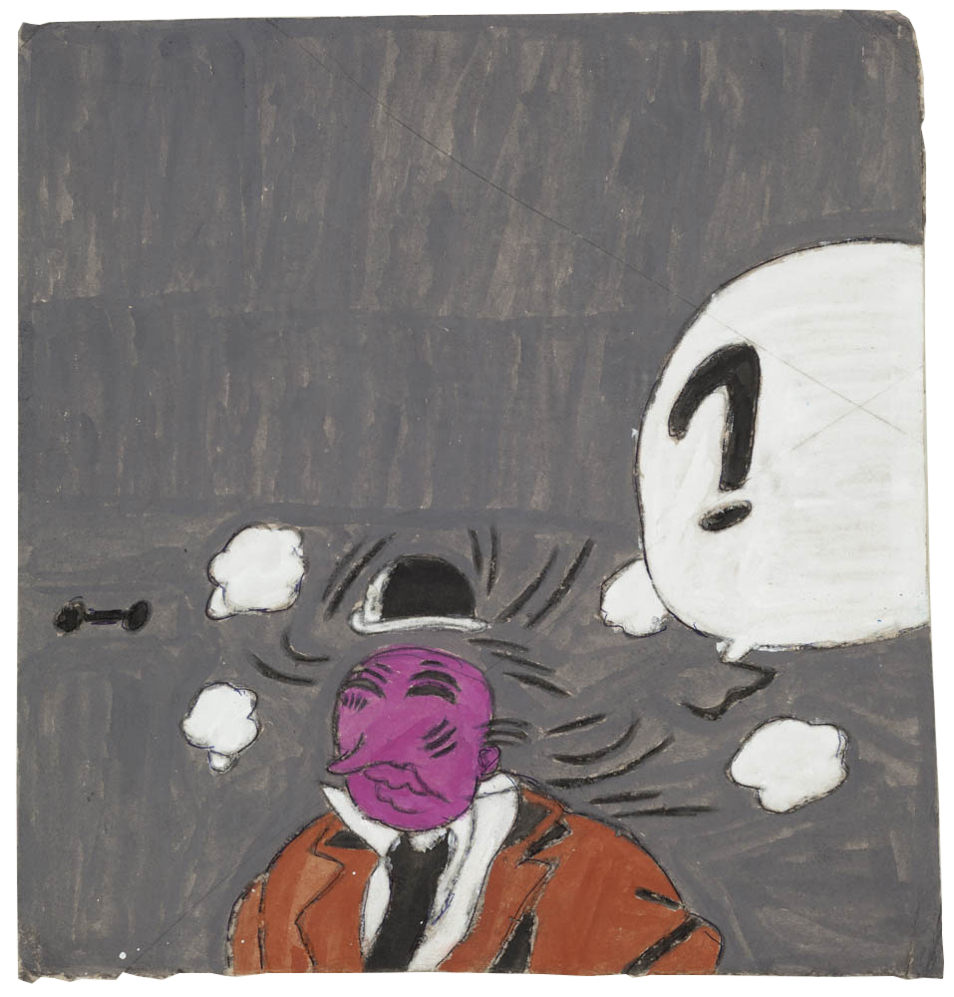
Courtesy of Frêmok

The impetus behind Frêmok’s collaboration with the S Grand Ateliér is publisher Thierry Van Hasselt. His empathy for people with developmental disabilities and his commitment to the studio result in truly symbiotic creative experiences: "The work that the S Grand Ateliér does transforms its residents, their self-confidence, and the way they interact with other people. But it also changes the way we look at them”. And in 2016, his relationship with studio resident Marcel Schmitz resulted in an astonishing collaboration, Living in FranDisco. Marcel lives in the moment, having created his own fascinating mythology, the ever-expanding city of FranDisco. This city, made of cardboard, masking tape, color transparencies, and drawn on with crayons and magic markers, is always growing. There are airplanes and blimps and helicopters that circle the city. Depending on the venue at which they are displayed, the city can fill entire galleries. And as the city expands, so does the mythology of Marcel Schmitz. The city is inhabited by the characters Lord Building, three versions of Saint Nicholas, a City Parade Girl, a Madonna, and Marcel Schmitz himself. Marcel Schmitz and Thierry Van Hasselt have formed a very close friendship and creative bond. In Living in Frandisco, Thierry Van Hasselt interprets the mythology and physical world envisioned by Schmitz. Together they created a book of profound beauty, in which they share this mythology, and imbue it with pathos and significance. Van Hasselt brings great sensitivity to his interpretation, never overwhelming the physical presence of the city. Rendered in the delicate line of a fine point Micron pen, the work acts as a support to the weighty and complex construction. The drawings stand on their own in this beautiful book, but in museum and gallery spaces, the art and the sculptural city are shown together. The drawings are created on delicate paper, and are exhibited by being pinned to a wall, row after row. Living in FranDisco serves as a beautiful and expansive theatrical storyboard for Schmitz's vision as king of his city. Together they have shared in FranDisco’s creation and its travels across Belgium and France; Van Hasselt views his relationship to Schmitz as an incredible gift. “It has brought some lightness, and a positive kind of nonchalance to my drawings. That never would have happened without Marcel. Meeting him has unleashed a real transformative power." Van Hasselt has grown as an artist by his coming to understand the way in which Schmitz creates and fantasizes about the kingdom he has made, both physically and conceptually. Art making becomes not about what you expect from the process of making, but it is about what is imaginable. Through the collaboration, it’s about elasticity of ideas and freeing oneself from the preconception of what art should be. The relationship between artists of Frémok and the S Grand Ateliér is about the transformative potential of art through shared experiences.
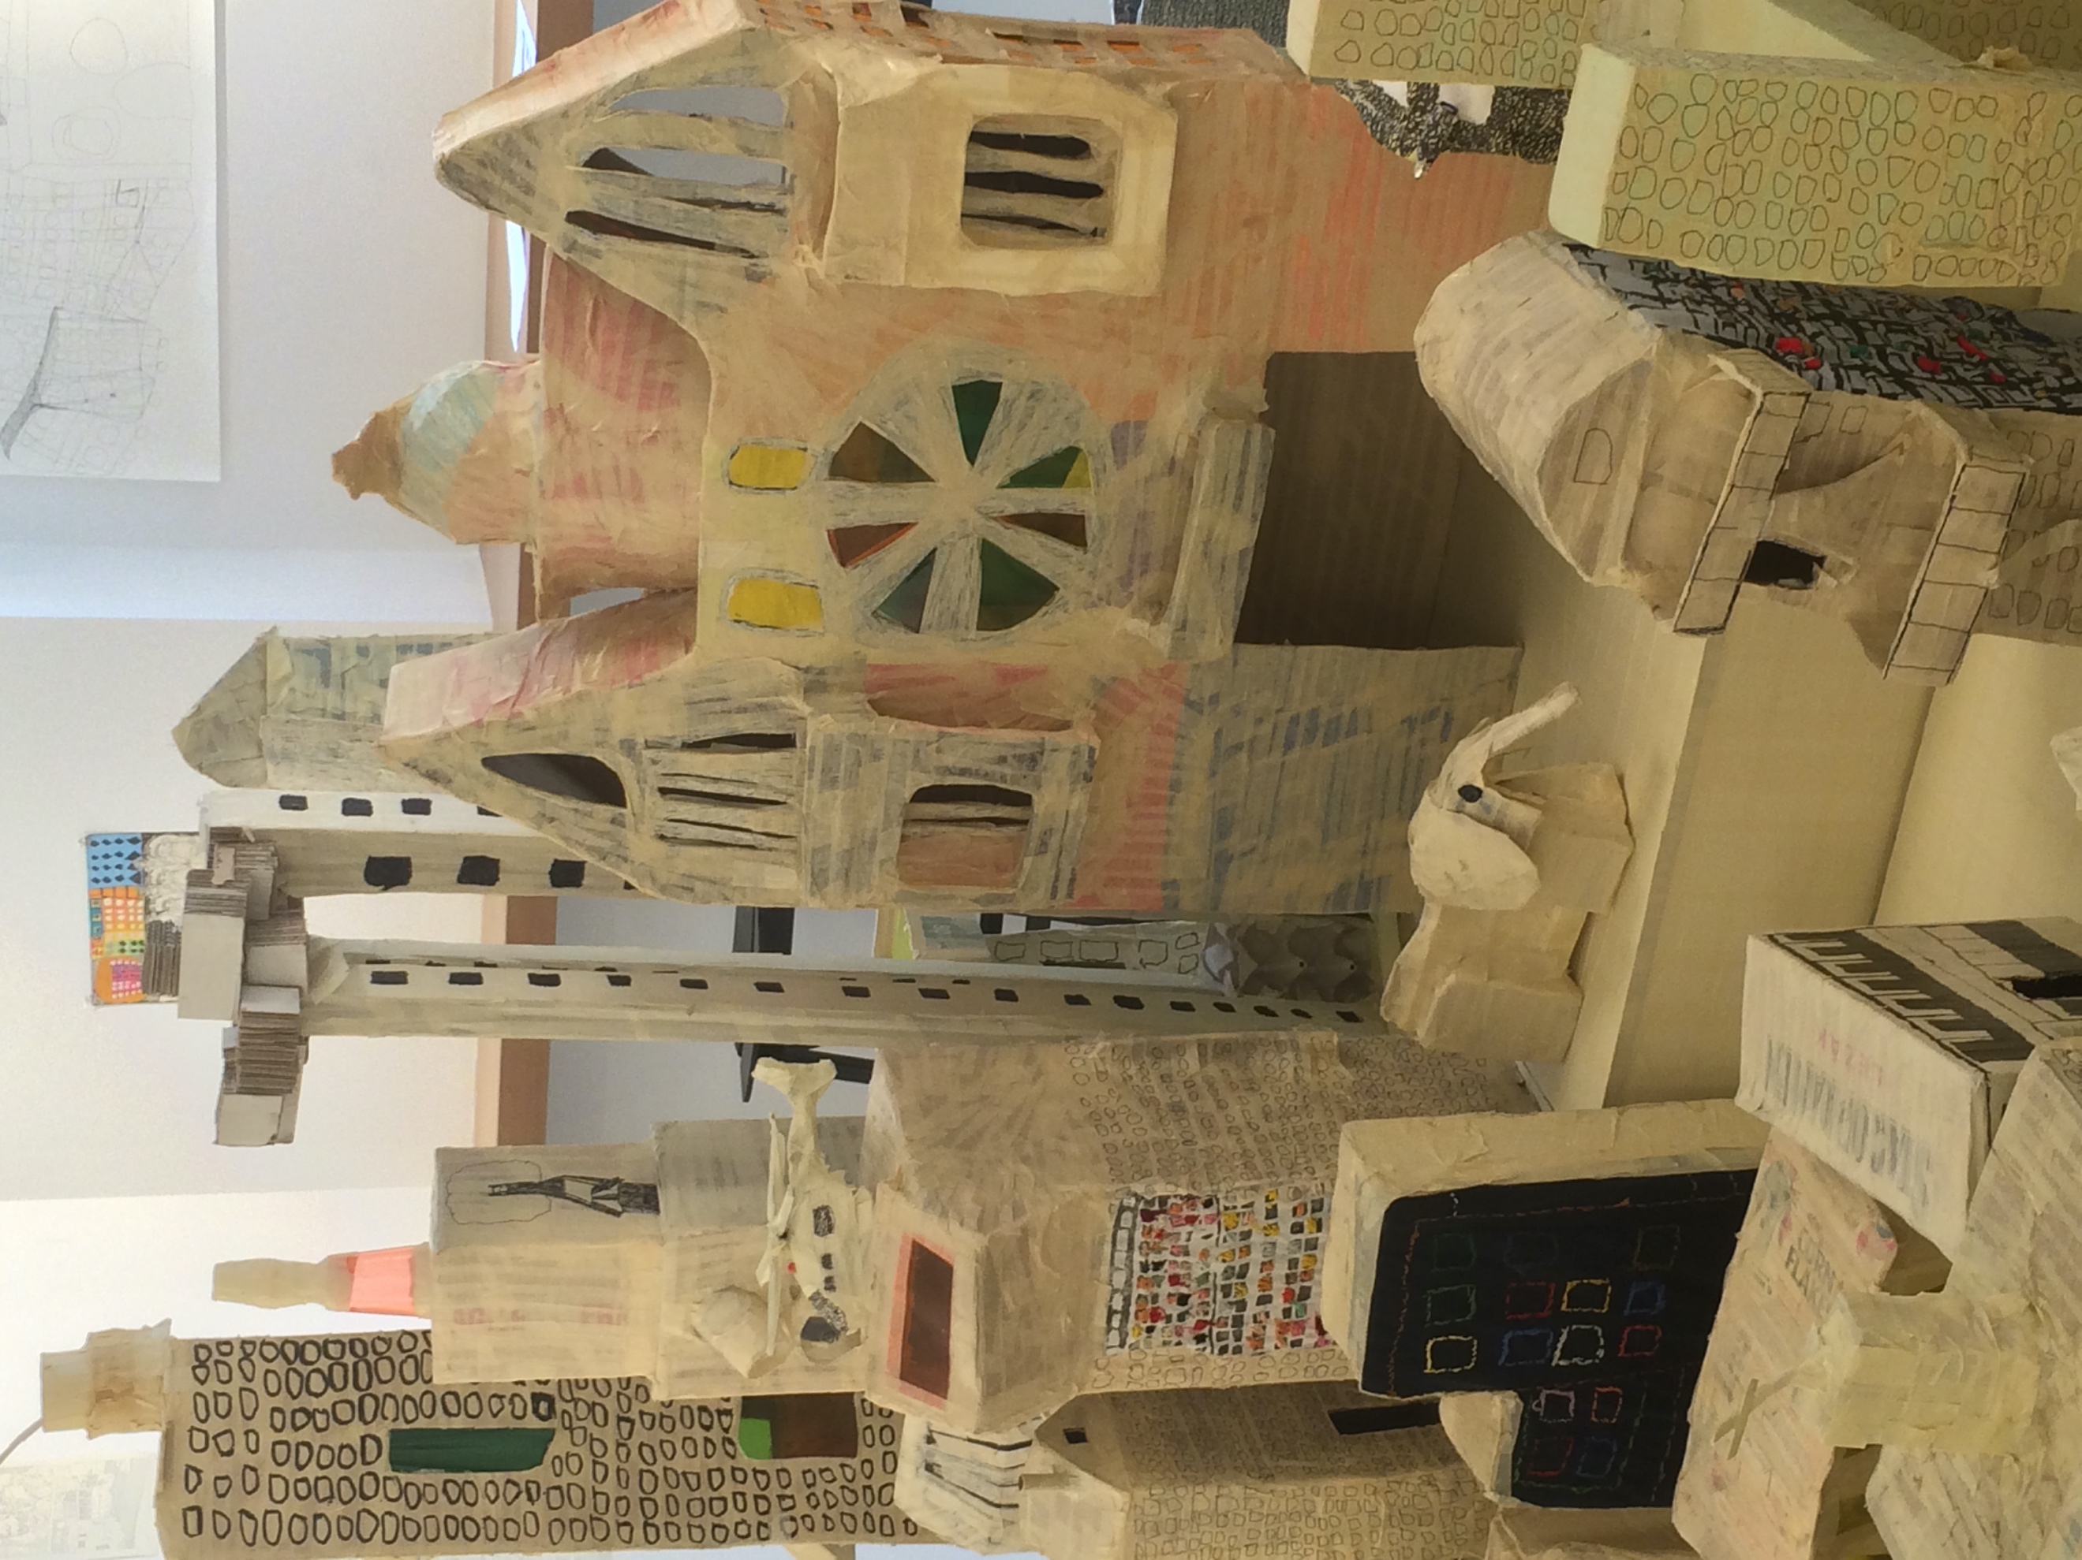
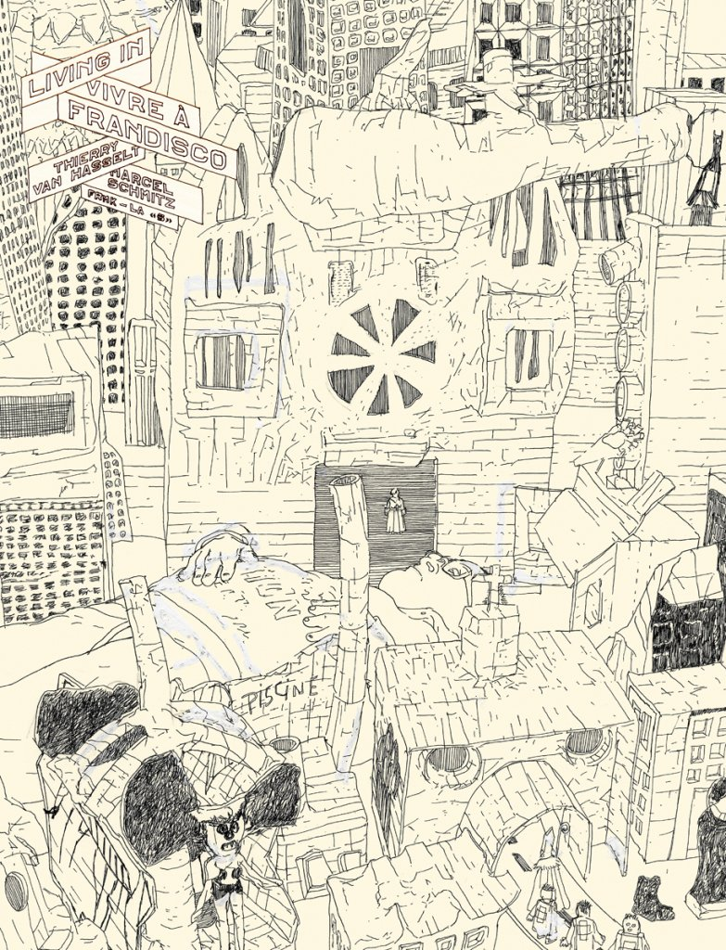
Courtesy of Thierry Van Hasselt and Frêmok

By looking at the comics published by Frêmok, we develop new methods for analyzing and appreciating this fascinating hybrid art form, which joins images, words and abstract symbols into elaborate compositions. Moreover, this group has changed the language of the art form by asking us to consider sensitive topical issues related to the human condition from a myriad of perspectives. The term parataxis refers to phrases and clauses placed one after another independently, without conjunctions. Often used in poetry, the joining of disparate thoughts aids in our consideration of ideas and imbues phrases with conceptual potential. That the work of Frêmok is done principally with pictures and limited text emphasizes the impact that visual semiotics have in influencing our perspective. Art influences society by changing opinions, instilling values and translating experiences across space and time. The essence of Frêmok is to create experimental, poetic work that evokes emotional consequences to our perceptions of the world.

