Doctor Doom Survey Results
In April 2020 I conducted an online survey in order to try and discover Doctor Doom's core characteristics - the things that make him Doctor Doom. I promoted the survey via twitter, which was much more successful than I expected - I was hoping for about 50 responses, but by the end of the survey period I had had 225 completed surveys returned.
As I analysed the responses I realised that it made more sense to examine the data in section five of the survey ("Your Experience Of Doctor Doom") first, rather than using the order in which the questions were asked, as this gave an insight into the background knowledge of those taking part, which would in turn shed light on some of the results. For that reason, this analysis will start with that section before moving onto the rest.

Contents
Respondents' Experience Of Doctor Doom | 2
Doctor Doom | 9
Doctor Doom's World | 17
Creators And Marketing | 23
Anything Else | 26
Overall Analysis | 27
Primary Sources | 29
Bibliography | 29

Respondents' Experience Of Doctor Doom
There were six main questions in this section, asking respondents about their experience of Doctor Doom in different media.

Media types: In which of the following media have you experienced Doctor Doom stories?
Respondents were asked to answer "Yes", "No" or "Don't know" to this question to indicate which types of media types they had experienced Doctor Doom in.
Media Type | Yes | No | Don't Know | Missing
Comics | 221 | 2 | 1 | 3
Movies | 185 | 30 | 7 | 5
Animated TV shows | 164 | 40 | 17 | 6
Video games | 108 | 92 | 19 | 8
Newspaper strips | 50 | 152 | 17 | 8
Radio shows | 6 | 209 | 4 | 8
Action Figures/Toys | 136 | 77 | 9 | 5
Other | 54 | 64 | 70 | 39

If the respondent answered "Yes" to "Other" they were asked which other media they had seen featuring Doctor Doom. The answers were as follows:
Other Media Types | Mentions
Costumes/Cosplay | 11
MF Doom/Hip Hop | 9
Trading Cards/Table top games | 9
Fan-Art/Fan-fiction | 8
Prose fiction/Text Books | 7
Memes | 4
Vinyl record/Audio story | 4
Collectibles | 3
Other | 7

By adding the top answers here to the main table the following graph was produced.

Comics came out clearly on top, although movies and animated TV shows were not far behind. This was to be expected, as most of the respondents were recruited via comics-related groups, but I did not expect Action Figures/Toys to be such a popular response. As will be seen throughout this analysis, respondents regularly gave answers that I would not have considered important, or included at all, if the survey had not been run.

Comics: How familiar are you with comics from each of the following decades?
The next questions were only asked for people who had answered "Yes" or "Not sure" to the question "Comics" at the start of the section. Results were as follows:
Decade | Scale of 1 to 5 where 1 means " Not familiar at all" and 5 means "Very familiar"
 | 1 | 2 | 3 | 4 | 5 | Missing
1960-1969 | 12 | 51 | 59 | 27 | 55 | 21
1970-1979 | 19 | 53 | 62 | 25 | 44 | 22
1980-1989 | 19 | 34 | 50 | 38 | 62 | 22
1990-1999 | 19 | 45 | 65 | 36 | 38 | 22
2000-2009 | 16 | 47 | 56 | 41 | 43 | 22
2010 - present day | 22 | 44 | 50 | 30 | 56 | 23

By recoding scores 1 and 2 as "Not familiar", 3 as "Neither" and 4 and 5 as "Familiar" the following graph was produced.

This shows that awareness of Doctor Doom's appearances was fairly evenly spread across time, with a slight bias towards the 1980s, which could be accounted for by his leading appearance in Marvel Superheroes Secret Wars during this period. This might also explain why so many people thought of Doom appearing as an action figure, as this was the commercial driving force behind the creation of the Secret Wars series (Shooter, 2011; Howe, 2012).

Comics series: Which comics series are you aware of Doctor Doom appearing in?
This was only asked for people who answer 'Yes' or 'Not sure' to the previous question.
Comics Series | Yes | No | Don't Know or Missing
Fantastic Four | 203 | 2 | 20
Marvel Superheroes Secret Wars | 164 | 39 | 22
The Avengers | 164 | 40 | 21
What If? | 156 | 46 | 23
The Amazing Spider-man | 145 | 59 | 21
Unbeatable Squirrel Girl | 144 | 59 | 22
Doom 2099 | 141 | 63 | 21
The X-Men | 129 | 75 | 21
Infinity Gauntlet/Infinity War | 127 | 76 | 22
Secret Wars | 127 | 76 | 22
Secret Wars II | 127 | 75 | 23
Spidey Super Stories | 101 | 102 | 22
Infamous Iron Man | 100 | 102 | 23
Dark Reign | 94 | 107 | 24
Not Brand Echh | 80 | 120 | 25
Books Of Doom | 74 | 127 | 24
Super-Villain Team-Up | 64 | 137 | 24
Doctor Doom and the Masters of Evil | 50 | 152 | 23
Other | 80 | 95 | 50

Predictably, Fantastic Four and Marvel Superheroes Secret War were the most popular answers here, although it was intriguing to find What If? appearing so high in the list. This is not a series that I personally would associate particularly with Doom, even though I know he did appear in it several times.
One important thing to note here is how many people were aware of Doom's appearances in Unbeatable Squirrel Girl. This is likely, in part at least, to be due to so many respondents finding out about the survey via Ryan North's retweet of the call for participation. As will be seen as the analysis continues, this would lead to some skewing of other results.
If the respondent answered "Yes" to "Other" they were asked which other series they had seen featuring Doctor Doom. The top answers were as follows:
Series | Mentions
Iron Man | 13
Doctor Strange and Doctor Doom: Triumph and Torment Graphic Novel | 12
Luke Cage Hero For Hire | 12
Doctor Doom (2019) | 10
Thor | 9
Daredevil | 7
Astonishing Tales | 6
Black Panther | 5
Dazzler | 5
Future Foundation | 4
invincible iron man | 4
X-Men/Fantastic Four | 4

It is notable here that so many people mentioned Doom's appearance in Luke Cage: Hero For Hire, a series which he only appeared in for two issues but which did generate a popular internet meme.
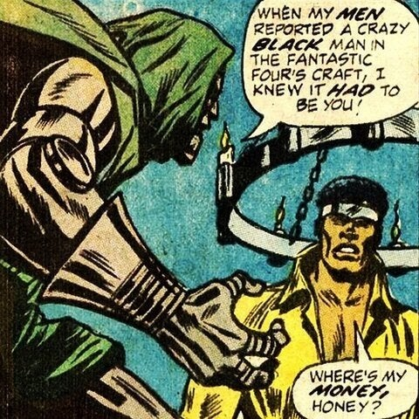
Widely quoted panel from Luke Cage, Hero For Hire #9 (Englehart et al, May 1973)

There were another 66 separate series mentioned for this question, all with three or less responses, demonstrating how widely Doom has travelled throughout the Marvel Universe.

Movies: Which movies do you remember seeing that featured Doctor Doom?
The next two questions were only asked for people who had answered "Yes" or "Not sure" to question "Movies" in question 13. Results were as follows:
Movie | Yes | No | Don't Know or Missing
Fantastic Four (2005) | 154 | 25 | 46
Fantastic Four: Rise Of The Silver Surfer (2007) | 117 | 60 | 48
Fantastic 4 (2015) | 84 | 92 | 49
The Fantastic Four (1994) | 78 | 98 | 49
Other | 0 | 131 | 94

Even the most widely known movie was known by only 154 of the respondents, which is less than the top four series in the comics section. This may be due to the bias towards comics fans in my recruitment, although it may also be because none of the films listed were particularly successful (Clark, 2019).
As one might expect, the most widely known film appearance by Doom was the film that did best commercially, and the least known was the Roger Corman version which has never been officially released.

Animated TV shows: Which animated TV shows do you remember seeing that featured Doctor Doom?
This question was only asked for people who had answered "Yes" or "Not sure" to "Animated TV shows" at the start of this section. Results were as follows:
 | Yes | No | Don't Know or Missing
Fantastic Four (1967) | 85 | 77 | 63
Fantastic Four: The Animated Series (1994) | 83 | 79 | 63
Spider-man And His Amazing Friends (1981) | 79 | 82 | 64
Spider-man: The Animated Series (1994) | 64 | 98 | 63
The New Fantastic Four (1978) | 60 | 101 | 64
Fantastic Four: World's Greatest Heroes (2006) | 52 | 106 | 67
Spider-man (1981) | 50 | 111 | 64
The Marvel Super Heroes (1966) | 49 | 113 | 63
The Avengers: Earth's Mightiest Heroes (2010) | 48 | 110 | 67
The Super Hero Squad Show (2009) | 39 | 120 | 66
The Incredible Hulk (1996) | 34 | 125 | 66
Avengers Assemble (2013) | 25 | 132 | 68
Iron Man: Armored Adventures (2009) | 22 | 136 | 67
Ultimate Spider-man (2012) | 21 | 137 | 67
Hulk and the Agents of S.M.A.S.H. (2013) | 11 | 145 | 69
Other | 3 | 125 | 97

The main point of interest for this list is that it appears to favour the older TV shows, perhaps because most people responding would be older than the target audience for the shows from the 2010s.

Video games: Which video games do you remember seeing or playing that featured Doctor Doom?
 | Yes | No | Don't Know or Missing
Marvel vs Capcom (1995-2011) | 77 | 34 | 114
Marvel: Ultimate Alliance (2006-2019) | 74 | 35 | 116
Lego Marvel Super Heroes (2013) | 45 | 66 | 114
Marvel Heroes (2015-2016) | 26 | 82 | 117
The Amazing Spider-man and Captain America in Dr. Doom's Revenge! (1989) | 23 | 86 | 116
Spider-man: The Video Game (1991) | 15 | 95 | 115
Marvel Super Hero Squad (2009-2011) | 14 | 96 | 115
Other | 13 | 79 | 133

The "Other" answers included 18 different games, including 3 which were included in the list above and some which Doom definitely does not appear in. I was quite surprised that Lego Marvel Super Heroes was not higher in the list, as that was the one I was most aware of, but again there does not seem to be any particular trend in the dates for different games.

Analysis
These results demonstrate that the survey respondents had a broad knowledge of Doctor Doom in different media and different time periods. On average, each respondent was aware of Doom appearing in 3.89 (median answer 4) out of the 8 different media types, with the overwhelming majority (77.78%) being aware of him in 3-6 media types. Similarly, on average respondents had some familiarity (score 3-5) with 3.72 out of the 6 eras, with a slight bias, as described previously, towards the period of this thesis.
There were other biases, such as for comics or for Squirrel Girl, which came from the method of recruitment, and if I was to run such a survey again I would make a greater effort to engage with fans of other media, but I think it is fair to say that this group of respondents could be trusted to give an informed view of who Doctor Doom was generally thought to be.
The following sections will look at what that view actually was.

Doctor Doom
This, and the other remaining sections, allowed respondents to enter as many answers as they liked in free text.

Appearance: Please enter as many aspects of Doctor Doom's appearance as you can think of.
Aspect of appearance | Mentions
Green Cape | 212
Metal armour | 187
Metal Mask | 186
Green Hood | 119
Scarred face | 85
Green tunic/skirt | 57
Gauntlets | 51
Eyes visible | 47
Gold disk clasps | 47
Leather belt | 32
Rectangular/Grill in mouth | 24
Gun on hip | 23
Square eye holes | 23
Rivets | 19
Metal Boots/Jet boots | 14
Tall | 12
Red/brown hair | 10
D-shaped belt buckle | 8
Gritted teeth/Scowl | 6
Robotic looking | 6
Doombot nearby (or he is one) | 5
Discs on joints | 5
Blasters in hands | 5
Muscular | 3
Brown Eyes | 3
Triangular nose | 3
White | 2
Medieval | 2
Other | 26

The "Other" category featured a range of signifiers that were only mentioned by single respondents, most of which were ones that belonged in other categories, such as "over the top speech patterns" or "Wine goblet".
The value of using a survey to find aspects of Doom's character, rather than simply deciding on my own, was demonstrated very clearly during the analysis of this category as there were several aspects of Doom's appearance that are obvious but which I would not have thought to include myself, notably "Gauntlets", "Eyes visible" (often stated as "angry eyes visible") and "Rivets".
Some aspects that seemed important to me, however, did not rate highly in the survey - for example the discs on his knee and elbow joints were only mentioned five times. Other characteristics were perplexing, such as the "D-shaped belt buckle" mentioned by five respondents. I had never seen a "D" on Doom's belt in any media, within or without my sampling area, but when I mentioned this to a younger comics reader (my nephew Noah) he immediately knew what I meant and fetched an image of Doom from a character guide which featured a belt buckle stylised to look something like a "D".
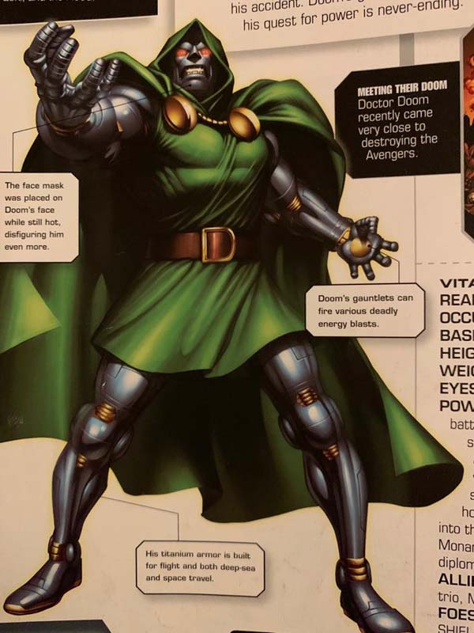
Image from Marvel Avengers: The Ultimate Character Guide (Last & March, 2010)

Names and titles: Please enter ways that Doctor Doom is addressed, either by other characters, the narrator, or himself.
Name or Title | Mentions
Doom | 145
Victor von Doom | 132
Dr/Doctor Doom | 123
Victor | 85
Ruler of Latveria | 35
Master | 31
Emperor/God Emperor Doom | 27
von Doom | 23
Lord Doom | 19
King of Latveria | 17
Doc Doom | 16
Vic | 13
Your highness | 13
Lord of Latveria | 10
Doomsie/Doomie/Doomsy | 10
Monarch of Latveria | 9
Majesty | 8
Excellency | 6
Doc | 6
Lord | 6
Doctor | 6
uncle doom | 6
Sire | 6
Infamous Iron Man | 4
Sorcerer Supreme | 4
Victor Van Damme | 2
Honey | 2
Invincible Man | 2
Leader of Latveria | 2
my liege | 2
Other | 46

As can be seen, there were a lot of variations on "Doctor Victor Von Doom", all of which were recorded separately as I was aware that a character addressing him as "von Doom" had very different connotations to another using "Victor". Similarly, the different titles relating to Latveria ("Ruler", "King", "Lord" etc.) were retained separately. Others, such as "Doomsie/Doomie/Doomsy" were compacted into one simply because they were different spellings on the way that he is often referred to by the Thing.
What is abundantly clear from this category is that while other titles do exist, Doom is generally called either simply "Doom", various permutations of "Doctor Victor Von Doom" or some version of "Ruler of Latveria".

Physical actions: Please enter specific physical actions that you associate with Doctor Doom.
Physical Action | Mentions
Bolts of energy from hands | 80
Shakes or clenches fist/hand gestures | 72
Magic/Dark Arts | 58
Dramatic pose/Power pose | 57
Flies/hovers (often with jetpack) | 45
Builds/invents things | 40
Sits on Throne | 36
Manipulates machinery (buttons/levers) | 35
Doombot (uses or is one) | 26
Monologues | 19
Curses reed richards | 17
Makes a speech/Addresses crowd | 16
Strides (through crowds) | 15
Arms in the air (while speaking) | 14
Fighting/hand to hand combat | 14
Rules Latveria | 12
Rants/Shouts | 12
Cape flourish | 10
Broods (often on parapets) | 10
Gives Orders | 10
Arms crossed | 10
Combines science and sorcery | 9
Uses Weaponry/gadgets (in armour) | 9
Pointing | 9
Drinks Wine | 9
Experiments/works in lab | 8
Looms | 8
Time Travel | 7
Zaps things with electricity | 7
Fist hits table | 7
Laughs manically | 7
Kidnaps/traps people | 6
Gloats | 6
Howls with rage | 6
Shoots gun | 5
Glares | 4
Grimaces/Scowls | 4
Attempts to conquer the world | 4
Hands clasped behind back | 4
Backhanding/swatting enemies | 3
Speaks in third person | 3
looking at monitors/video screen | 2
Plays chess | 2
preside over sumptuous feast | 2
Removes mask | 2
Blows the seahorn | 2
Other | 42

A major problem with coding and this section was that many of the responses were not really physical activities at all. Answers such as "Magic" or "Dark Arts", "Combines science and sorcery", " Builds/invents things" and "Time Travel" refer to more general activities which would be better suited in the "Behaviours" category, while a lot of the unique answers in the "other" category referred to past events ("Putting on his mask and scarring his face forever", "being attacked by squirrels").
Clearly there was an issue here with the description of what was meant by "Physical actions", and if this exercise was repeated there would need to be a reappraisal of how this question was phrased. Having said that, the benefits of undertaking this survey were once more made clear, as several responses arose which I would not have considered. These included "Bolts of energy from hands" or "Shakes or clenches fist/hand gestures". Conversely, aspects such as "looking at monitors/video screen", which to my mind is one of Doom's defining characteristics, was only mentioned by two people.

Behaviours: Please enter general behaviours or personality traits that you associate with Doctor Doom.
This category had 83 different answers which were given by more than one respondent, and 150 other unique replies. For the sake of brevity only the behaviours mentioned by 10 or more respondents are included here.
Behaviour | Mentions
Arrogant | 88
Megalomania | 77
Genius/High Intelligence | 63
Reed Richards obsession | 60
Egotistical/Narcissistic | 54
Scheming/Plotting/Devious | 43
Concern for his own country and people | 33
Vengeful | 26
Authoritarian/Tyrannical | 25
Mother Obsession | 25
Angry | 25
Sense of justice/honor/chivalry | 24
Condescending/haughty | 22
regal/imperious/aristocratic | 22
Vain | 20
proud/prideful | 20
Jealous | 17
Speaks in third person | 15
Commanding | 14
driven/self-motivated | 13
Evil | 13
Pompous/verbose | 12
Cruel | 11
self-aggrandising | 11
soft spot for Valeria Richards/other children | 10
Confident | 10
Boastful | 10

Luckily for me, this sort of complexity is not unique to this survey, and is in fact a longstanding problem for the psychological analysis of personality traits. This goes back to at least 1936 when Allport & Odbert initially identified18,000 words to describe personalities (Trait names: A psycholexical study, 1936). Since then many theories have been put forward about how to address this issue, with the most widely used currently being 'The Big Five', a system for grouping together personality traits into five broad dimensions to describe human personality (Diener & Lucas, 2020). These factors are: openness to experience, conscientiousness, extraversion, agreeableness and neuroticism, often referred to with the acronym OCEAN (de Raad & Perugini, 2002; Matthews, Deary, & Whiteman, 2003).
I will use aspects of this codification scheme when I move onto the next stage of this project, using the responses to create a tool for analysing the comics themselves. However, it will not form the basis of the tool itself - certain specific aspects of Doom's personality, such as his obsessions with Reed Richards and his mother, need to be recorded as specific details, rather than in the more general terms of this psychological tool.
For the moment, however, it is clear that Doom's characteristics are broadly centred around his arrogance, desire for power, and the twin obsessions mentioned above.

Dialogue: Please enter things that Doctor Doom regularly says - his catchphrases.
This question had far fewer types of response partly because many people found it difficult to think what Doom's dialogue might consist of - the phrase "Can't think of any specific (catch)phrases" or similar came up so often that it was included as a category of its own. Also, as can be seen below, there were several popular answers which referred to a general way of speaking rather than specific phrases.

Dialogue | Mentions
Speaks in Third Person | 49
Doom used in various self-aggrandising statements | 42
Richards! | 36
Fool(s) | 34
Can't think of any specific (catch)phrases | 32
I am Doom | 31
Accursed (Reed) Richards | 21
Kneel/Bow before Doom | 18
Confound these squirrels! | 14
Bah! | 11
Doctor Doom does/toots as he pleases | 9
You dare/how dare you? | 9
Says his own name a lot | 6
Mentions Latveria | 4
None shall/can/will... | 4
So swears/says Doom | 4
Curses/Curse/Damn you! | 4
Doom commands (it/you) | 4
Dolt | 4
Fear the wrath of DOOM! | 3
Silence! | 3
Cretin(s) | 3
Doom cares not! | 3
Formal language | 2
Doom's word... | 2
Tremble before Doom | 2
You will rue the day | 2
My people love me | 2
Witless fool | 2
Other | 27

The presence of "Confound these squirrels!" (and variations thereof) shows yet again the influence of Ryan North's followers on the survey.
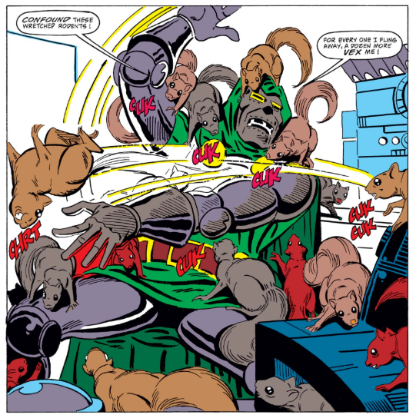
Doom in "The Coming Of Squirrel Girl" from Marvel Superheroes #8 (Ditko & Murray, Dec. 1991)

Doctor Doom's World
This section asked questions about Doom's world, with respondents asked to give answers within a much more specific range. This generally gave fewer answers, although difficulties arose again when there was confusion about what categories some of these answers should go into.

Other characters: Please enter any other characters who regularly appear in Doctor Doom's stories - his supporting cast.
Character | Mentions
Fantastic Four | 191
Doombots | 58
Sub-Mariner | 53
Kristoff/son | 49
Boris | 37
Doctor Strange | 35
Iron Man | 32
Valeria Richards | 28
Mother (Cynthia) | 27
Reed Richards | 27
Spider-Man | 26
Mephisto | 25
Latverian citizens | 23
Silver surfer | 21
Franklin Richards | 20
Avengers | 20
Squirrel Girl | 19
Valeria (true love) | 16
Galactus | 10
Black Panther | 8
Marvel Universe in general | 7
Kang The Conqueror | 7
Scarlet Witch | 7
various lackeys/servants | 6
Father | 5
Morgana Le Fay | 5
Luke Cage | 5
Sue Richards | 5
X-Men | 4
Victorious | 4
Captain America | 4
Hauptmann | 4
Magneto | 4
Thor | 3
Red Skull | 3
Peasants | 3
Klaw | 3
Layla Miller | 2
Zorba | 2
Hulk | 2
Agatha Harkness | 2
Beyonder | 2
Loki | 2
OTHER | 37

One of the issues that arose here was that respondents had difficulty in remembering some of the characters' names, especially for Boris. They usually described the character well enough to be clear who they meant, using terms such as "faithful manservant". A similar problem was working out which of the two characters called Valeria was being referred to. Usually respondents would make this clear themselves, by prefacing it with terms such as "his lost love..." if they meant Doom's childhood sweetheart, or giving the full name "Valeria Richards" if they meant his goddaughter. However, on other occasions the identity had to be discerned through context, so that if the respondent included "Valeria" directly after members of the Fantastic Four I assumed they meant Valeria Richards, while mentioning the name alongside Boris or Doom's mother would lead me to assume they meant the childhood friend.
Also of note here is that Doom's relationship with Valeria Richards is one of the few aspects of his character, apart from his encounters with Squirrel Girl, that first appeared after 1987. Indeed, most aspects were defined within the character's first few years of existence and were little changed afterwards.
Another coding issue arose around the group description "Fantastic Four". Whilst some respondents would enter the name of the group as a whole, others would list all four names. In both cases I coded their answer as "The Fantastic Four", as this allowed me to reflect the fact that lot of respondents gave answers like "Reed Richards and The Fantastic Four", clearly prioritising the latter. While there were also many occasions where respondents would only name Reed Richards, the only other member of this team to also be highlighted in this way was Sue Storm/Richards, and much less often.
It was also interesting to see how many respondents mentioned Kristoff, a character who I assumed had only appeared in a few John Byrne stories but, according to The Marvel Database, has made over 70 appearances in the Marvel Universe (Fandom, 2020).

Objects: Please enter any objects that regularly appear in Doctor Doom's stories.
Object | Mentions
Doombots/Robots | 107
Armour | 62
Time machine | 57
Machinery/KirbyTech | 41
Castle | 37
Mask | 35
Throne | 29
cloak and/or hood | 25
Goblets | 17
Weaponry (high tech) | 16
Mad Science Device (new to this story) | 13
Magical artifacts | 11
cosmic cube | 9
Gun | 9
infinity stones/gauntlet | 8
laboratory equipment | 8
Books | 7
Gauntlets | 6
Dining tables/chairs | 6
Traps | 5
McGuffin - the evil device Doom seeks | 4
Plane | 2
Crown and sceptre | 2
Viewing screens | 2
Bombs | 2
Lasers | 2
OTHER | 53

This category had the most overlap with other categories, with the top item "Doombots" also cropping up in answers to the "Appearance" (5 responses), "Physical actions" (26), and "Other characters" (58) questions. Several other items here - "armour", "mask", "cloak and/or hood" etc. - are also part of his "Appearance", whilst "Castle" is also a location. Clearly these are all core components of Doom, however they are categorised, but for the purposes of my own analysis later they would need to be placed in one category only. This will be done based on the number of respondents mentioning them in each category, so that Doombots would be included in the "Other Characters" category because that is where they received the most mentions.
Apart from these the top answer was Doom's time machine and then machinery in general. Machinery is coded as "Machinery/Kirby Tech" because the latter term was frequently used to describe Doom's devices . The code "Mad Science Device (new to this story)" however is a different signifier, referring to the stream of new inventions that often form the starting point for Doom's adventures, which were referred to in this manner by respondents.
Also of interest was the fact that only two people mentioned "viewing screens". During my research I have noticed that these appear again and again, across all media versions of Doctor Doom, and yet they do not seem to have left an impression on respondents. One explanation for this could be that they were answering questions in the twenty first century, where viewing screens are so common as not to be notable, whereas the stories themselves were written and consumed in a time when they were still the stuff of science fiction.

Locations: Please enter any places that you associate with Doctor Doom stories.
Location | Mentions
Latveria | 210
New York | 88
Baxter building | 57
Castle Doom | 43
Castle | 37
Hell | 26
Doomstadt | 20
Latverian embassy | 19
Space | 18
Battleworld | 10
Laboratory | 10
college (ESU) where he met Reed Richards | 9
Four Freedoms Plaza | 7
other dimensions/realms | 6
Throne room | 6
Atlantis | 5
Tibet | 4
United Nations Building | 4
Doom Island | 4
USA | 3
Upstate New York Castle | 3
Earth | 3
the Moon | 3
2099 universe/timeline | 3
Camelot | 2
Wakanda | 2
wherever the FF are | 2
Avengers Mansion | 2
Eastern Europe | 2
Other | 33

This was another category that was straightforward to code, with a very clear top answer. The only real issue was with the different Castles that Doom inhabits. Occasionally respondents would state that they were referring to Doom's original castle in New York, which appeared in his debut appearance, but others said just "Castle Doom" (i.e. the one in Latveria) or just "Castle", so for clarity I coded each separately.
There was another difference here between my own perceptions of Doom and that of the respondents. My reading (and viewing) has shown that the United Nations building occurs again and again in Doom's stories across different media - while analysing the survey I was watching the Spider-Man cartoon series from 1981, which features the UN building in almost every episode where Doom appears - yet only four people mentioned it. Unlike the viewing screens in the previous category, this is less easy to explain away with advances in technology, and may point to differences in the way that comics fans and creators view the core components of character.

Previous events: Please enter any important events from the past that are referred to in Doctor Doom's stories.
Event | Mentions
Scarring of face (in explosion) | 150
University | 83
Early meetings with Reed Richards | 81
Death of his mother | 78
Overthrowing ruler of Latveria | 51
Mother's damnation | 49
Mask place on face | 33
Time in Tibet/Himalayas | 32
Attempts to save mother from hell/Mephisto | 30
Gypsy life/Childhood in Latveria | 30
Armour being built | 28
Finds mother's spells/learns magic | 23
Ongoing rivalry with Reed Richards | 22
Father's death | 20
Steals Silver Surfer's power/board | 16
Steals Beyonder's Power | 16
Various confrontations with FF | 13
Mother was a witch | 8
Remade the universe/Became a God | 8
Time Machine/Blackbeard's treasure adventure | 8
FF Origin | 7
Loses his true love/wife | 6
Birth of Valeria | 6
Secret Wars | 6
shooting Baxter Building into space | 6
Tries to take over the world | 5
Doom as part of FF Origin | 5
Beaten by Squirrel Girl | 4
Father was a doctor | 3
Camelot | 3
expulsion from school | 3
Adopted Kristoff | 3
Marrying Scarlet Witch (almost) | 2
Murdered Valeria for more magic | 2
Confrontations with Iron Man | 2
Stiffing Luke Cage for payment | 2
Hands crushed by Thing | 2
Became Iron Man | 2
Tried to date Sue | 2
On the run with father | 2
Other | 72

There seemed to be some confusion amongst respondents here. The question asked for "important events from the past that are referred to in Doctor Doom's stories", but what most people entered seems to have been the events that they themselves remembered. This is especially noticeable in the "Other" category, which largely consists of specific stories recalled by respondents, or indeed internet memes. Perhaps the question did not make this sufficiently clear, erring on the side of brevity rather than clarity.
Other than that the responses here did tally with my own experience of reading Doom's stories, with aspects of his origin story rating most highly, along with the events regarding his mother's death and damnation. These are clearly core to Doom's character, and the fact that very few subsequent events are referred to points to the way Doom is often used as a "modular" or "portable" character who can be dropped into any storyline without need of much introduction or knowledge of anything except his origin.

Creators And Marketing
This section deals with the aspects of Doom as a fictional character, created and sold by people and commercial entities in the "real world".

Creators: Please enter the names of any people or organisations that you associate with the creation of Doctor Doom's stories. Please note that this can refer to anybody who worked on any story, not just the original creators of the character.
There were 59 creators mentioned by two or more respondents, with 54 additional unique responses. For brevity's sake I have only included those with 4 or more mentions here.
Creator | Mentions
Stan Lee | 192
Jack Kirby | 188
John Byrne | 85
Jonathan Hickman | 42
Marvel Comics | 28
Mark Waid | 25
John Buscema | 24
Walt Simonson | 21
Jim Shooter | 21
Mike Weiringo | 17
Ryan North | 16
Roy Thomas | 15
Mike Mignola | 15
Joe Sinnott | 15
Chris Claremont | 14
Roger Stern | 11
Steve Ditko | 10
Ed Brubaker | 9
Mike Zeck | 9
Brian Michael Bendis | 9
Wally Wood | 9
Josh Trank | 7
Erica Henderson | 7
Warren Ellis | 7
Steve Englehart | 6
Mark Millar | 6
Gene Colan | 6
George Perez | 6
John Romita (Sr) | 6
Tom deFalco | 6
Bob Layton | 6
Esad Ribic | 5
Marv Wolfman | 5
Roger Corman | 5
Tim Story | 5
Julian McMahon | 4
David Michelinie | 4
Rich Buckler | 4

The first thing to notice about this category is that although the question said "this can refer to anybody who worked on any story, not just the original creators of the character", the vast majority of respondents still identified Doom's creators, Stan Lee and Jack Kirby, as people they associated with the character.
After that we see the names of the creators responsible for fan-favourite runs on Fantastic Four - John Byrne, Jonathan Hickman, Mark Waid and Mike Weiringo, and Walt Simonson (Burlingame, 2018; Franke, 2018; Marston, 2020). Interestingly, "Marvel Comics" is included in this category. As we will see, this would be a better fit for the next section "Market Authors", but it is interesting to see how many people think of the brand as an actual creator of Doom's stories.
As seen for other categories, the bias inherent in the selection of respondents is clear, not just the usual one towards the Unbeatable Squirrel Girl series (with both series creators, Ryan North and Erica Henderson, included in the responses), but in the fact that almost all of the names mentioned come from comics. The first non-comics creator is Josh Trank, Director of Fantastic 4, with Roger Corman (the unreleased 1994 Fantastic Four movie), and Tim Story and Julian McMahon (the director and the actor who played Doom in the 2005 Fantastic Four and 2007 Fantastic Four: Rise Of The Silver Surfer movies) also appearing.

Marketing: Please enter the names of any people or organisations that you associate with the marketing of Doctor Doom's stories. This could include names that you have already entered in the previous question, but does not have to.
Creator | Mentions
Marvel Comics | 111
Marvel | 84
Stan Lee | 68
20th Century Fox | 28
Fox studios | 26
Jack Kirby | 25
Disney | 12
Sony Pictures | 7
Jim Shooter | 7
John Byrne | 7
ToyBiz | 5
Mattel | 4
MF Doom | 4
Hanna-Barbera | 4
Jonathan Hickman | 4
Roy Thomas | 3
Fantastic Four | 3
Secret Wars | 3
Capcom | 3
Universal | 2
Mark Waid | 2
Roger Corman | 2
Don't know | 2
OTHER | 53

Unsurprisingly, "Marvel Comics" and "Marvel" were mentioned most here, along with the different movie studios that have produced Doom's appearances. Similarly, the creators named are broadly in line with the top answers from the previous category, as these are the ones whose names are often used in conjunction with collected editions. Also, most Marvel comics from the mid-1970s are headed with "Stan Lee Presents..." so it is expected that his name should be quite high in the list.
The only surprise for me was the appearance of "MF Doom" here, an artist I was completely unaware of until starting this PhD, although given the amount of times people have mentioned him to me since I began, perhaps it shouldn't have been!

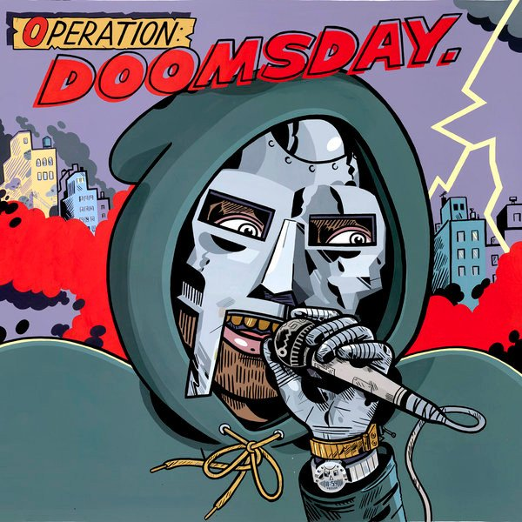
Cover of Operation: Doomsday (MF Doom, 1999)

Anything Else

Other associations: Is there anything else that you associate with Doctor Doom that has not been covered in this survey so far?.
Topic | Mentions
Behaviours and Actions already discussed | 54
Characters and object already discussed | 20
MF Doom | 11
Cartoons/movies (and comments on quality) | 11
Secret Wars | 7
Action figures/toys | 5
Doom 2099 | 3
Darth Vader | 3
OTHER | 39

This category was included so that respondents could mention anything else that had not been covered. Most did not use it, and many of those who did used it to mention other media they had seen Doom in. This is another argument for re-ordering the survey - if they had already listed the media they had seen Doom in then they would hopefully not feel the need to do so again.
In fact, the only topics brought up by more than one person which were not covered in the main survey questions were MF Doom again, and Doom's relationship to Darth Vader. If nothing else, I feel that this shows how comprehensive the survey was.

Overall Analysis
The survey appeared to work well, although there were two main issues which would need to be addressed if the process were repeated with other characters.
Firstly, the selection of respondents was clearly biased in favour of comics, due to the way in which they were recruited. This was especially clear from the way that Squirrel Girl and Ryan North were represented, due to Ryan North's (very helpful) retweeting of the recruitment request. For Doctor Doom, who appeared mostly in comics during this period, this should not pose too many difficulties, but for characters who appear more often in other media I would recommend taking the time to reach out to other fandoms. I would also suggest that, although it was gratifying to have so many respondents, it is not actually necessary, and a smaller group taken from wider sources would give results that were at least as good, and possibly better.
The second issue was with the design of the survey itself. As noted throughout the chapter, leaving the questions about which media respondents had experienced Doom in to the end of the survey meant that many tried to answer them elsewhere. It is my belief that moving this section to the start of the survey would reassure respondents that this would be asked, and also give a clearer idea of which areas were being examined. There were also several questions where respondents were not always clear about what was required of them, and these should be rephrased. A revised version of the survey, which attempts to address these issues, will thus be included in my final thesis.

Having said all this, the survey did elicit a wide range of responses which painted a rich, and surprisingly coherent, picture of who Doctor Doom is. The answers can be broadly characterised as follows:
- He is an arrogant, megalomaniacal, egotistical genius who is obsessed with Reed Richards, the welfare of his country, and the fate of his dead mother. This is shown by his use of dramatic actions, often involving his hands, and penchant for striking dramatic poses, as well as the way he refers to himself in the third person, making self- aggrandising claims and using phrases such as "Fools!" "Bah!" and "Curse you!"
- He is generally referred to in three ways - as Doctor Doom (or simply "Doom", usually by himself), variations of his full name Victor von Doom, or with honorifics referring to his status as the ruler of Latveria. He wears a mask and suit of armour with a green tunic over the top, a hooded cloak, attached with golden clasps, and a leather belt with a gun holster. His eyes are visible beneath the mask, and his face is scarred after an accident. This incident occurred while at University with Reed Richards, and is the most important event in his life, followed by the damnation of his mother.
- Doom is most often associated with the Fantastic Four, especially Reed Richards, and the Doombots of his own creation. Other close associates include Namor the Sub-Mariner, his son Kristoff, and his manservant Boris, but he interacts with a wide variety of characters across the Marvel Universe.
- He can mostly be found in Latveria, especially in his castle, or in New York locations such as the Baxter Building, his castle in the Adirondacks, or the Latverian Embassy.
- He was created by Stan Lee and Jack Kirby, with other notable creators being John Byrne, Jonathan Hickman, Mark Waid and Mike Weiringo, and Walt Simonson.
- He is a Marvel comics character.

This description would, I think, be agreed as true by anybody familiar with the character. However, not all aspects of it are true all the time - there are, for instance, versions of Doom in other media which do not include Reed Richards at all. Similarly, there are many aspects of his character that are apparent from a close reading of the corpus, such as his use of viewing screens and many visits to the United Nations, that are hardly mentioned. This will be examined further in the analysis of the comics themselves.
The next step of this process, therefore, will be to take the character components identified in this survey to form the basis of an empirical tool which can be used to analyse the texts themselves, and see whether Doom's actual characteristics as displayed in my sample of texts match the perception outlined above.

Mark Hibbett, 16 July 2020

Primary Sources
Ditko, Steve (plot,p,i), Will Murray (script). "The Coming Of Squirrel Girl". Marvel Superheroes v2 #8 (Dec. 1991), Marvel Comics.
Stern, Roger (w), Mike Mignola (p), Mark Badger (i). "Doctor Strange and Doctor Doom: Triumph and Torment". Marvel Graphic Novel v1 #49 (Jul. 1989), Marvel Comics
Englehart, Steve (w), George Tuska (p), William Graham Jr. (i). "Where Angels Fear to Tread!" Luke Cage, Hero For Hire v1 #9 (May 1973), Marvel Comics.

Bibliography
Allport, G., & Odbert, H. (1936). Trait names: A psycholexical study. Psychological Monographs, 47.211.
Burlingame, R. (2018, March 26). The Fantastic Four Runs That Prove Marvel's First Family Deserve a Second Chance. Retrieved from Comicbook.com: https://comicbook.com/marvel/news/fantastic-four-runs-that-prove-they-deserve-better/
Clark, T. (2019, Mar 21). After several 'Fantastic Four' flops, Disney should use its upcoming Netflix competitor to revamp the franchise. Retrieved from Business Insider: https://www.businessinsider.com/disney-revamp-of-fantastic-four-in-marvel-cinematic-universe-analysis-2019-3?r=US&IR=T
de Raad, B., & Perugini, M. (2002). Big five assessment . Boston, MA: Hogrefe & Huber Publishers.
Diener, E., & Lucas, R. (2020). Personality traits. In R. Biswas-Diener, & E. Diener, Noba textbook series: Psychology (p. Retrieved from http://noba.to/96u8ecgw). Champaign, IL: DEF publishers.
Fandom. (2020, June 23). Kristoff Vernard (Earth-616). Retrieved from Marvel Database: https://marvel.fandom.com/wiki/Kristoff_Vernard_(Earth-616)
Franke, J. (2018, August 8). Top 3: The Best Runs of Fantastic Four. Retrieved from The Fifth World: http://www.thefifth.world/2018/08/top-3-best-runs-of-fantastic-four.html
Howe, S. (2012). Marvel Comics: The Untold Story. New York: Harper.
Last, S., & March, J. (2010). Marvel Avengers The Ultimate Character Guide. New York: DK Publishing.
Marston, G. (2020, April 1). 10 Best Fantastic Four stories of all time. Retrieved from Games Radar: https://www.gamesradar.com/uk/best-fantastic-four-stories/
Matthews, G., Deary, I. J., & Whiteman, M. C. (2003). Personality Traits. Cambridge: Cambridge University Press.
MF Doom. (1999). Operation Doomsday. Metal Face Records.
Shooter, J. (2011, April 4). Secrets Of The Secret Wars. Retrieved January 2018, from JimSooter.com: http://jimshooter.com/2011/04/secrets-of-secret-wars.html/

Reed and Sue Richards' daughter Valeria is Doom's goddaughter, and named after his childhood sweetheart, as a result of Doom saving the life of both mother and daughter during childbirth.

